Style Guidelines for Final Year Project ReportsDrive Net

Final Year Project

Session 2020-2024

A 4th Year Student

A 4th Year Student

A project submitted in partial fulfilment of the

COMSATS University Degree

of

BSc. (Hons.)BS in Computer Science / Software Engineering (CUI)



Department of Computer Science

COMSATS University Islamabad, Lahore Campus

29 May 2024

**Project Detail**

|  |  |  |  |  |  |
| --- | --- | --- | --- | --- | --- |
| Type (Nature of project) | | | [✔️ ] **D**evelopment [ ] **R**esearch [ ] **R**&**D** | | |
| Area of specialization | | | Mern, AI/ML | | |
| **Project Group Members** | | | | | |
| Sr.# | Reg. # | Student Name | | Email ID | *Signature |
| (i) | Group Leader  FA20-BSE-051 | Muhammad Zohaib | | [FA20-BSE-051@cuilahore.edu.pk](mailto:FA20-BSE-051@cuilahore.edu.pk) | *zohaib* |
| (ii) | FA20-BSE-064 | Hafiz Kunwar M. Ahmad | | [FA20-BSE-064@cuilahore.edu.pk](mailto:FA20-BSE-064@cuilahore.edu.pk) | *Kunwar* |
| (iii) | FA20-BSE-071 | Muhammad Mehroz | | [FA20-BSE-071@cuilahore.edu.pk](mailto:FA20-BSE-071@cuilahore.edu.pk) | *Mehroz* |

*The candidates confirm that the work submitted is their own and appropriate credit has been given where reference has been made to work of others

**Plagiarism Free Certificate**

This is to certify that, I am ____Muhammad Zohaib____ S/D/o ___Muhammad Zahid___, group leader of FYP under registration no CIIT/FA20-BSE-051/LHR at Computer Science Department, COMSATS University Islamabad, Lahore Campus. I declare that my FYP proposal is checked by my supervisor and the similarity index is ____8____% that is less than 20%, an acceptable limit by HEC. Report is attached herewith as Appendix A.

Date: _26 May 2024_ Name of Group Leader: __Muhammad Zohaib___ Signature: ____ *zohaib* ____

Name of Supervisor: _____Sana Maqabool___ Co-Supervisor (if any):____________________

Designation: _____Lecturer________ Designation: _____________________

Signature: ___*Sana Maqbool*_____ Signature: _____________________

**Abstract**

Selling vehicles is not left behind in the digital era as technology is shaping the ways consumers want it. The website of the ‘DriveNet’ project aims to solve the problems of car sellers and buyers, which makes it remarkable. ‘DriveNet’ project is the trading site that enables the sellers to list their vehicles for sales and enable the buyers to have a view of the vehicles which they require and then contact the respective seller for the deal. DriveNet, using the Machine Learning approach, estimates the fair price of vehicles to provide the seller with superior values as well as the buyer to make informed decisons. It also aimed at creating a community of users with passion for cars or motorcycles as it is the case with many young people. The goals remain at 80% accuracy of the price prediction, the increase of the amount of users, 75% satisfaction rate, and a non-biased feedback system. No other investing application is as specialized in vehicles as DriveNet, which feature an easy-to-navigate GUI, ML vehicle price forecast, and a built-in community. The goal of the project is to facilitate selling cars, enhance the experience of the users, and enable people connected with cars to share their passion. The approach consists of requirement gathering phase, design phase, selection of technology stack, development phase, integration with community, machine learning and final phase of intense user testing phase. The overall design of the system is client/server with an object-oriented design paradigm.

Table of Contents

1 Chapter 1 - Introduction 14

1.1 Introduction 15

1.2 Objectives 16

1.3 Problem Statement 16

1.4 Assumptions and Constraints 17

1.5 Project Scope 17

1.6 Machine Learning Models 18

1.6.1 Random Forest Model 18

1.6.2 Linear Regression 18

1.6.3 Decision Tree Regression 19

1.6.4 XgBoost 19

2 Chapter 2 – Requirement Analysis 20

2.1 Literature review 21

2.2 Stake Holder List 22

2.3 Requirement Elicitation 22

2.3.1 Functional Requirements 22

2.3.2 Non-Functional Requirements 28

2.3.3 Requirement Traceability Matrix 29

2.4 Use Case Design 31

2.4.1 User Registration 31

2.4.2 User Log In 31

2.4.3 Reset Password 32

2.4.4 Admin Management 32

2.4.5 Create Listing Ad 33

2.4.6 Edit Listing 34

2.4.7 Browse Listings 34

2.4.8 Search and Filtering 35

2.4.9 Contact and Messaging 35

2.4.10 Issue Reporting 36

2.4.11 Interact Community 37

2.5 Software Development Life cycle and Justification 37

2.5.1 Justification for Agile Scrum Adoption in DriveNet: 37

2.5.2 Summary: 38

3 Chapter 3 - System Design 39

3.1 Work Breakdown Structure Diagram 40

3.2 Activity Diagrams 41

3.2.1 User Registration 41

3.2.2 User Login 42

3.2.3 Listing Ad Activity 43

3.2.4 Edit Vehicle Listing Activity 44

3.2.5 Price Prediction Activity 45

3.2.6 Vehicle Browsing and Buying 46

3.2.7 Search and filtering 47

3.2.8 Contact and Messaging 48

3.2.9 Saving and Comparison 49

3.2.10 Admin: Issue Reporting Activity 50

3.2.11 Admin: Event Handling Activity 51

3.2.12 User: Issue Reporting 52

3.2.13 Community Interaction Module 53

3.2.14 Analytics 54

3.3 Sequence Diagram 55

3.3.1 Registration Sequence 55

3.3.2 Login Sequence 56

3.3.3 Create Vehicle Listing Sequence 57

3.3.4 Edit Vehicle Listing 58

3.3.5 Vehicle browsing and buying 59

3.3.6 Price Prediction Sequence 60

3.3.7 Chatting Sequence 61

3.3.8 Search and Filtering Sequence 62

3.3.9 Save and Comparing Sequence 63

3.3.10 Report Issue 64

3.3.11 Interact with community Sequence 65

3.3.12 View Analytics 66

3.4 Collaboration Diagrams 67

3.4.1 Registration Collaboration 67

3.4.2 Login Collaboration 68

3.4.3 Create Vehicle Listing Collaboration 69

3.4.4 Edit Vehicle Listing Collaboration 70

3.4.5 Price Prediction Collaboration 71

3.4.6 Browsing and Buying Collaboration 71

3.4.7 Chat and Messaging Collaboration 72

3.4.8 Search and Filtering Collaboration 72

3.4.9 Save and Comparing Collaboration 73

3.4.10 Issue Reporting Collaboration 73

3.4.11 Community Interaction Collaboration 74

3.4.12 Generate Report Collaboration 74

3.5 Class Diagram 75

3.6 Architecture Diagram 76

3.7 Database Diagram 77

4 Chapter 4 - System Testing 78

4.1 System Testing 79

4.2 Test Cases 79

4.3 Unit Testing 79

4.3.1 TC-01 User Registration 79

4.3.2 TC-02 User Login 80

4.3.3 TC-03 Forgot Password 81

4.3.4 TC-04 User Profile Edit 81

4.3.5 TC-05 Test User Management 82

4.3.6 TC-06 Test Vehicle listing 83

4.3.7 TC-06.1 Test Editing Vehicle listing 84

4.3.8 TC-07 Test Vehicle browsing and buying 84

4.3.9 TC-08 Test Search and filtering 85

4.3.10 TC-09 Test Contact and Messaging 86

4.3.11 TC-10 Test Saving and comparison 87

4.3.12 TC-11 Test Price prediction 88

4.3.13 TC-12 Test Issue reporting 89

4.3.14 TC-13 Test Community interaction and help 90

4.3.15 TC-14 Test Analytics 91

4.3.16 TC-NF-01 Test Performance 91

4.3.17 TC-NF-02 Test Reliability 92

4.3.18 TC-NF-03 Test Scalability 93

4.3.19 TC-NF-04 Test Availability 94

4.3.20 TC-NF-05 Test Security 95

4.3.21 TC-NF-06 Test Maintainability 96

4.3.22 TC-NF-07 Test Portability 96

4.3.23 TC-NF-08 Test Usability 97

4.3.24 TC-NF-09 Test Interoperability 98

4.3.25 TC-NF-10 Test Compliance 98

5 Chapter 5 – Application 100

5.1 Web App 101

5.1.1 Homepage or Market Page 101

5.1.2 Vehicle Description Page 102

5.1.3 Vehicle Selling Page 102

5.1.4 User/Seller Profile Page 103

5.1.5 Profile Editing Page 103

5.1.6 Vehicle Price prediction Component 104

5.1.7 Drivenet Community Page 104

5.1.8 Drivenet Chat Page 105

5.1.9 Admin Module 106

5.1.10 Issues Handling Page 106

5.2 Machine Learning Application 106

5.2.1 Comparison of Evaluation Metrics of different models 107

5.2.2 Scratch and dent detection 108

6 Chapter 6 – Conclusion 110

6.1 Project Summary 111

6.2 Problems Faced and Lessons Learned 111

6.3 Future Work 112

7 References 113

8 Appendix A 114

8.1 Originality Report 115

8.2 AI Plagiarism Report 119

**List of Tables**

**List of Tables**

Table 1FR01 User Registration 22

Table 2 FR02 User Login 23

Table 3 FR03 User Profile 23

Table 4 FR04 User Management/Admin Panel 23

Table 5 FR05 List Vehicle for Sale 24

Table 6 FR06 Vehicle Browsing and Buying 25

Table 7 FR07 Search and Filtering 25

Table 8 FR08 Contact and Messaging 26

Table 9 FR09 Saving and Comparison 26

Table 10 FR10 Price Prediction 26

Table 11 FR11 Issue Reporting 26

Table 12 FR12 Community Interaction and Help 27

Table 13 FR13 Analytics 28

Table 14 NFR01- Performance 28

Table 15 NFR02 Reliability 28

Table 16 NFR02 Scalability 28

Table 17 NFR04 Availability 28

Table 18 NFR05 Security 29

Table 19 NFR06 Maintainability 29

Table 20 NFR07 Portability 29

Table 21 NFR08 Usability 29

Table 22 NFR09 Compliance 29

Table 23 NFR10 Interoperability 29

Table 24 Requirement Traceability Matrix 30

Table 25 TC-01 User Registration 80

Table 26 TC-02 User Login 81

Table 27 TC-03 Forgot Password 81

Table 28 TC-03 User Profile Edit 82

Table 29 TC-03 Test User Management 83

Table 30 TC-06 Test Vehicle Listing 84

Table 31 TC-06.1 Test Vehicle Listing 84

Table 32 TC-07 Test Vehicle Browsing and Buying 85

Table 33 TC-08 Test Search and Filtering 86

Table 34 TC-09 Test Contact and Messaging 87

Table 35 TC-03 Test Saving and comparison 88

Table 36 TC-11 Test Price Prediction 89

Table 37 TC-12 Test Issue reporting 89

Table 38 TC-13 Community interaction and help 90

Table 39 TC-14 Test Analytics 91

Table 40 TC-NF-01 Test Performance 92

Table 41 TC-NF-02 Test Reliability 93

Table 42 TC-NF-03 Test Scalability 94

Table 43 TC-NF-01 Test Availability 95

Table 44 TC-NF-05 Test Security 95

Table 45 TC-NF-05 Test Maintainability 96

Table 46 TC-NF-01 Test Portability 97

Table 47 TC-NF-08 Test Usability 97

Table 48 TC-NF-09 Test Interoperability 98

Table 49 TC-NF-10 Test Compliance 99

**List of Figures**

Activity Diagram 1 User Registration 41

Activity Diagram 2 User Login 42

Activity Diagram 3 Listing Vehicle 43

Activity Diagram 4 Edit Vehicle Listing 44

Activity Diagram 5 Price Prediction 45

Activity Diagram 6 Vehicle Browsing and Buying 46

Activity Diagram 7 Search and Filtering 47

Activity Diagram 8 Contract and Messaging 48

Activity Diagram 9 Saving and Comparison 49

Activity Diagram 10 Reporting Issue 50

Activity Diagram 11 Event Handling 51

Activity Diagram 12 Issue Reporting 52

Activity Diagram 13 Community Interaction 53

Activity Diagram 14 View Analytics 54

Collaboration Diagram 1 User Registration 67

Collaboration Diagram 2 Login User 68

Collaboration Diagram 3 Vehicle Listing 69

Collaboration Diagram 4 Edit Vehicle Listing 70

Collaboration Diagram 5 Price Prediction 71

Collaboration Diagram 6 Browsing and Buying 71

Collaboration Diagram 7 Chat and Messaging 72

Collaboration Diagram 8 Search and Filtering 72

Collaboration Diagram 9 Saving and Comparing 73

Collaboration Diagram 10 Issue Reporting 73

Collaboration Diagram 11 Community Interaction 74

Collaboration Diagram 12 Generate Report 74

Figure 1Results of Random Forest Regressor Model 18

Figure 2 Results of Linear Regression Model 18

Figure 3 Results of Decision Regression Model 19

Figure 4 Results of XgBoost Model 19

Figure 5 WBS Diagram 40

Figure 6 Class Diagram 75

Figure 7 Architecture Diagram 76

Figure 8 Database Diagram 77

Sequence Diagram 1 Registration 55

Sequence Diagram 2 Login 56

Sequence Diagram 3 Create Vehicle Listing 57

Sequence Diagram 4 Edit Vehicle Listing 58

Sequence Diagram 5 Vehicle buying 59

Sequence Diagram 6 chatting sequence 61

Sequence Diagram 7 Search and filter 62

Sequence Diagram 8 Save and compare 63

Sequence Diagram 9 Report Issue 64

Sequence Diagram 10 Interact with community 65

Sequence Diagram 11 View Analytics 66

Use Case Diagram 1 User Registration 31

Use Case Diagram 2 User Login 31

Use Case Diagram 3 Reset Password 32

Use Case Diagram 4 Admin Management 32

Use Case Diagram 5 Create Listing Ad 33

Use Case Diagram 6 Edit Listing 34

Use Case Diagram 7 Browse Listing 34

Use Case Diagram 8 Search and Filtering 35

Use Case Diagram 9 Contact and Messaging 35

Use Case Diagram 10 Reporting Issue 36

Use Case Diagram 11 Community Interaction 37

# Chapter 1 - Introduction

## Introduction

Much has changed within the automotive industry over the last several years and this ongoing transformation is only set to continue as the demand for newer, more advanced technology as well as constantly fluctuating consumer preferences are being addressed. When people finally are choosing to purchase or sell a car, they stand before a range of questions which involve the identification of the best platform to use for buying or selling a car or the search for an accurate value of the car. A simple question as – “What is the right price?” or “How to find the like-minded car lovers?” forms a web of questions that can rake up feelings of regret for having sold a car or regret for having bought a car. In response to the aforementioned challenges which are very real, allow us to introduce DriveNet – A sleek and technologically advanced project that will revolutionize the selling and purchasing of vehicles.

DriveNet targeted at developing a website where people can trade in vehicles as well as have a platform to predict the prices for cars. The sellers can post their car for sale and the potential buyers can browse through the list of cars posted and then can get back to the sellers of those cars for more information. DriveNet hosts a live chatting feature included within the website to facilitate communication between sellers and buyers but without revealing their explicit identities. It also allows viewing seller details if the seller agreed to share such details, and sellers receive notifications about who viewed their details, and so they know who to expect further calling and contacting. Thus, the formation of DriveNet results in a protected and secure environment for trading vehicles.

In its essence, DriveNet is not just a website but an overarching system built to address and eliminate key challenges currently affecting the automotive industry and its stakeholders. Among them, one of the recognizable is the inclusion of Machine Learning technology which enables them to estimate the right price worth of their vehicle for successful trading. Vehicle price prediction helps both sellers and buyers to make informed decisions about the vehicle trading by knowing that they are trading at fair price. The use of Machine Learning modal has enhanced through employing a complex linear regression model whose purpose is to compute the correct market value of the vehicle. This technological infrastructure makes sure the sellers are not left helpless, with sufficient information and adequate self-assertion for taking crucial decisions. Straight line regression utilized in DriveNet is a powerful instrument, which allows analyzing the large number of characteristics, making the deviation from the ideal valuation minimal in comparison with other manual inspection in the automotive industry, making the principles of effective pricing as precise as possible.

DriveNet is more than just a place where people can buy or sell vehicles such it is a community with the intention of connecting people who have the passion in automobiles. The vehicle platforms allow lovers of automobiles to congregate, exchange stories and ideas and have lively discourse with one another. Individuals can post in the community, view other posts, what they are currently working on for their project cars and motorcycles, post comments on what they have seen or even search for the best modifications for their vehicles.

Besides the filing of ads for their car for sale through the DriveNet, many users of this community benefit from a lot of information pertaining to auto events in communities. The integration of real-time event information improves the overall navigation experience to provide a more concise experience for users seeking various forms of information about automobiles, which makes Divenet a unique and large-scaled site with multiple aspects for car enthusiasts. This is because in addition to providing details of an auto show near the locality of the customer or a simple community walkthrough or even a professional auto event that is soon to go down; DriveNet ensures customers are well informed of the ever changing market in the car world.

Concisely, by using DriveNet, the users can boost their car trading activity. This particular e- commerce platform facilitated through Machine Learning algorithm and a web application makes the process of selling and buying cars easier while providing accurate valuation at the click of a button made possible by Linear regression. Apart from selling car spare parts and accessories, DriveNet provides users with community – an individual page with whom people can have common discussion, share experience, photos or stories on cars and motorcycle. Additionally, the feature of informing users about current events in the automotive industry provides this aspect with another twist of trading and car lovers which makes DriveNet a single shopping center and entertainment for those who seek vibrant automobiles.

## Objectives

The idea is to have a site where you can easily buy and sell a used/pre-owned car and an accompanying application to facilitate the same and the website would have a Machine learning component to suggest a good price to sell/buy as well as being a car community.

* Simplify the process of vehicle selling and purchasing by connecting sellers and buyers by creating a vehicle trading site
* Enhance a mechanism of used vehicles that can give an outline of the estimated market value of the vehicle - a price estimator for used vehicle, along with computer vision to assess the condition of damages incurred by the vehicle to be sold with at least 80% optimal accuracy of Machine Learning Modal.
* Establishment of feedback and problem reporting mechanism as a way of increasing the efficiency of the system.
* Certainly, provide a community system to adapt the Internet space for the people who have the same kind of passion to vehicles and can discuss their projects, exchange experience and receive recommendations.
* People of interest in community should be motor vehicle enthusiasts
* Successfully obtaining the public participation and providing the fair and safe trading of mobility.
* Introduce a website through which you as a consumer can easily know the current price for that specific make or model of car you intend to buy or even sell without necessarily having to look at the car physically or be charged a lot of cash for a mechanic to do the assessment on your behalf (inspection).

## Problem Statement

In the modern world people using the site services, and the re-sale of the old vehicles has become a trend of modern society. Although both the sellers and buyers have the privilege to enjoy the benefits of this system, they are also bound to encounter several complications. There being some among them as follows: The one major issue is that of arriving at the right price at which a used item should be sold. Sellers are always in dilemma when it comes to setting attractive or fair prices that will make it easier to sell the product while on the other hand buyers are always in a challenge of making actual purchase decisions based on fair market price. Although the vehicle owners may find some chance to be attracted to other vehicle owners who have the same interests in automobiles. And buyers are in the lookout for individuals to help them make that decision as to which vehicle to get and the price that comes with it of course. Numerous platforms provide car inspection [1] [2] allowing the buyers to know the right value of the vehicle. However, it may be sometimes difficult to find a place to share common vehicle interests and knowledge, and showcase our project cars somewhere.

## Assumptions and Constraints

Regarding the concept of “DriveNet”, it is possible to notice that there are several critical assumptions. Such a concept states that a huge amount of high-quality data about various types of cars and potential markets is required to implement the implementation of AI-based efficiency. The interaction suggests the so-called ‘activation’ of user stakeholders, while it depends on their desire to become active users of the platform’s features, such as car selling/buying and get a predicted price. Also, it is believed that valuating car using current technologies like machine learning algorithm will yield better results. People who are interested in cars will also contribute to the growth of our community page where an array of blogs and posts should be made for the purpose of enlightening the audience.

An important limitation that has affected the “DriveNet” project, it is possible to mention the problem of the absence of the ideal dataset. This constraint arises from the fact that it is difficult to obtain a sample that captures a number of brands and type of automobiles as well as market conditions. This is a disadvantage since the amount of information that can be obtained about the car may be less – thus making the efficiency of the platform for car valuation less.

In addition, currently, there are certain restrictions both regarding methods and computational resources to assess the inner car condition and characteristics of engines. These constraints severely limit our ability to study the inner workings of the vehicle like the engine, gear shift and other core systems of a vehicle. First among these is the lack of comprehensive essential diagnostic instruments and some improved approaches that form the mainstay in offering accurate and more expanded diagnostic assessment, which are still out of reach.

## Project Scope

The scope of the "DriveNet" project encompasses the development of a web-based platform for vehicle trading, which includes:

* **Price Prediction Module:** Developing a machine learning/deep learning-based module for vehicle price prediction for use convenience.
* **Vehicle Management Module:** For creating, editing, removing and sharing of vehicle advertisement.
* **Vehicle Viewer Module:** A module for viewing the on-sale vehicles and its details.
* **Chat Module:** A communication system to contact vehicle’s seller or vehicle enthusiasts in the community of website.
* **Vehicle Community Module:** A built-in community for vehicle enthusiasts for making friendships with each other to seek guidance and help from specialists. And for posts and events listings related to vehicles and automotive enthusiasts
* **UI Module:** User-friendly interfaces for both sellers and buyers.
* **Problem Reporting Module:** Feedback and reporting mechanisms for fair pricing.
* **Admin Module:** A panel for admin for handling reported issues, user management (blocking/unblocking), and posting the events in the community, and view website analytics.

## Machine Learning Models

### Random Forest Model

* Can handle numerous relationships – there are numerous features of a car that makes it cost a particular amount thus the relationships existing are numerous.
* Feature Importance – Features can be ranked so that one can have higher importance than the other for example Car Factory Price may be ranked higher than the others.
* Deals with missing data and keeps the machine accurate at the same time – some of the sellers may not give details about the condition of the car.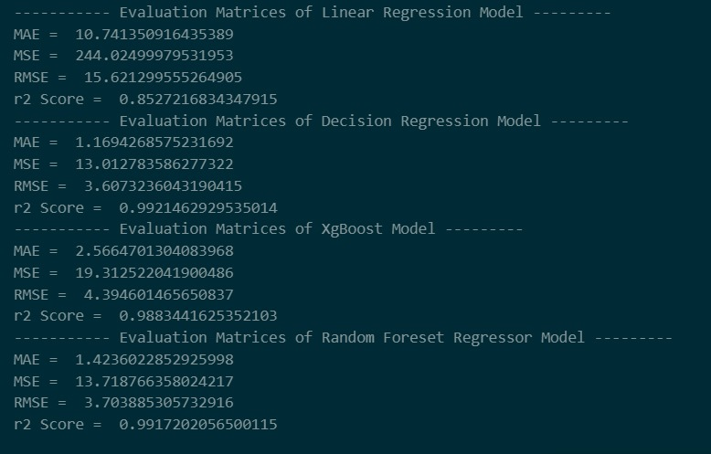

Figure 1Results of Random Forest Regressor Model

### Linear Regression

* Linear regression is useful in a situation where there are linear associations between the various characteristics such as the engine capacity, year of model, and price of the car.
* It generates coefficients that depict how each of the features contributes to the outcome, which can be easily understood which of the feature has a greater importance.
* Linear Regression involves least computations and is appropriate for moderate ranges within features and therefore can be applied to initial car price prediction analysis. 

Figure 2 Results of Linear Regression Model

### Decision Tree Regression

* Another attractive feature that Decision Tree Regression possesses is the ability to fit non-linear data because of the presence of in the splits, between and after. For instance, it can take into account interactions of complications such as; relation between the size of the engine and the year of manufacture among others that cannot be simply added to the price in direct proportionality.
* The decision trees give a visual representation of the importance of each feature in respect of hierarchal split. This is of paramount importance in a bid to endeavor to identify some of the factors that make up the evaluation of the price of car. For instance, by evaluating the price data by the log transformation process, it is possible to determine if the price is significantly influenced by the Car_name or the registered city.
* Decision Tree Regression is flexible and can handle both numerical data and categorical and as well, this does not require so much data pre-processing. This makes it appropriate for occasions where the data one is dealing in has features of a mix type like categorical which are fuel type, assembly and ordinal which is the body condition.

Figure 3 Results of Decision Regression Model

### XgBoost

* XGBoost is known for its high predictive accuracy and ability to capture complex relationships in the data. It can effectively handle both linear and non-linear relationships between features like car model, engine capacity, and price, resulting in more accurate predictions compared to simpler models.
* XGBoost provides insights into feature importance through metrics like feature importance scores or SHAP (SHapley Additive exPlanations) values. This helps in understanding which features contribute the most to the prediction of car prices. For instance, it can reveal whether the model year or the category of the car has a stronger impact on its price.
* XGBoost implements techniques like regularization and tree pruning to prevent overfitting, which can be a common issue in complex datasets with many features. This ensures that the model generalizes well to new data, leading to more reliable predictions for car prices.



Figure 4 Results of XgBoost Model

# Chapter 2 – Requirement Analysis

## Literature review

Recently, the demand for developing sophisticated automotive platforms has gained a high level of popularity resulting in the creation of new applications that changes buying and selling car processes. Some of these services are as follows:

**PakWheels** [3] has come as one of the leading and emerging online automotive market places in Pakistan. PakWheels provides a one stop solution for selling or purchasing both new and used cars unhindered. Opportunity to list their vehicles and socialization with the potential buyers forms part of the many features that are provided to users. For instance, PakWheels offers superior services, including inspection services [1], so customers benefit from the best value for money when buying or selling cars.

Another important application, **OLX Motors** [4]actually a sub-section of OLX that is concerned with the trading of vehicles. It can be used by people who own cars, motorcycles, and any other vehicles as a platform where they can post advertisements of their vehicles for sale. They also offer inspection services where inspectors inspect the vehicles and customers pay for the inspection fees and still purchase isn’t guaranteed. For people who are in search of vehicles they want to buy, they can check through the available advertisements and look for the vehicle they want to buy. Moreover, it provides the car inspection service to make an appropriate price about the car through physically accessing the car owner/seller [2].

**Carwow**, one of the biggest company in field Automotive in the UK, focuses on changing the approach to car purchasing [5]. Carwow is trusted for being open and simple, and it sets itself apart with the help of a different strategy. It allows the users to compare the offers, get connected to reliable car dealers, identify the most suitable cars, look for lease deals, as well as aid in car selling. All of the services offered by Carwow are oriented towards the cars’ lovers, thus providing all needed services to make the car owning process as easy and efficient as possible.

**VAVACars [6],** therefore, positions itself as a convenient marketplace for users in buying cars and selling cars. Apart from your typical search options, VAVACars has other tools like inspections which may be used to establish the reliability of the listed cars. Also, users can use a tool to estimate prices accurately, and customers have the opportunity to donate or exchange their cars easily. Compared to other car trading services, VAVACars offers comprehensive services for improving each stage of the trading process as seen from the user perspective.

**TrueCar** [7], an internet automotive marketplace in United States, has proved itself as important place of selling /buying after introducing new platform. As for the strategies, TrueCar has been devoted to offering the most transparent services to its users and helping them to find the best car by providing them with highly effective services that cover their needs at different stages of searching for a car.

In addition, **DriveNet** itself is an innovative business idea for changing the experience of car trading. The main components the model involve the Price Prediction Module which is a separate feature intended to provide users with estimation of costs for their vehicles. Through the help of these algorithms and the knowledge on market trend, DriveNet guarantees that the price that is offered to the user is reasonable and affordable. By doing this, DriveNet intends to change the general perception of how car valuation is done which in return will help to transform the automotive industry and ensure that a helpful resource is available for car owners.

## Stake Holder List

* Admin
* Seller
* Buyer

## Requirement Elicitation

### Functional Requirements

#### FR01 - User Registration

|  |  |
| --- | --- |
| FR01-01 | The system shall provide a user registration form with fields for essential information, including email, password, and optional profile details. |
| FR01-02 | The registration form shall implement validation checks to ensure that all required fields are filled, and the entered data meets specified criteria (e.g., valid email format, strong password). |
| FR01-03 | The system shall verify that the chosen username and email address are unique and not already associated with an existing account during the registration process. |
| FR01-04 | User passwords shall be securely encrypted before storage to protect user account information. |
| FR01-05 | The system shall verify the users through email to enhance trust with in the community |
| FR01-06 | The system shall allow registered users to switch the roles between seller and buyer. |

Table 1FR01 User Registration

#### FR02 - User Login

|  |  |
| --- | --- |
| FR02-01 | The system shall provide a secure login form with fields for username (or email) and password. |
| FR02-02 | The system shall provide different login portals for admin and general users (seller and buyer). |
| FR02-03 | The system shall authenticate users based on the entered credentials against the stored user data. |
| FR02-04 | The system shall allow users to reset and recover their passwords in case of forgotten credentials. |
| FR02-05 | The system shall handle the login sessions of the users and should logout the user after 30 days of non-activity. |
| FR02-06 | After a 20 unsuccessful login attempts, the system shall temporarily lock the user account to prevent unauthorized access. |
| FR02-07 | The login form shall include a "Remember Me" option, allowing users to stay logged in across sessions on the same device. |

Table 2 FR02 User Login

#### FR03 - User Profile

|  |  |
| --- | --- |
| FR03-01 | The system shall provide a profile page to allow sellers and buyers to view their current information. |
| FR03-02 | Registered users shall have the ability to edit and update their profile. |
| FR03-03 | The user shall be able to view their favourite ads and saved ads. |

Table 3 FR03 User Profile

#### FR04 - User Management/Admin Panel

|  |  |
| --- | --- |
| FR04-01 | The admin panel shall provide interface for managing user accounts. |
| FR04-02 | Admins shall be able to block/unblock user accounts as needed. |
| FR04-03 | The admin panel shall include a module to manage reported issues by general users, within the system. |
| FR04-04 | Admins shall be able to review and take necessary actions on reported problems. |
| FR04-05 | The admin panel shall enable administrators to post and manage events within the vehicle enthusiast community module. |

Table 4 FR04 User Management/Admin Panel

#### FR05 – List Vehicles for Sale

|  |  |
| --- | --- |
| FR05-01 | The users shall be able to sell their vehicle online by creating an advertisement on the system. |
| FR05-02 | The system shall provide a user-friendly listing form for sellers to input relevant details about their vehicle, including make, model, year, mileage, condition, and price. |
| FR05-03 | Sellers shall have the option to upload images of the vehicle during the listing process, providing a visual representation for potential buyers. |
| FR05-04 | The system shall impose minimum limit of at least two images per ad, to ensure the better attraction of buyers. |
| FR05-05 | The listing form shall implement validation checks to ensure that mandatory fields are filled, and the entered data meets specified criteria. |
| FR05-06 | The system shall provide a suggested listing price range based on the machine learning algorithm's valuation of the vehicle, offering guidance to sellers, which attract more buyers. |
| FR05-07 | The system shall also allow the seller to set manual price for their vehicle in the range. |
| FR05-08 | The system shall alert seller if the entered price exceeds the suggested range and give a message that their vehicle may not attract more buyers. |
| FR05-09 | Sellers shall have the ability to mark their advertisements as urgent or featured for increased visibility. |
| FR05-10 | Sellers shall have the ability to remove or disable, their vehicle advertisements when necessary. |
| FR05-11 | The system shall disable the non-active ads after 30 days automatically to ensure only engaged sellers have their listing live. |
| FR05-12 | The seller shall be able to post multiple vehicle ads limited to five from their account. |
| FR05-13 | The system shall allow only registered users can list their vehicles for sale. |
| FR05-014 | Seller shall be able to edit their posted Listing. |
| FR05-015 | Seller shall be able to mark listed vehicle as sold. |
| FR05-016 | Seller shall be able to delete their vehicle listing. |

Table 5 FR05 List Vehicle for Sale

#### FR06 – Vehicle Browsing and Buying

|  |  |
| --- | --- |
| FR05-01 | The buyers shall be able to view the vehicles on sale on the system. |
| FR05-02 | The system shall show the list of relevant vehicles to buyers based on date, type, and user preferences from the user account. |
| FR05-03 | The system shall allow clicking on a listed vehicle shall direct the user to a detailed page displaying comprehensive information about the vehicle, including specifications, images, and the seller's contact details. |
| FR05-04 | The system shall provide a feature for users to compare the listed price of a vehicle with the machine learning algorithm's estimated value, aiding informed decision-making. |
| FR05-05 | Users shall have the ability to send inquiries or messages to sellers directly from the vehicle details page for buying purposes. |
| FR05-06 | The system shall allow the user to filter the vehicles based on various criteria such as make, model, year, and price range. |
| FR05-07 | The system shall provide a map to view the location of vehicle. |
| FR05-08 | The system shall show the most prominent and important features clearly on the vehicle description page. |
| FR05-09 | The system shall show nearby vehicle ads to the current browsing user. |

Table 6 FR06 Vehicle Browsing and Buying

#### FR07 – Search and filtering

|  |  |
| --- | --- |
| FR07-01 | The system shall provide users with a search functionality, allowing them to search for listed vehicles using keywords, vehicle type, manufacturer, or model etc. |
| FR07-02 | The system shall consider the user previous vehicle browsing interests and show related ads based on them. |
| FR07-03 | Users shall have the ability to filter search results to refine their search based on specific preferences, including features like mileage, condition, and location. |
| FR07-04 | System shall allow the user to ask for their location permission to allow filtering based on the buyer’s location. |

Table 7 FR07 Search and Filtering

#### FR08 – Contact and Messaging

|  |  |
| --- | --- |
| FR08-01 | The system shall allow the buyer to contact seller to talk about the listed vehicle ad. |
| FR08-02 | The system shall have an option to view the contact information of seller. |
| FR08-03 | The system shall show contact information to the registered buyers only. |
| FR08-04 | The system shall notify the seller that who viewed contact information through a messaging system. |
| FR08-05 | The system shall have a built-in messaging system to facilitate the in-app communication between buyer and seller without showing their personal information. |
| FR08-06 | Sellers and buyers should be able to communicate each other in real time through chat module. |

Table 8 FR08 Contact and Messaging

#### FR09 – Saving and Comparison

|  |  |
| --- | --- |
| FR09-01 | Buyer should be able to like and save multiple vehicle ads in their account, for future viewing purposes. |
| FR09-02 | Buyer should be able to view the list of liked vehicle listings. |
| FR09-03 | Buyer should be able to compare among the saved vehicle ads to show the distinguishing features of both vehicles. |
| FR09-04 | Buyer should be able to un-like/un-save the liked vehicle ads. |
| FR09-05 | Seller should be able to view the number of liked or interests. |

Table 9 FR09 Saving and Comparison

#### FR10 – Price Prediction

|  |  |
| --- | --- |
| FR10-01 | The system shall provide an option to predict the price range of vehicle being listed for sale based on explicit details of vehicle such as year, model, make, current price, and condition (mentioned by seller). |
| FR10-02 | The system shall have machine learning modal to accurately predict the price range. |
| FR10-03 | The system shall show the predicted price to the buyer as well, to ensure fair functionalities of both seller and buyer. |

Table 10 FR10 Price Prediction

#### FR11 – Issue reporting

|  |  |
| --- | --- |
| FR11-01 | The system shall allow buyers to report issues to admin, if details entered by sellers about vehicles are not correct after visiting. |
| FR11-02 | The system shall provide a form to fill about issue, seller details, and concerned vehicle listing, and submit to the admin. |
| FR11-03 | The system shall allow admin to block/unblock the vehicle alisting/ad. |
| FR11-04 | The system shall allow admin to block/unblock users. |

Table 11 FR11 Issue Reporting

#### FR12 – Community interaction and help

|  |  |
| --- | --- |
| FR12-01 | The system shall provide a community page to attract and build interest of users/vehicle enthusiasts to the system. |
| FR12-02 | The system shall have newsfeed to view the current trends, vehicles, events, and more about our system and vehicles. |
| FR12-03 | The system shall allow the registered users to post content on the news feed. |
| FR12-04 | The system shall have separate news feed for admin. |
| FR12-05 | Admin shall be able to create main events on the admin newsfeed. |
| FR12-06 | The system shall provide discussion forums where users can create and participate in discussions related to various automotive topics. |
| FR12-07 | System shall assign roles or badges to the most interested or participating users. |
| FR12-08 | System shall allow buyers to share their interested vehicle ads within the community to get guidance about that vehicle. |
| FR12-09 | System shall allow users of community to contact other prominent (most earned badges) users to get help and guidance. |
| FR12-10 | System shall allow community members to view the predicted price of shared vehicle and report “unreliable predictions” to admin. |
| FR12-11 | The system shall include a feature allowing users to like posts and make comment, contributing to the visibility and credibility of community content. |
| FR12-12 | The system shall include an event organizing system highlighting upcoming automotive events, gatherings, and meet-ups within the community. |

Table 12 FR12 Community Interaction and Help

#### FR13 – Analytics

|  |  |
| --- | --- |
| FR13-01 | The system shall allow the admin to view the number of visitors per day, month, and year in the form of graphs. |
| FR13-02 | The system shall show the time spent by users in the community of the system. |
| FR13-03 | The system shall allow the admin to view the number of users interested in the upcoming events. |
| FR13-04 | The system shall allow the seller to view the visitor trends on their listed vehicle ads. |
| FR13-05 | The system shall allow the seller to number of likes they got on their listed vehicles and time spent on the ads. |

Table 13 FR13 Analytics

### Non-Functional Requirements

#### NFR01 Performance

|  |  |
| --- | --- |
| NFR01-01 | The system shall load pages and respond to user interactions within 3 seconds. |
| NFR01-02 | The machine learning algorithm for price prediction shall generate results within 5 seconds. |

Table 14 NFR01- Performance

#### NFR02 Reliability

|  |  |
| --- | --- |
| NFR02-01 | The system shall have an uptime of at least 99.5%. |
| NFR02-02 | The machine learning algorithm for price prediction shall have an accuracy of at least 95%. |

Table 15 NFR02 Reliability

#### NFR03 Scalability

|  |  |
| --- | --- |
| NFR03-01 | The system shall be able to handle a simultaneous user load of at least 10,000 users. |
| NFR03-02 | The database should be scalable to accommodate a growing number of vehicle listings (up to 1 million). |

Table 16 NFR02 Scalability

#### NFR04 Availability

|  |  |
| --- | --- |
| NFR04-01 | The system shall be available 24/7, with scheduled maintenance windows communicated in advance. |

Table 17 NFR04 Availability

#### NFR05 Security

|  |  |
| --- | --- |
| NFR05-01 | User passwords shall be encrypted using industry-standard encryption algorithms. |
| NFR05-02 | The system shall implement secure protocols for user authentication and data transmission. |
| NFR05-03 | The admin panel shall have role-based access control, limiting access to authorized personnel. |

Table 18 NFR05 Security

#### NFR06 Maintainability

|  |  |
| --- | --- |
| NFR06-01 | Code shall follow coding standards and be well-documented. |
| NFR06-02 | The system shall be designed with modularity to facilitate future updates and enhancements. |

Table 19 NFR06 Maintainability

#### NFR07 Portability

|  |  |
| --- | --- |
| NFR07-01 | The system shall be accessible and usable on major web browsers (Chrome, Firefox, Safari). The system shall be accessible and usable on major web browsers (Chrome, Firefox, Safari). |

Table 20 NFR07 Portability

#### NFR08 Usability:

|  |  |
| --- | --- |
| NFR08-01 | The user interface shall adhere to accessibility standards. |
| NFR08-02 | The system shall provide user-friendly error messages and prompts |

Table 21 NFR08 Usability

#### NFR09 Compliance:

|  |  |
| --- | --- |
| NFR09-01 | The system shall comply with relevant data protection and privacy regulations. |
| NFR09-02 | The admin panel shall have features to handle reported issues and ensure compliance with community guidelines. |

Table 22 NFR09 Compliance

#### NFR10 Interoperability:

|  |  |
| --- | --- |
| NFR10-01 | The system shall integrate with external services for email verification and messaging. |
| NFR10-02 | APIs shall be provided to by the ML module to communicate with Drive Net website to allow ML predictions. |

Table 23 NFR10 Interoperability

### Requirement Traceability Matrix

|  |  |  |  |
| --- | --- | --- | --- |
| **Requirement ID** | **Requirement Description** | **Test Case ID** | **Test case Description** |
| REQ-01 | User Registration | TC-01 | Test User Registration |
| REQ-02 | User Login | TC-02 | Test User Login |
| REQ-02-01 | Forgot Password | TC-03 | Test Forgot Password |
| REQ-03 | User Profile Edit | TC-04 | Test User Profile Edit |
| REQ-04 | User Management | TC-05 | Test User Management |
| REQ-05 | Vehicle Listing | TC-06 | Test Vehicle Listing |
| REQ-05-01 | Edit Vehicle Listing | TC-06.1 | Test Editing Vehicle Listing |
| REQ-06 | Vehicle Browsing and Filtering | TC-07 | Test Vehicle Browsing and Listing |
| REQ-07 | Search and Filtering | TC-08 | Test Search and Filtering |
| REQ-08 | Contact and Messaging | TC-09 | Test Contact and Massaging |
| REQ-09 | Saving and Comparison | TC-10 | Test Saving and Comparison |
| REQ-10 | Price Prediction | TC-11 | Test Price Prediction |
| REQ-11 | Issue Reporting | TC-12 | Test Issue Reporting |
| REQ-12 | Community Interaction and Help | TC-13 | Test Community Interaction and Help |
| REQ-13 | Analytics | TC-14 | Test Analytics |

Table 24 Requirement Traceability Matrix

## Use Case Design

### User Registration

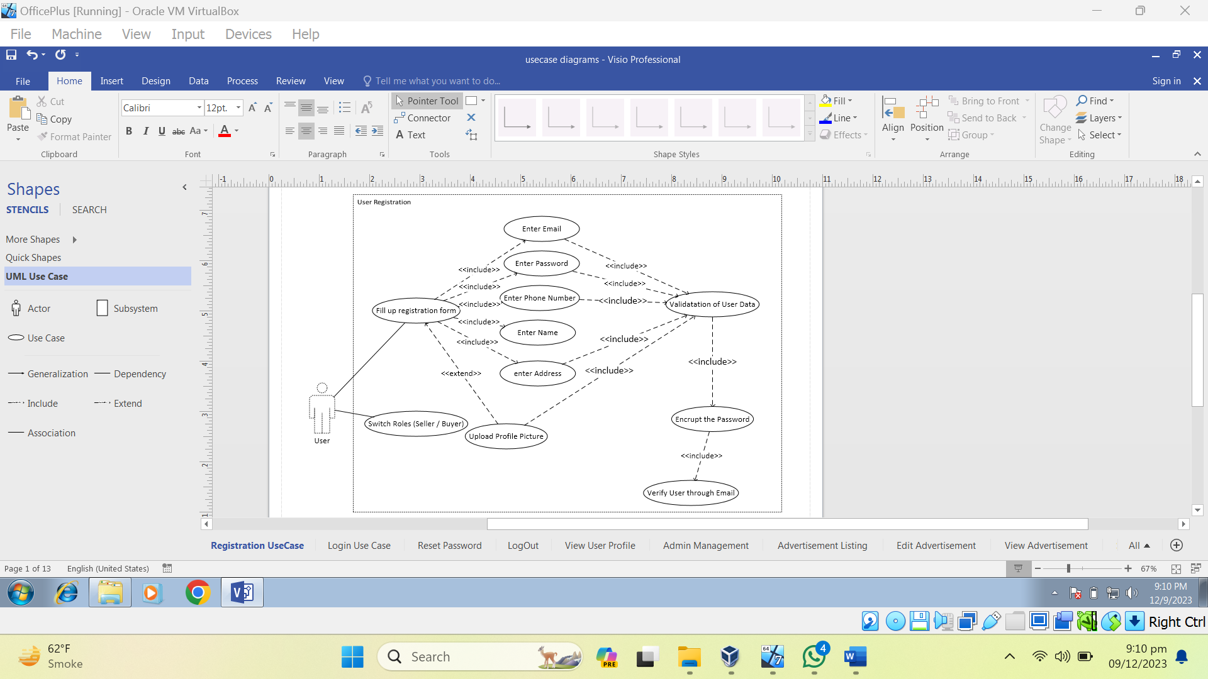

Use Case Diagram 1 User Registration

### User Log In

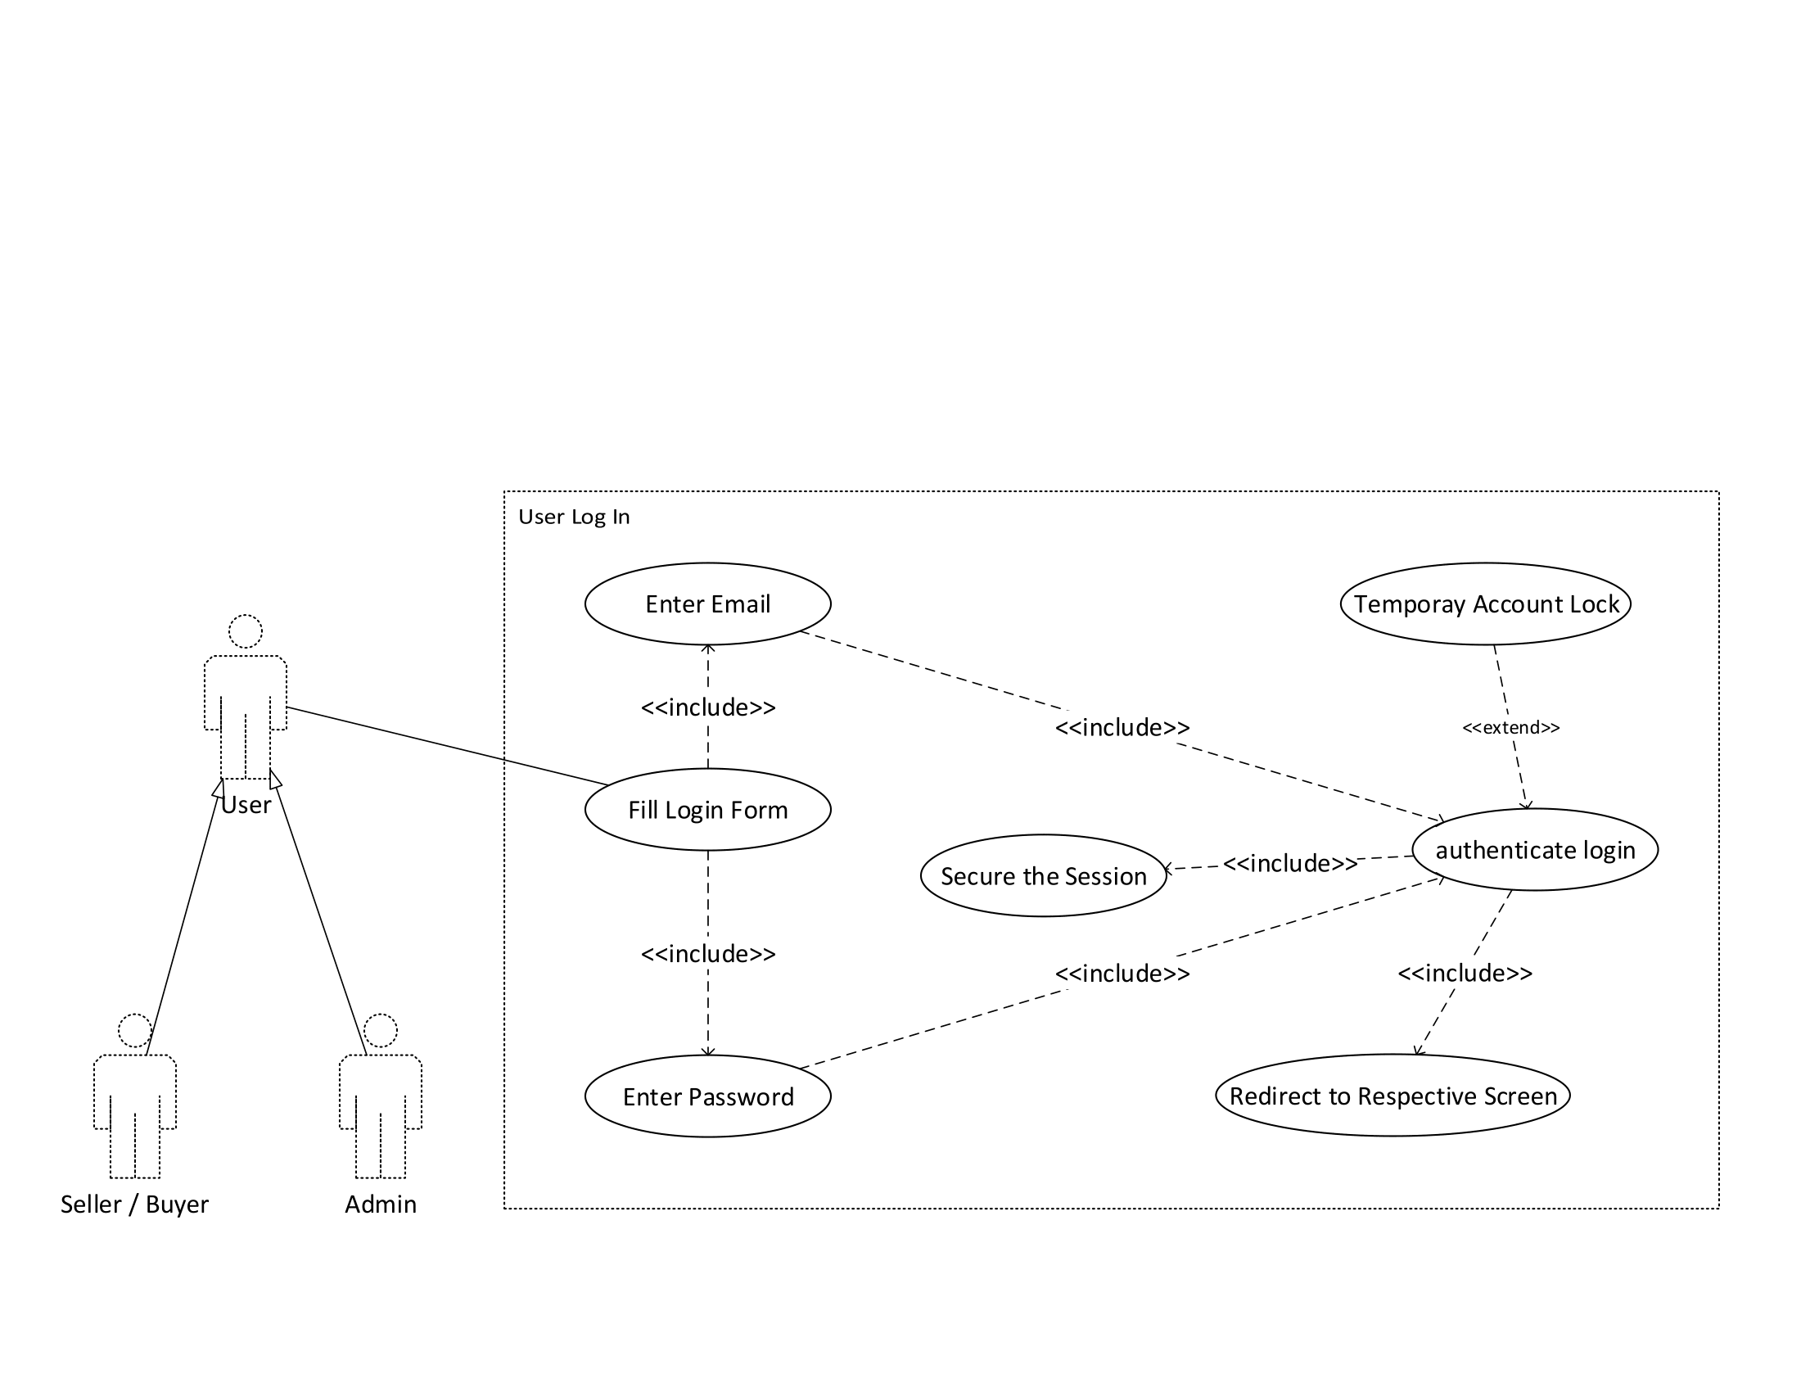

Use Case Diagram 2 User Login

### Reset Password

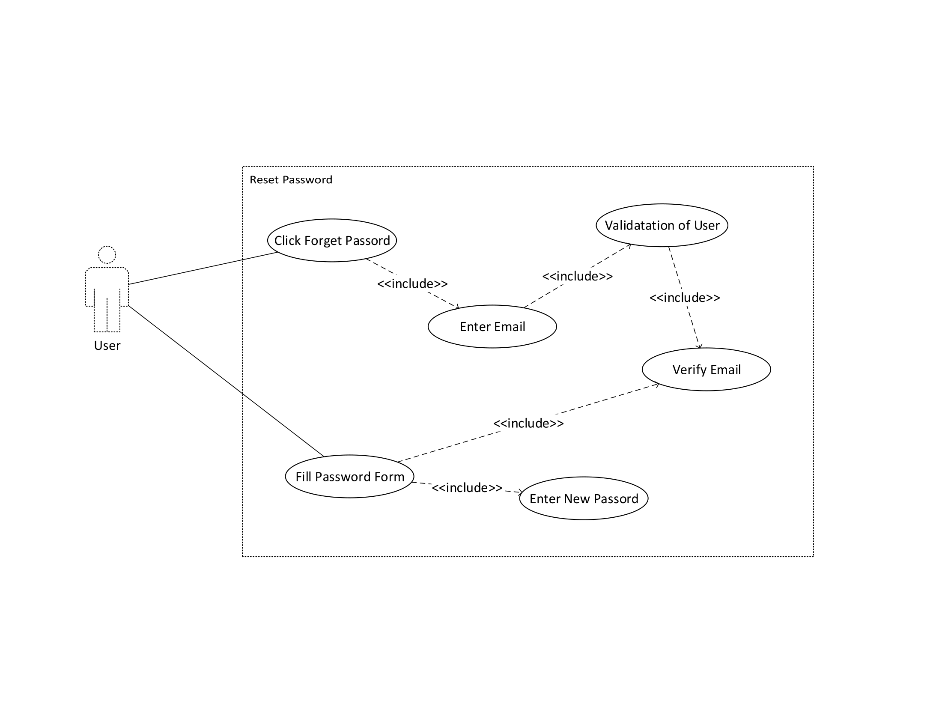

Use Case Diagram 3 Reset Password

### Admin Management

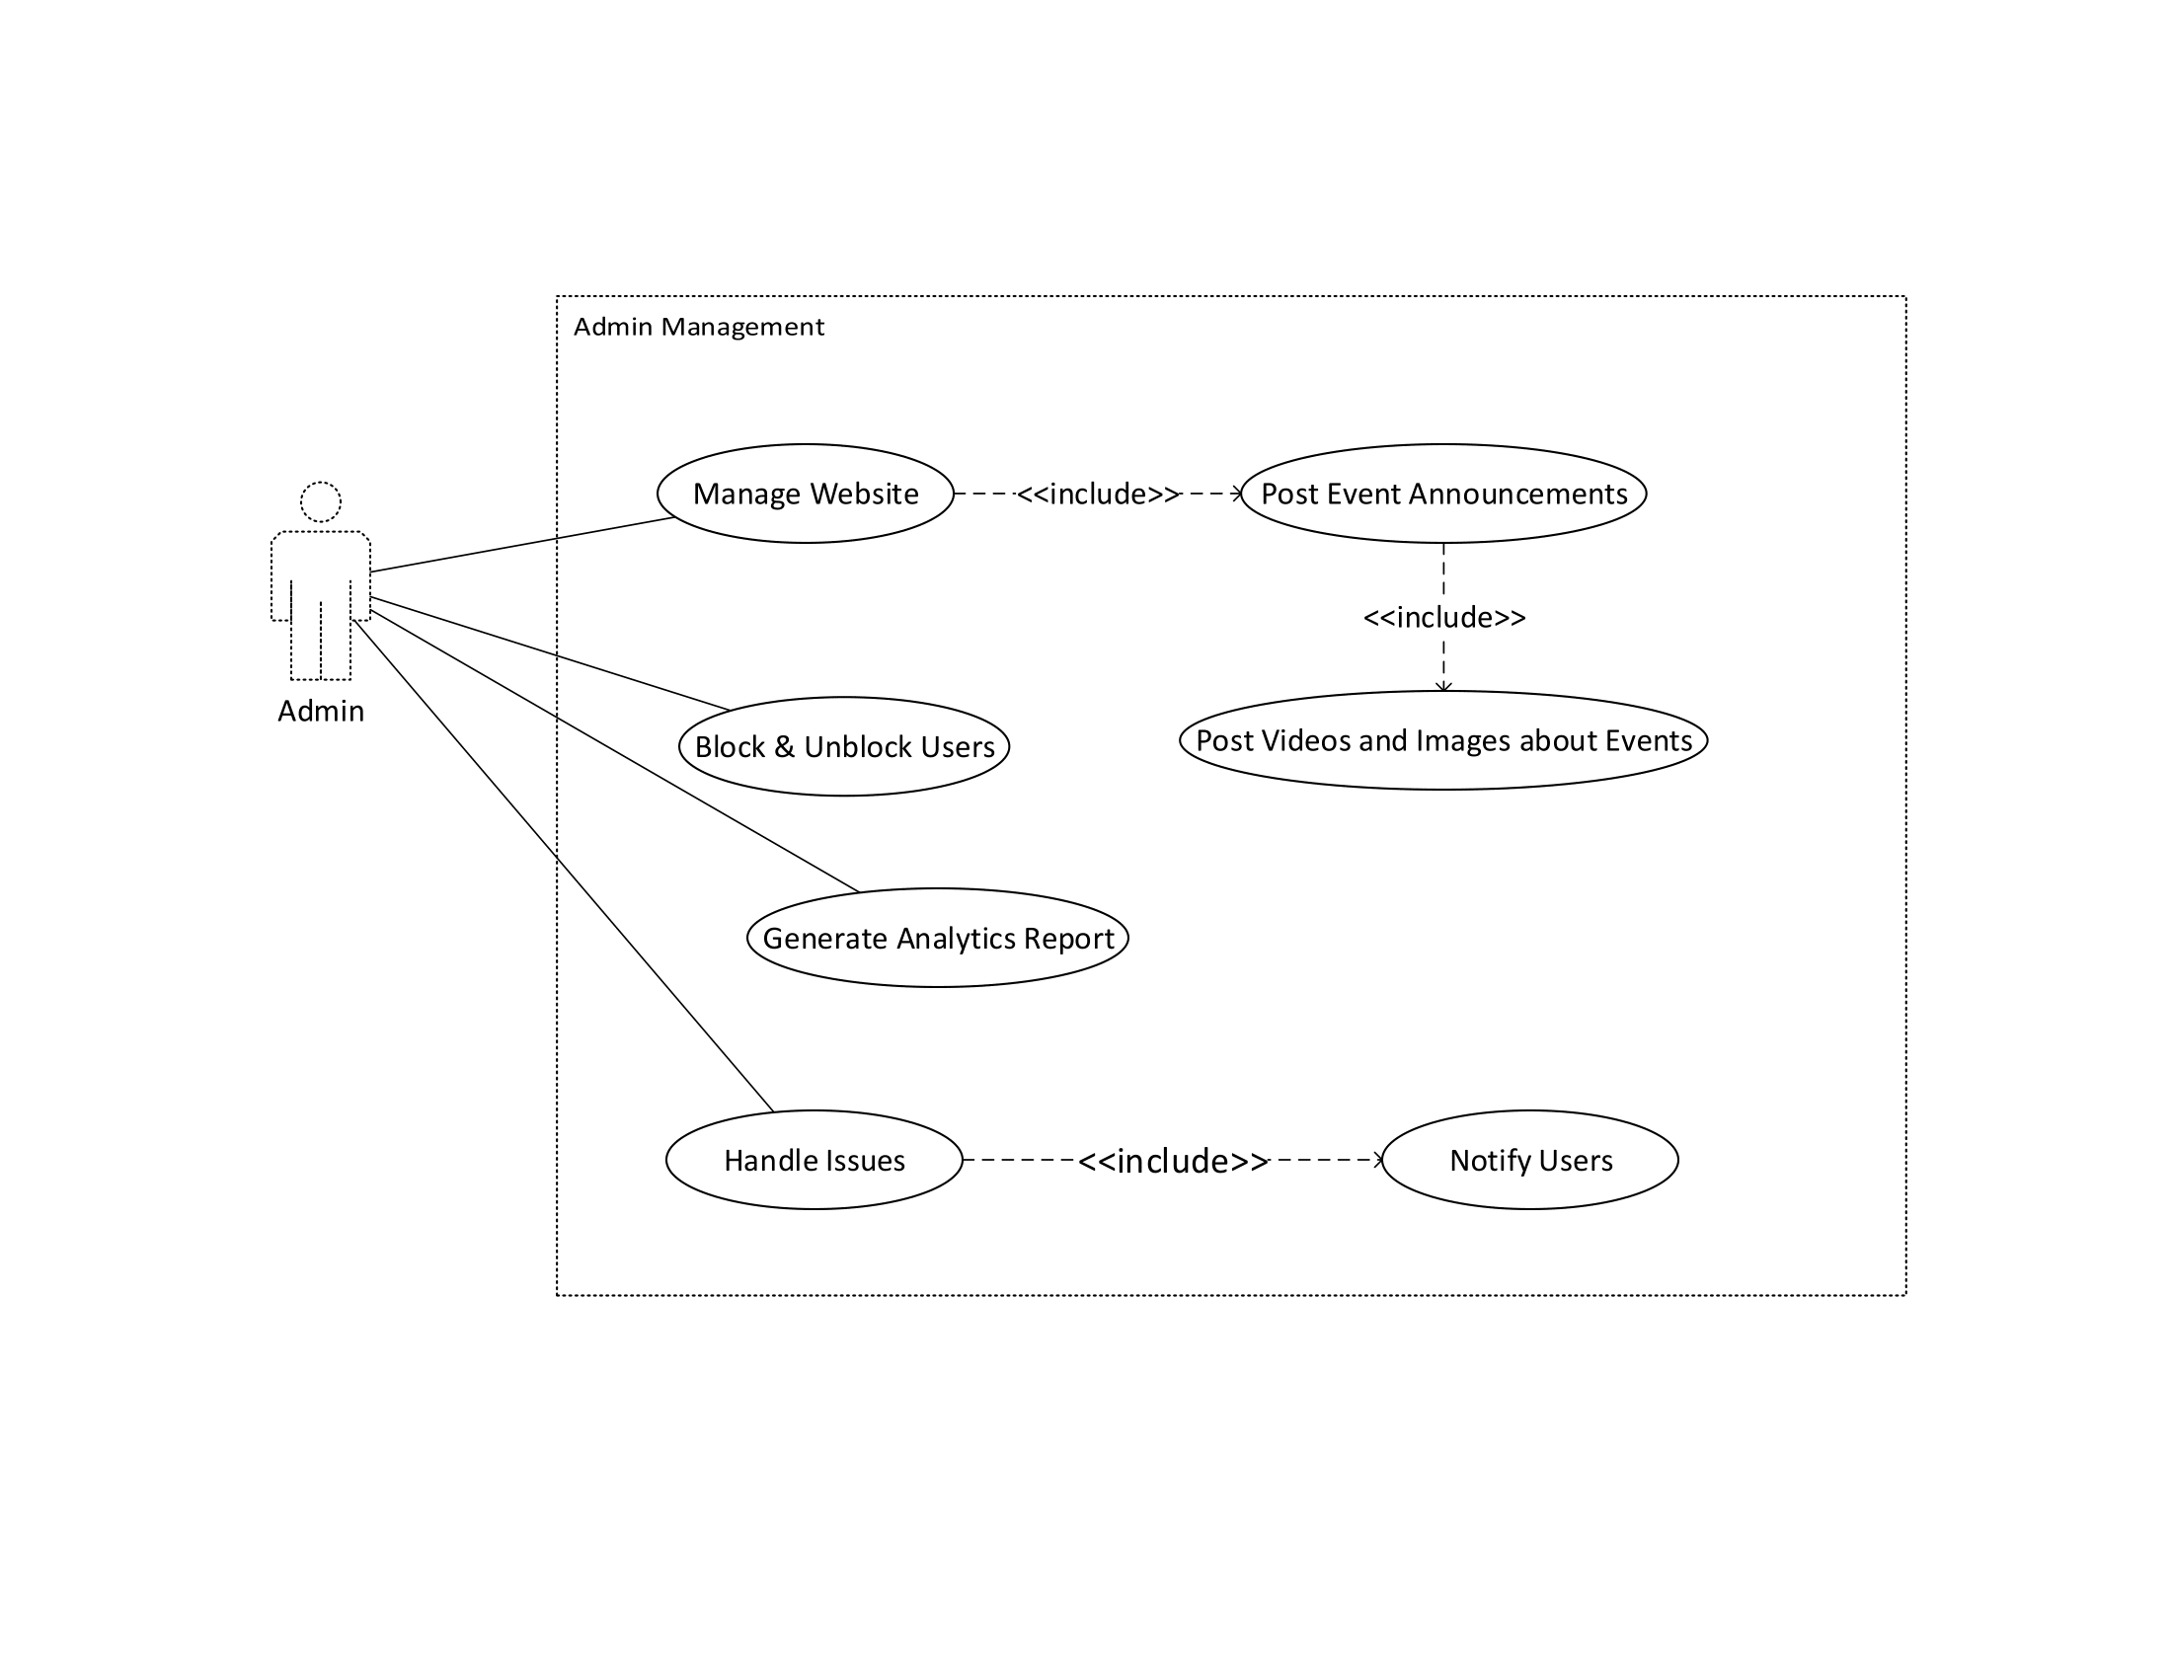

Use Case Diagram 4 Admin Management

### Create Listing Ad

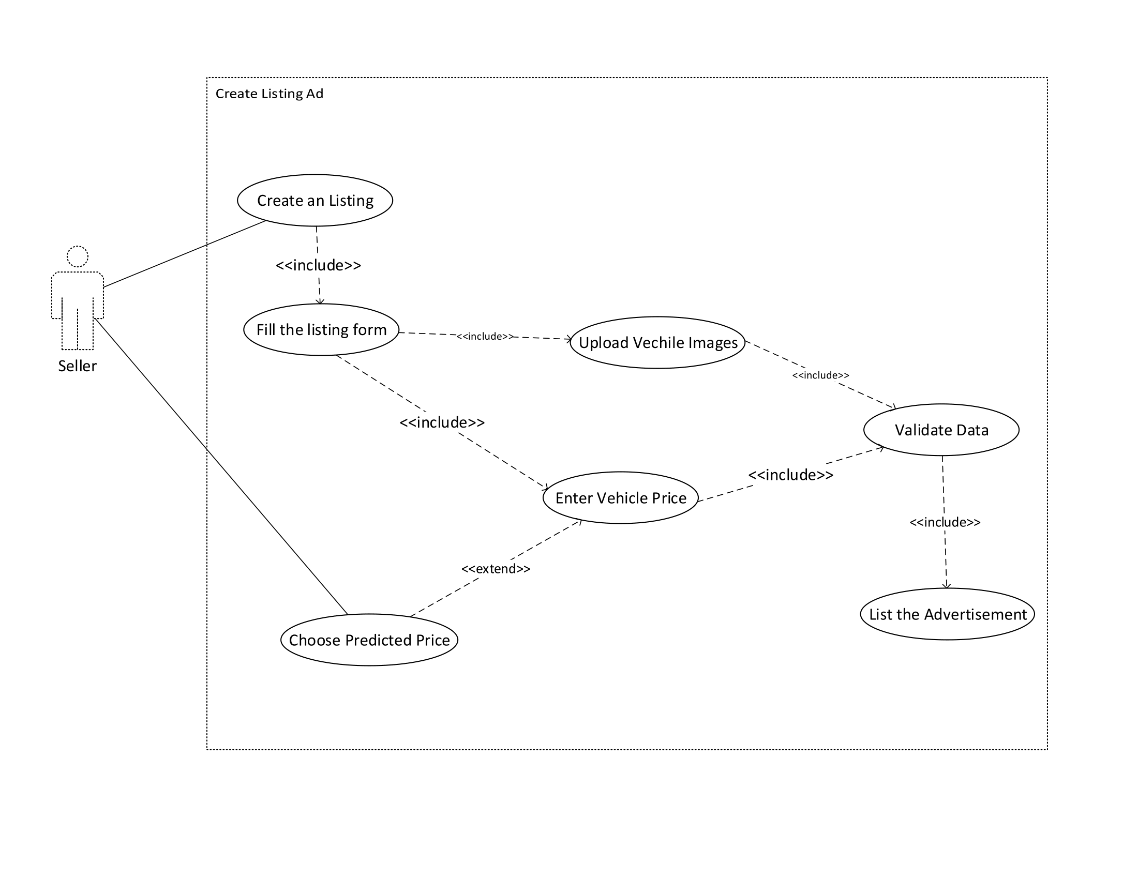

Use Case Diagram 5 Create Listing Ad

### Edit Listing

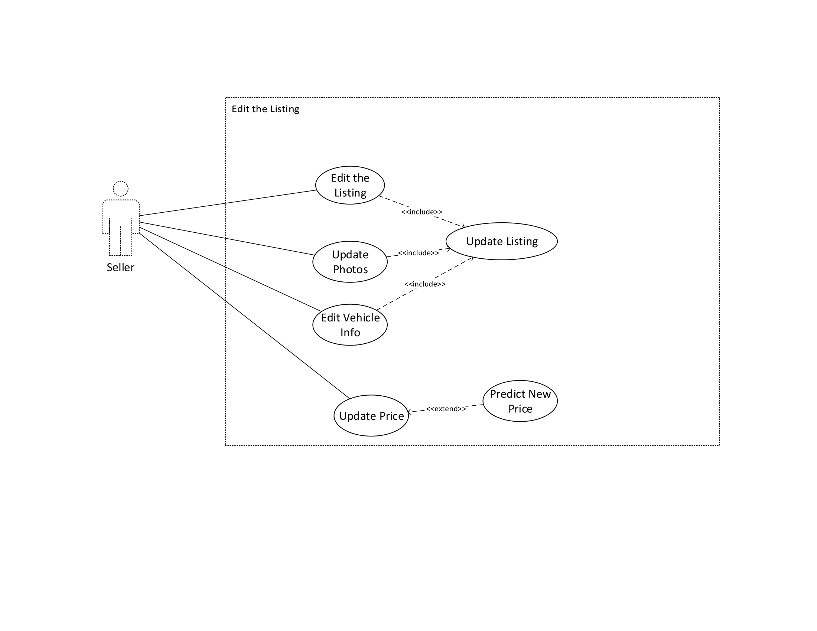

Use Case Diagram 6 Edit Listing

### Browse Listings

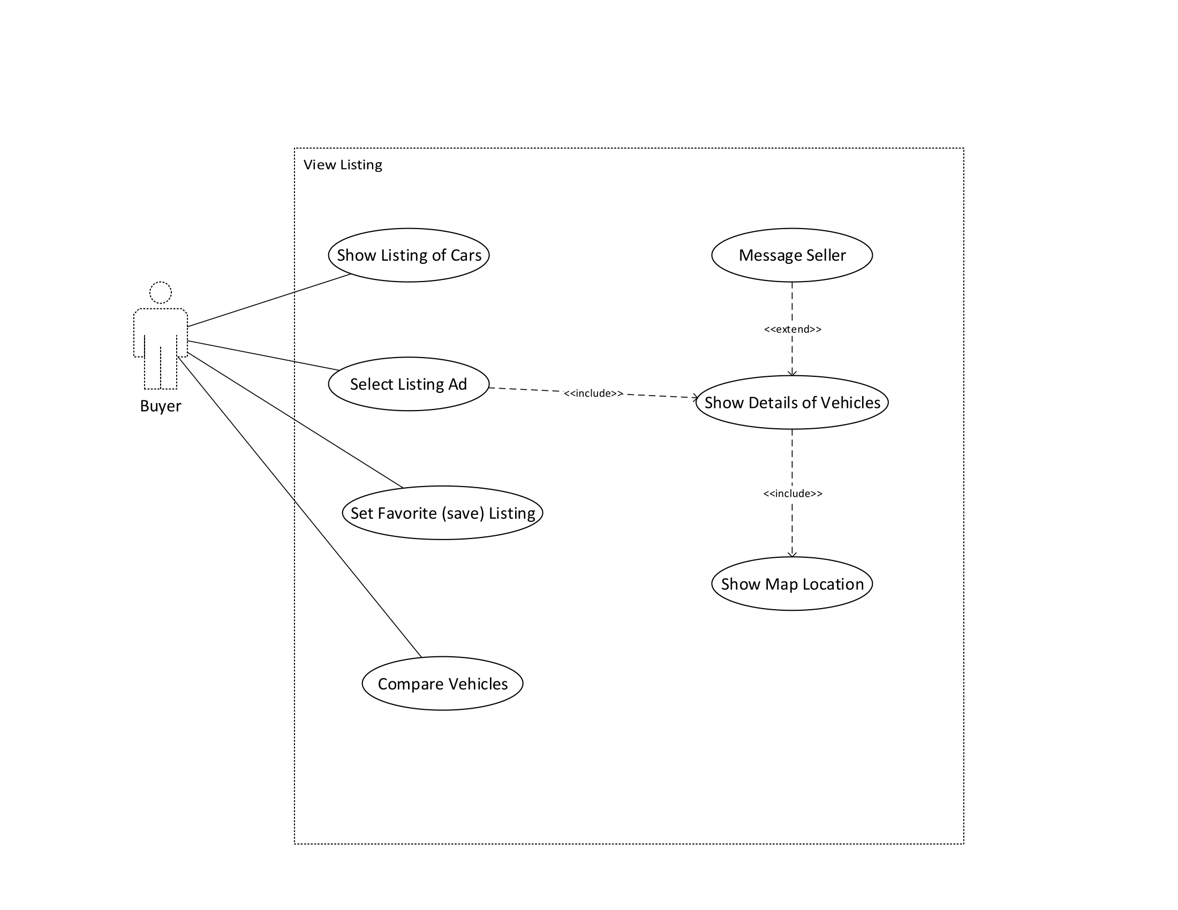

Use Case Diagram 7 Browse Listing

### Search and Filtering

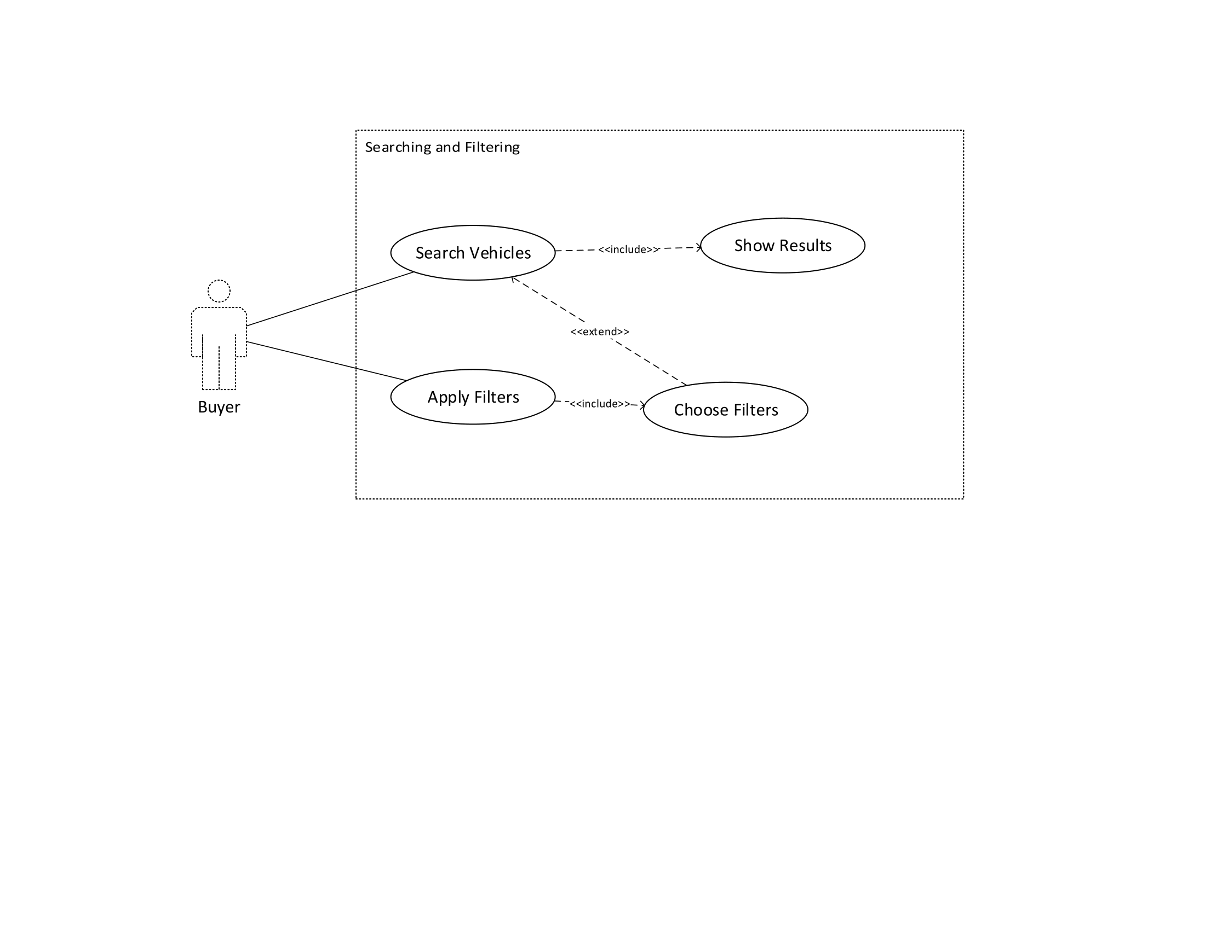

Use Case Diagram 8 Search and Filtering

### Contact and Messaging

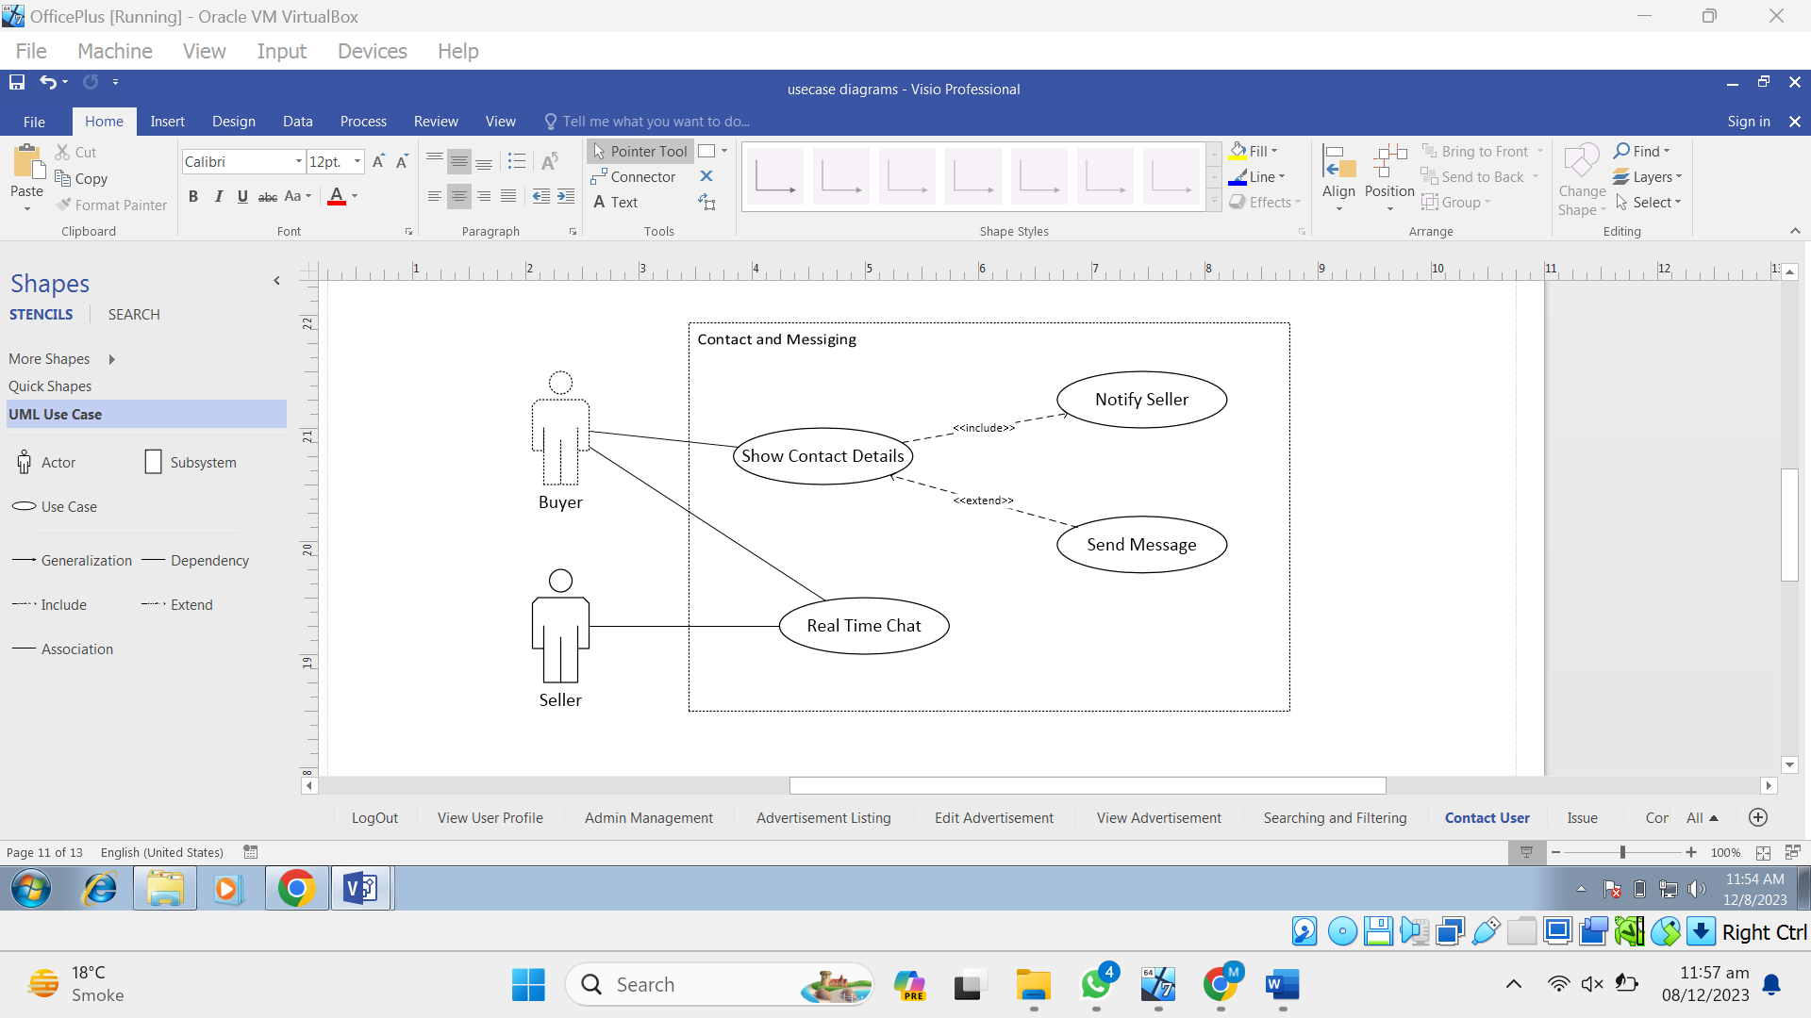

Use Case Diagram 9 Contact and Messaging

### Issue Reporting

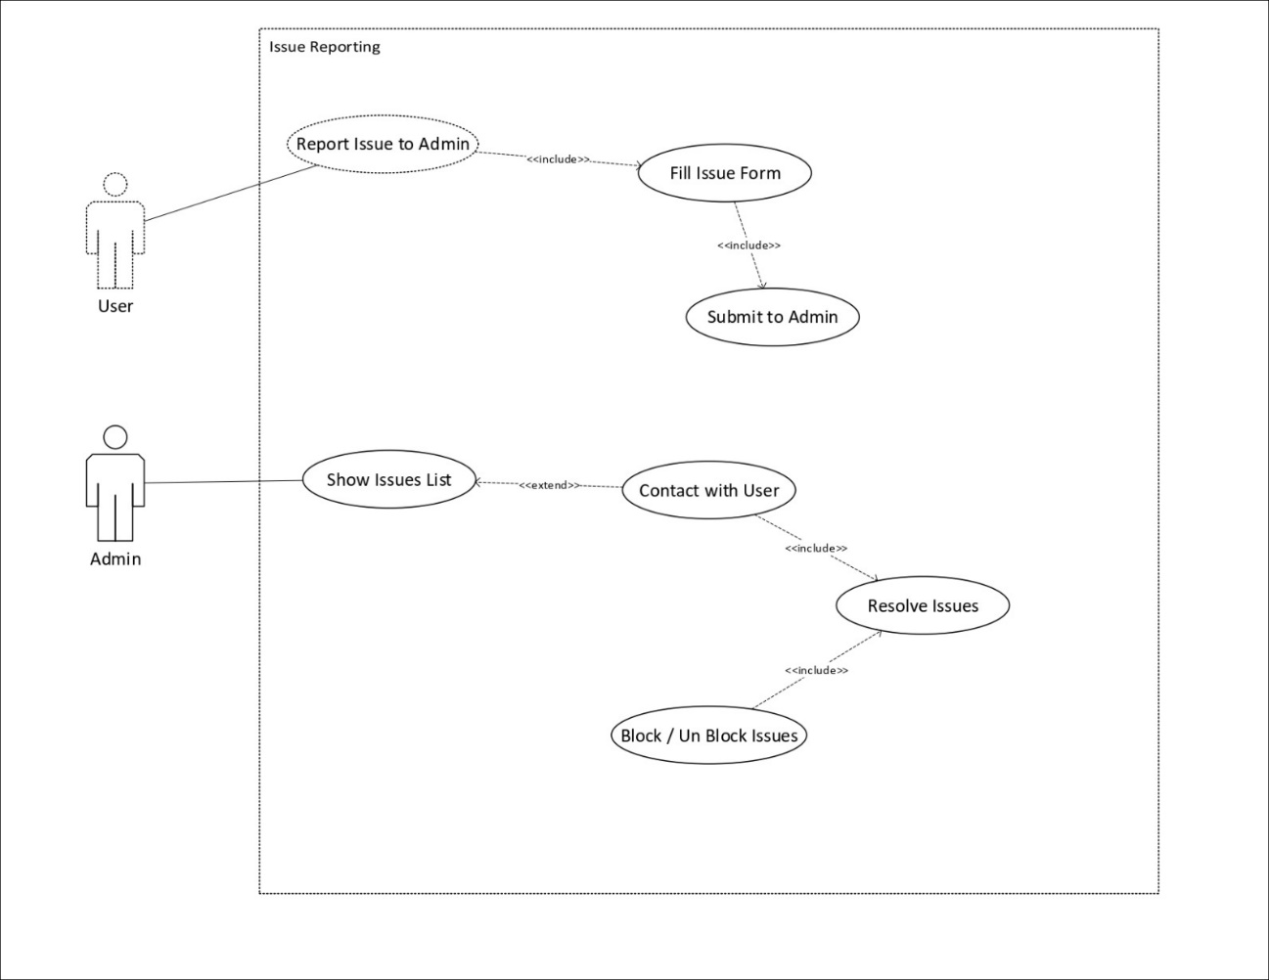

Use Case Diagram 10 Reporting Issue

### Interact Community

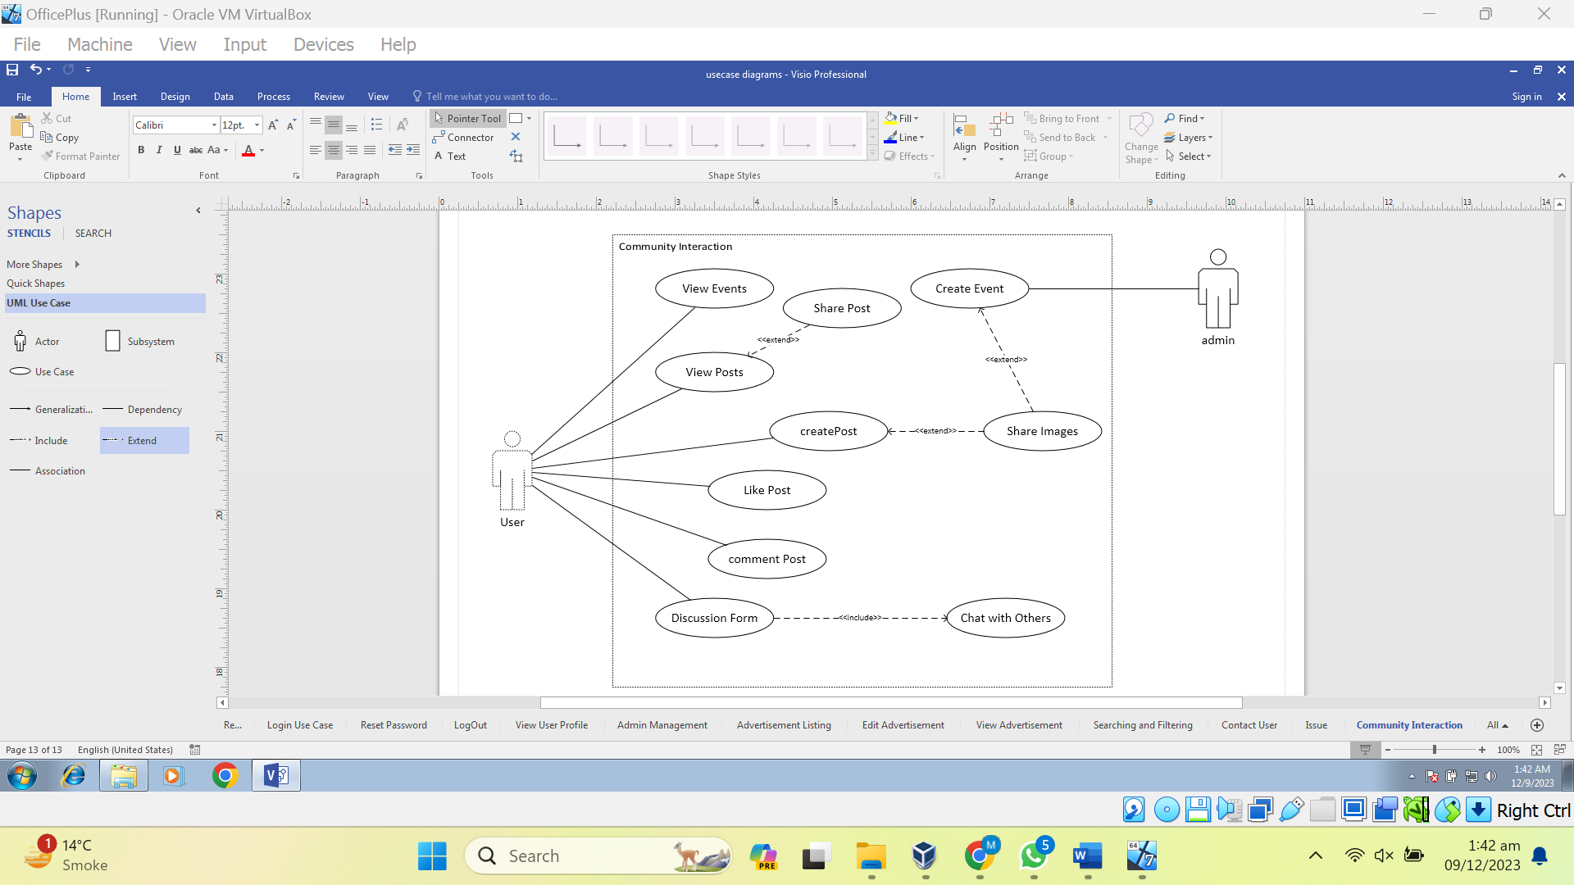

Use Case Diagram 11 Community Interaction

## Software Development Life cycle and Justification

In the course of creating the software for the DriveNet Project, the team has understood that an iterative and cyclic model of further development must be applied, and consequently the choice of Agile Scrum as the method of creating the project is made with the focus on the specific sub-modules: Price Prediction, Community, and Listing.

### Justification for Agile Scrum Adoption in DriveNet:

Continuous Improvement: The daily scrum meetings in an Agile Scrum environment ensure that the system supports iterative development in the module for the continual evaluation of requirements of the vehicle valuation algorithm for Price Prediction.

#### Iterative Development in Price Prediction Module:

**Flexibility:** It is equally effective in incorporating changes as new innovative ideas come up, and it also has the ability of ensuring that the algorithm is not fixed in front of market change hence making Scrum a better approach.

**User Feedback Integration:** The concepts of the Scrum approach include many notions one of which is the possibility of constant feedbacks coming from the end-users, and this perspective is good when it comes to the development of the Community module. It allows a team to create a ground, which the users respond to and one that is in regulation with their anticipation.

#### User-Centric Community Module Development:

**Adaptation to Changing Community Needs:** This combined with the ability to be responsive is especially beneficial for the Community module, as it evolves in order to address the dynamic demands from the user community within the system.

#### Dynamic Listing Module Planning:

**Prioritized Feature Development:** Because of this, the approached used for prioritizing the features of Scrum can make the Listing module even more effective. This ensures that during planning of the project there is a focus on the most essential of listing features involved in the development and deployment processes. The ‘‘Price prediction’’ module is followed by and the other features are a ‘‘second’’ priority.

**Adjustable Project Planning:** Regarding the variability of the work load due to changes in the scope, as well as priorities, of the Listing module Scrum shows itself flexible enough.

#### Cross-Functional Collaboration for Problem Resolution:

**Collaborative Problem Solving:** Scrum is effective also in improving the level of cooperation between coordinated functional units; any problem that may appear in a given module to can be effectively curbed.

**Continuous Communication:** Scrum meetings such as Daily Standups and Sprint Reviews of which the primary objective is communication help in solving straightforward issues and maintaining the flow of the process.

#### Visibility and Transparency in Agile Scrum:

**Increased Visibility**: Scrum provides visibility to all the aspects of the flow of the modules like Price Prediction, Community, and Listing that means the transparency is highly appreciable. All of them will be working on each of the module simultaneously and thus, the achievement of any of the module has to be addressed.

**Enhanced Project Control:** Since the project is progressing according to the business vision, it is recommended that frequent Sprint Reviews and Backlog Grooming sessions should remain the practice for DriveNet.

### Summary:

In summary, it has been decided that DriveNet project is using Agile Scrum to enhance the work progress of the Price Prediction, Community, and Listing modules, as it is an iterative and user-friendly framework. The projects structure aligns well with the scrum model based on all modules. The method used to develop the current study aligns with the organization’s goal of arriving at a more flexible and integrated web application in DriveNet that will also offer a predicted price of the vehicles accurately.

# Chapter 3 - System Design

## Work Breakdown Structure Diagram

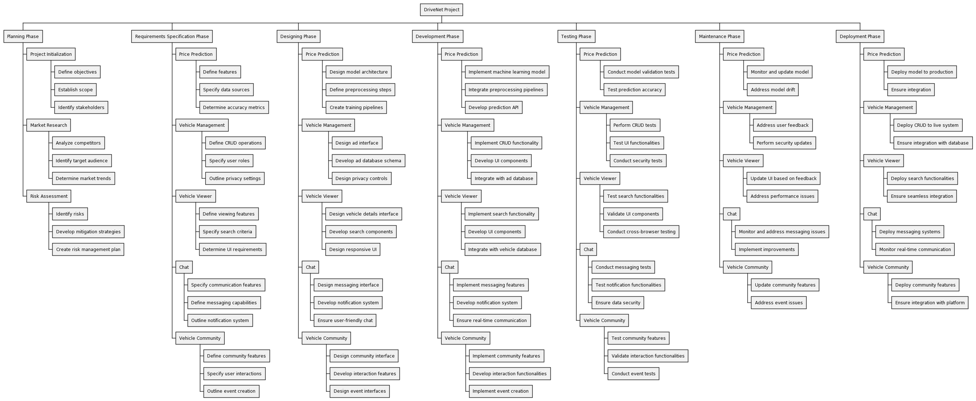

Figure 5 WBS Diagram

## Activity Diagrams

### User Registration

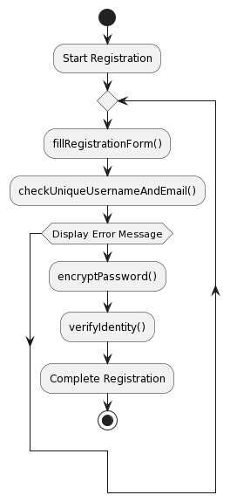

Activity Diagram 1 User Registration

### User Login

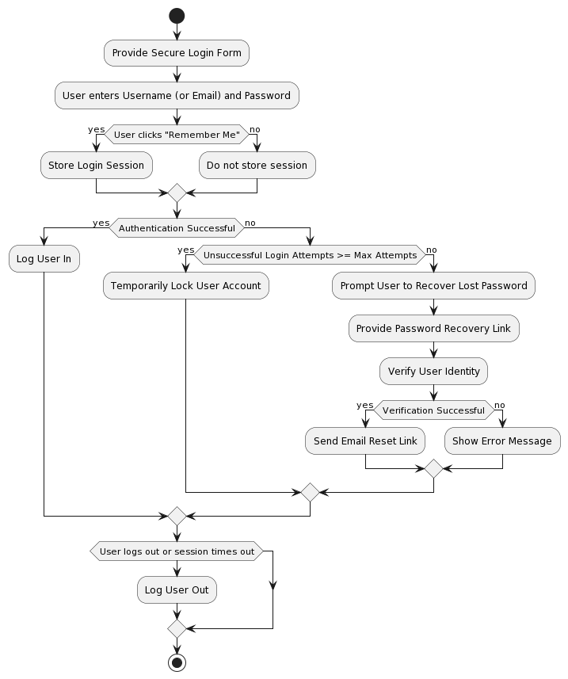

Activity Diagram 2 User Login

### Listing Ad Activity

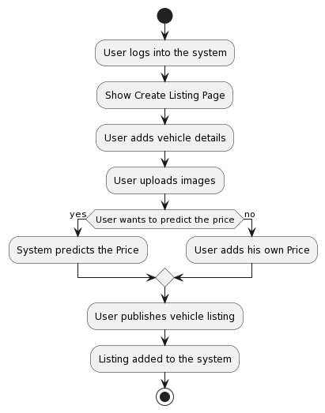

Activity Diagram 3 Listing Vehicle

### Edit Vehicle Listing Activity

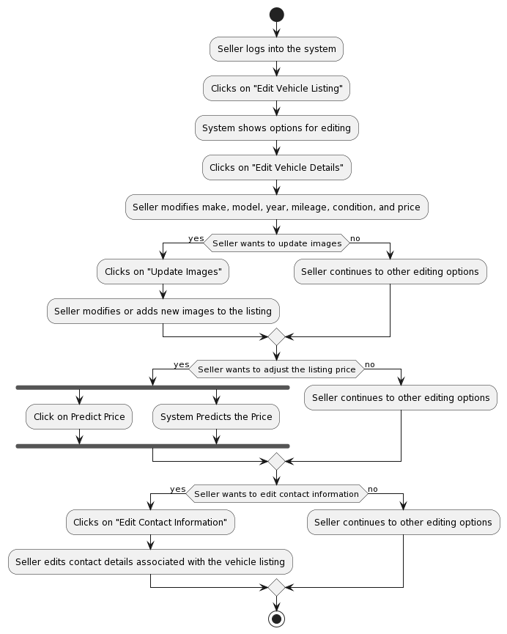

Activity Diagram 4 Edit Vehicle Listing

### Price Prediction Activity

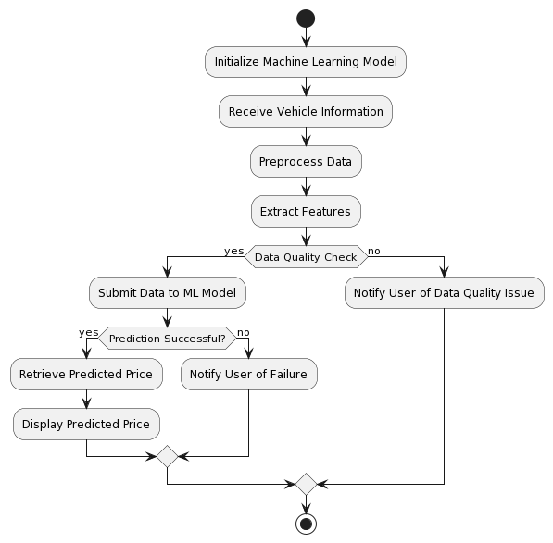

Activity Diagram 5 Price Prediction

### Vehicle Browsing and Buying

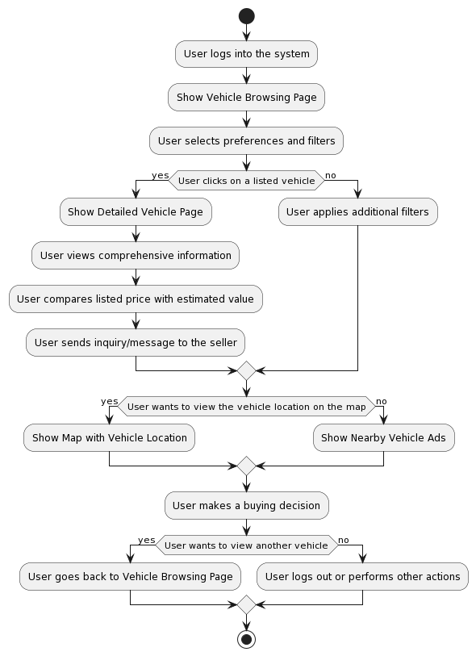

Activity Diagram 6 Vehicle Browsing and Buying

### Search and filtering

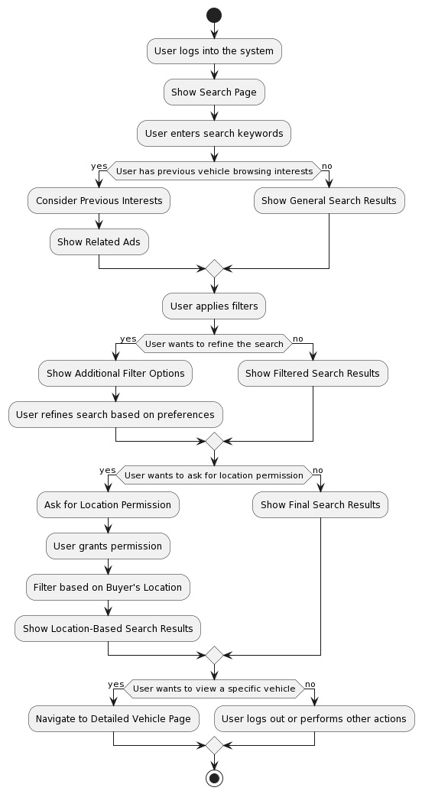

Activity Diagram 7 Search and Filtering

### Contact and Messaging

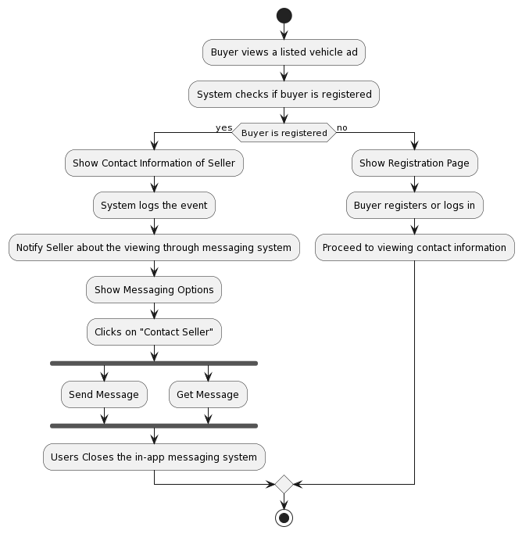

Activity Diagram 8 Contract and Messaging

### Saving and Comparison

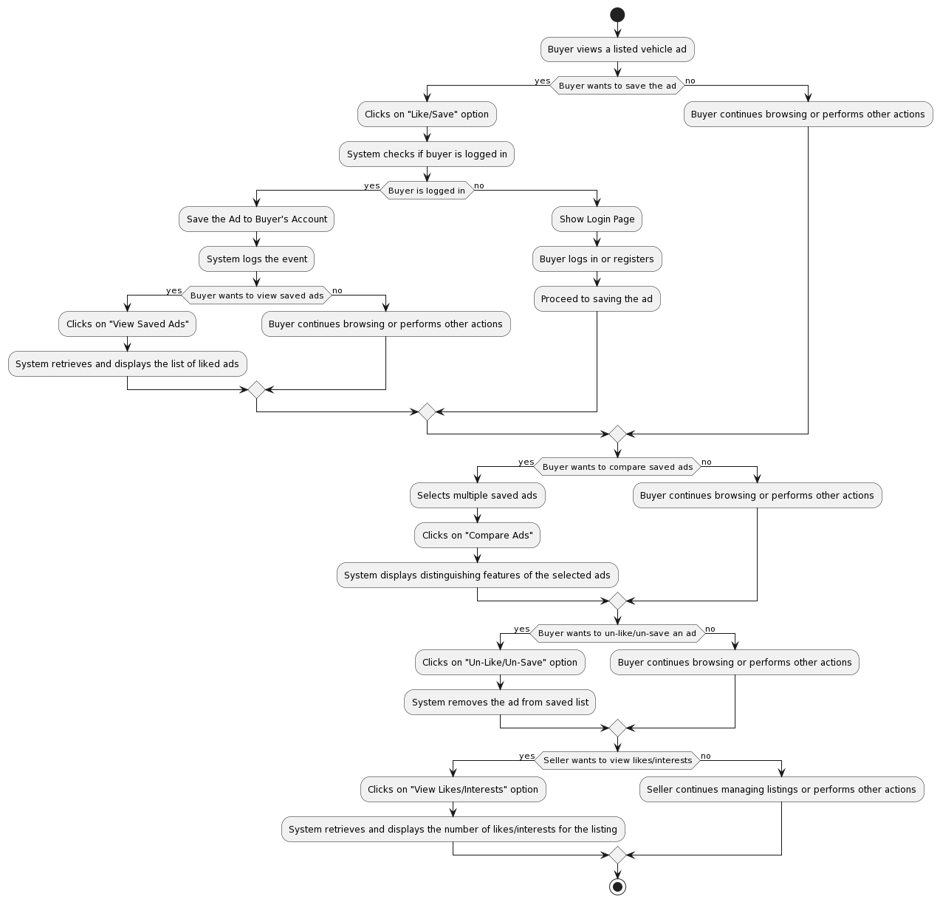

Activity Diagram 9 Saving and Comparison

### Admin: Issue Reporting Activity

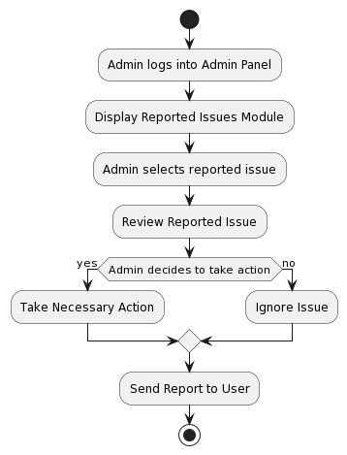

Activity Diagram 10 Reporting Issue

### Admin: Event Handling Activity

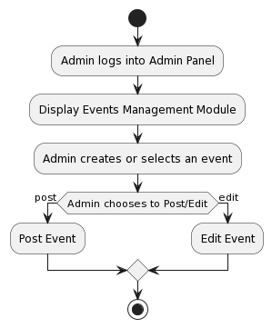

Activity Diagram 11 Event Handling

### User: Issue Reporting

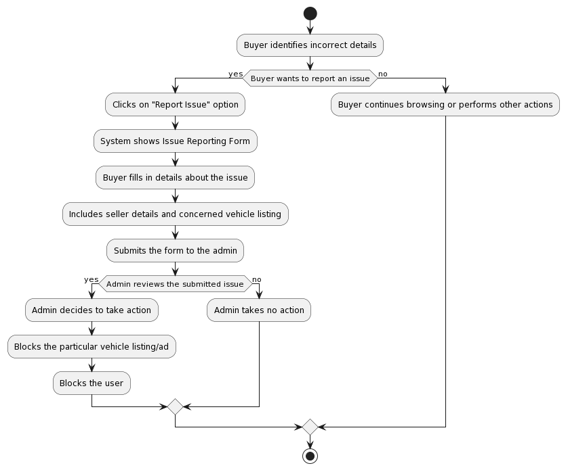

Activity Diagram 12 Issue Reporting

### Community Interaction Module

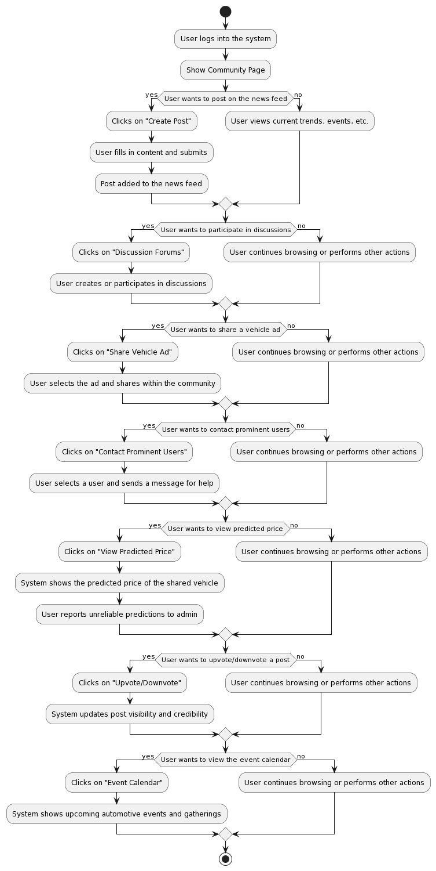

Activity Diagram 13 Community Interaction

### Analytics

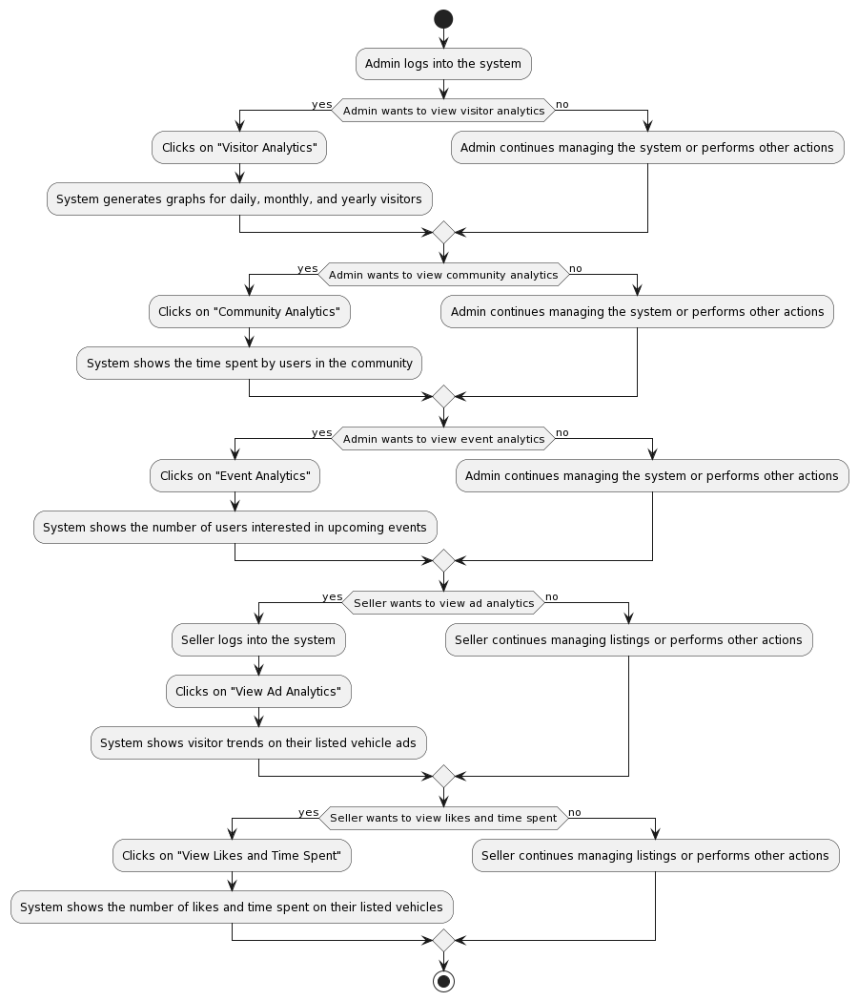

Activity Diagram 14 View Analytics

## Sequence Diagram

### Registration Sequence

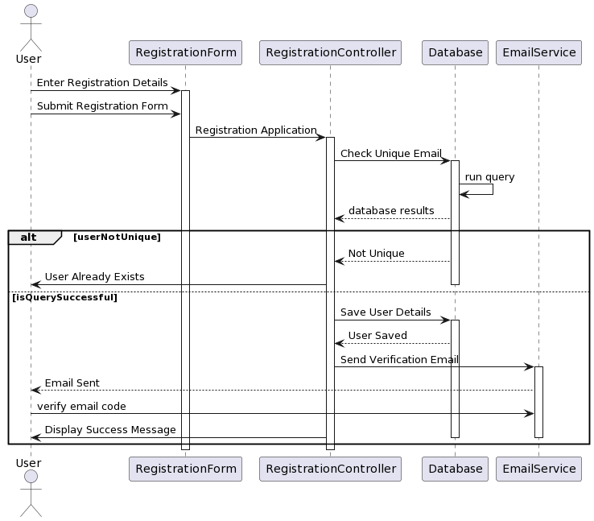

Sequence Diagram 1 Registration

### Login Sequence

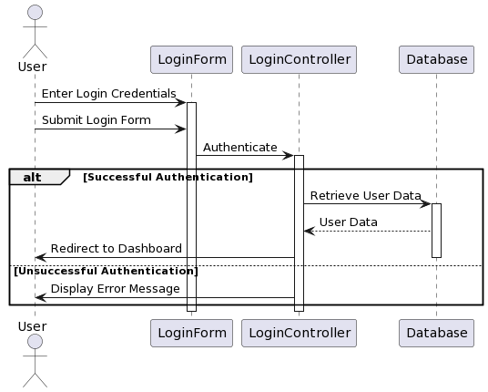

Sequence Diagram 2 Login

### Create Vehicle Listing Sequence

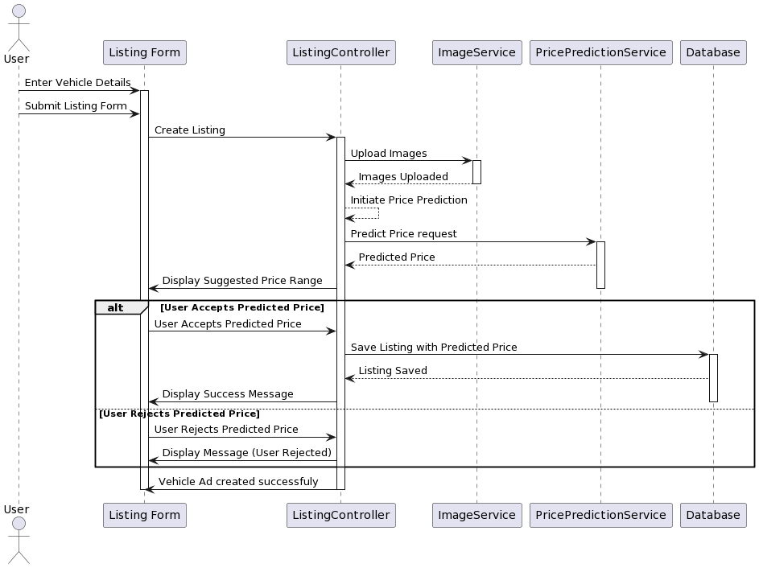

Sequence Diagram 3 Create Vehicle Listing

### Edit Vehicle Listing

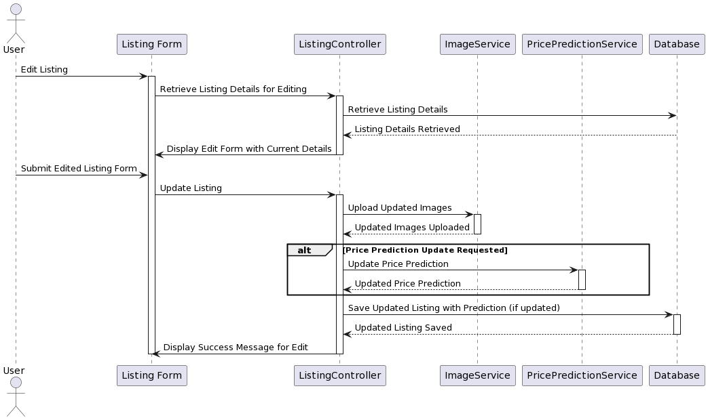

Sequence Diagram 4 Edit Vehicle Listing

### Vehicle browsing and buying

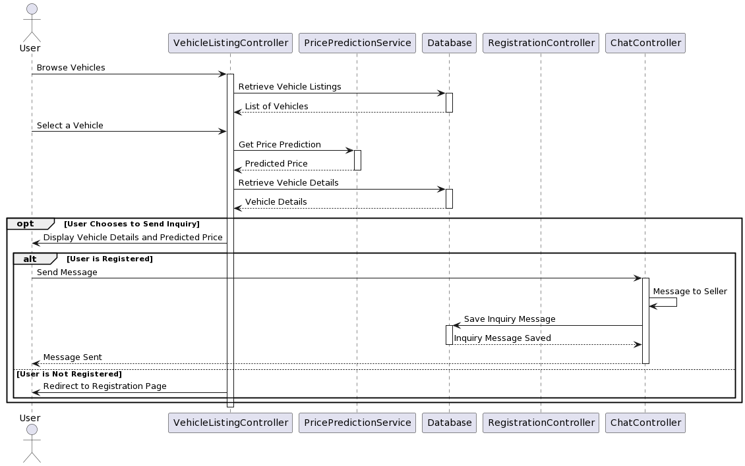

Sequence Diagram 5 Vehicle buying

### Price Prediction Sequence

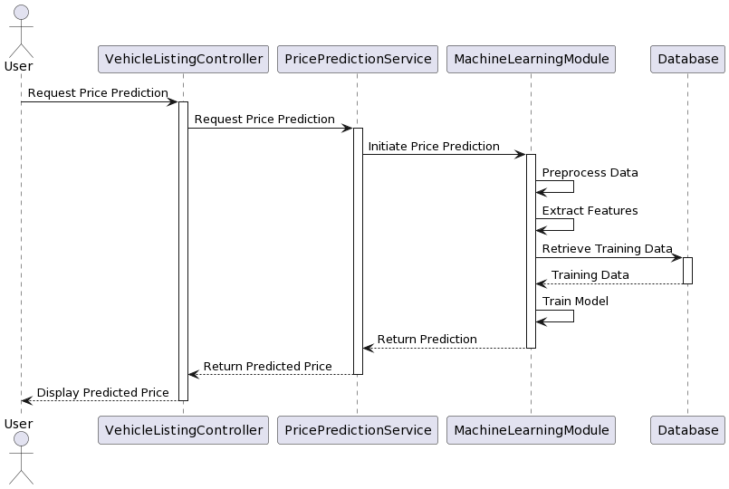

### Chatting Sequence

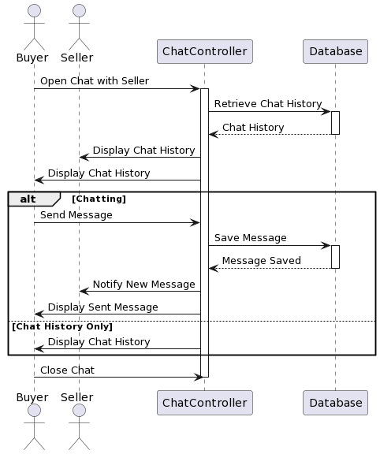

Sequence Diagram 6 chatting sequence

### Search and Filtering Sequence

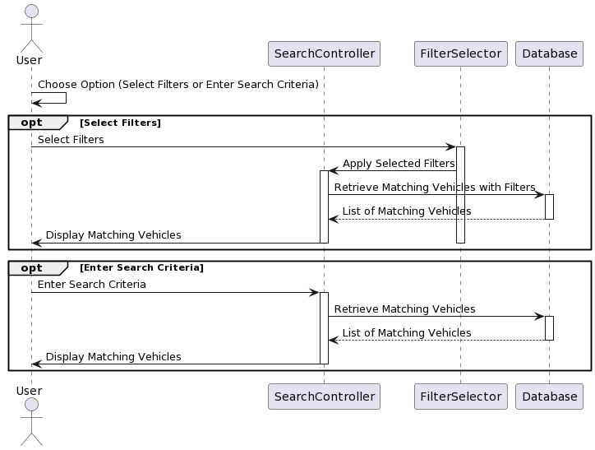

Sequence Diagram 7 Search and filter

### Save and Comparing Sequence

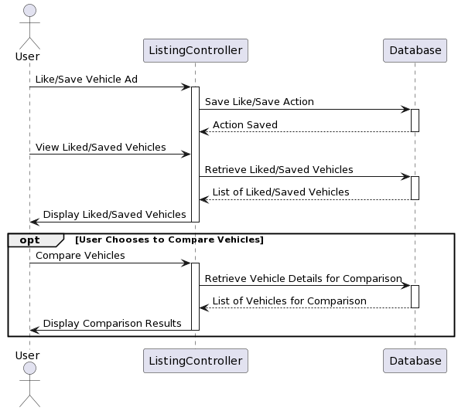

Sequence Diagram 8 Save and compare

### Report Issue

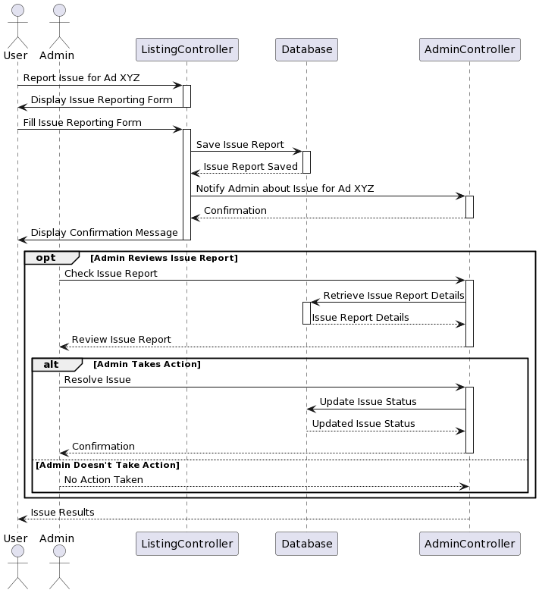

Sequence Diagram 9 Report Issue

### Interact with community Sequence

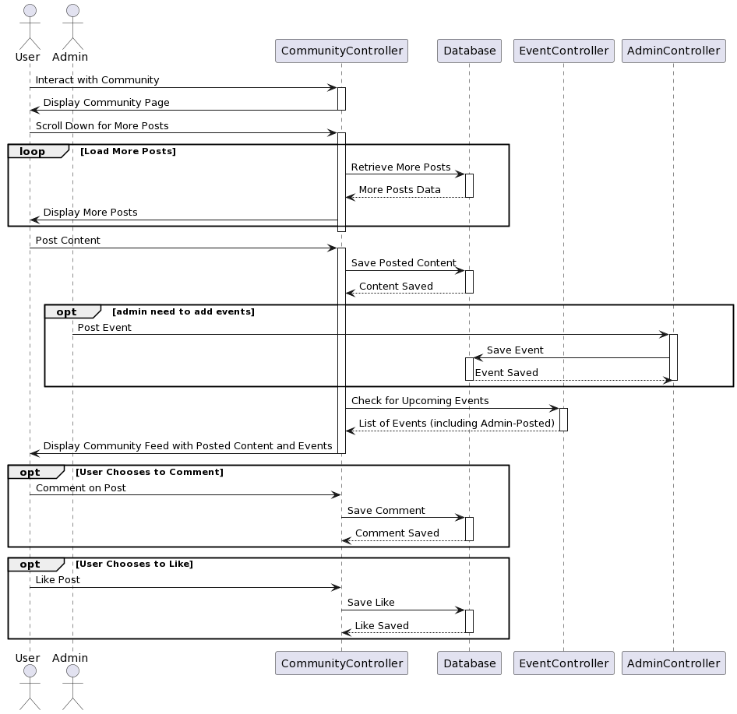

Sequence Diagram 10 Interact with community

### View Analytics

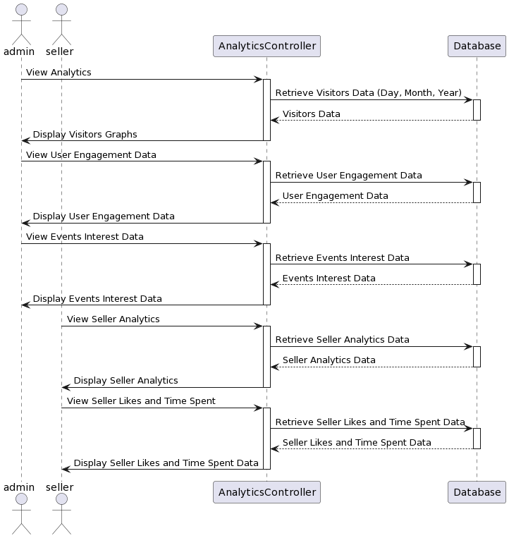

Sequence Diagram 11 View Analytics

## Collaboration Diagrams

### Registration Collaboration

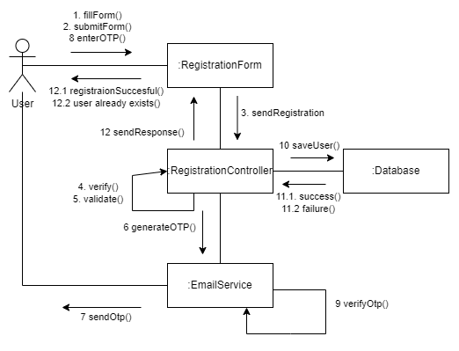

Collaboration Diagram 1 User Registration

### Login Collaboration

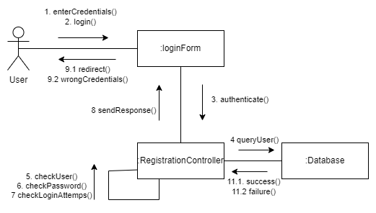

Collaboration Diagram 2 Login User

### Create Vehicle Listing Collaboration

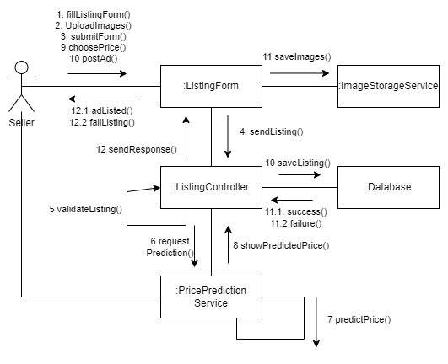

Collaboration Diagram 3 Vehicle Listing

### Edit Vehicle Listing Collaboration

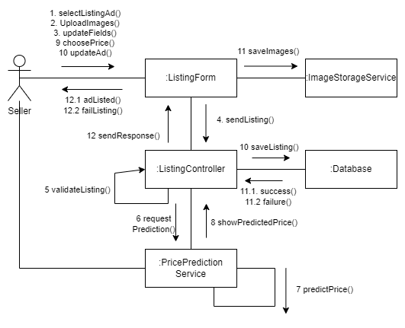

Collaboration Diagram 4 Edit Vehicle Listing

### Price Prediction Collaboration

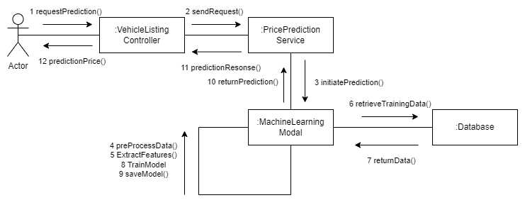

Collaboration Diagram 5 Price Prediction

### Browsing and Buying Collaboration

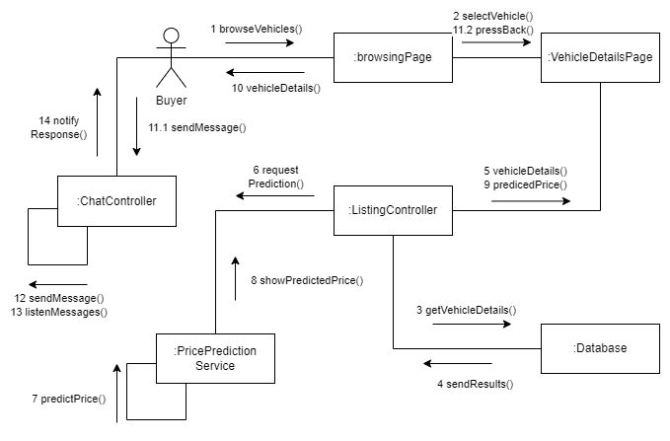

Collaboration Diagram 6 Browsing and Buying

### Chat and Messaging Collaboration

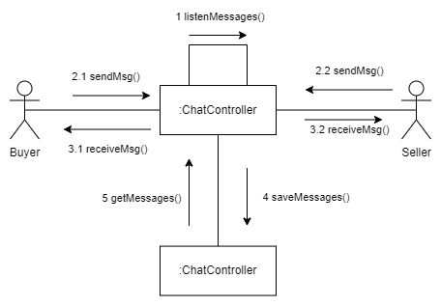

Collaboration Diagram 7 Chat and Messaging

### Search and Filtering Collaboration

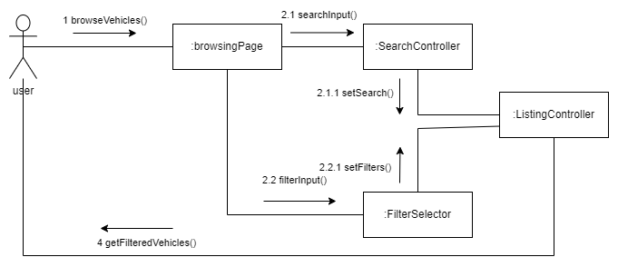

Collaboration Diagram 8 Search and Filtering

### Save and Comparing Collaboration

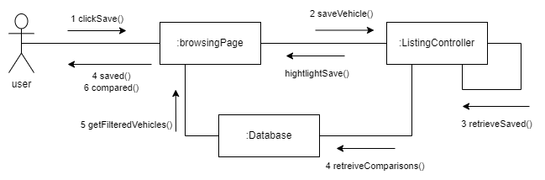

Collaboration Diagram 9 Saving and Comparing

### Issue Reporting Collaboration

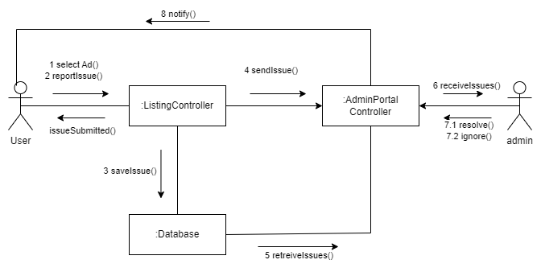

Collaboration Diagram 10 Issue Reporting

### Community Interaction Collaboration

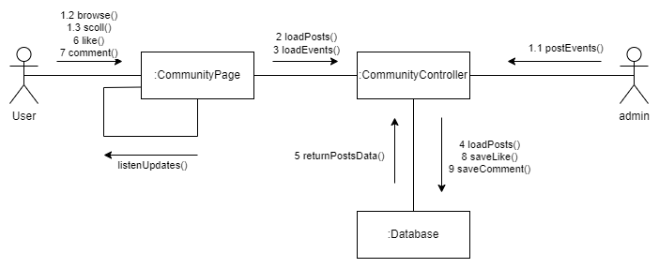

Collaboration Diagram 11 Community Interaction

### Generate Report Collaboration

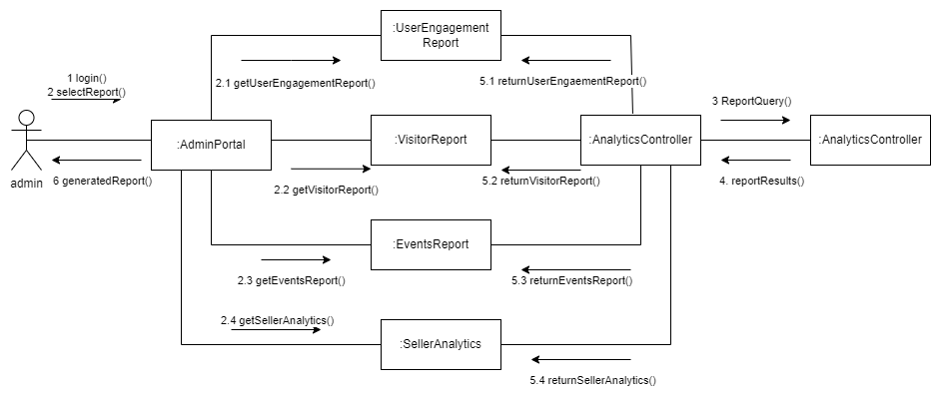

Collaboration Diagram 12 Generate Report

## Class Diagram

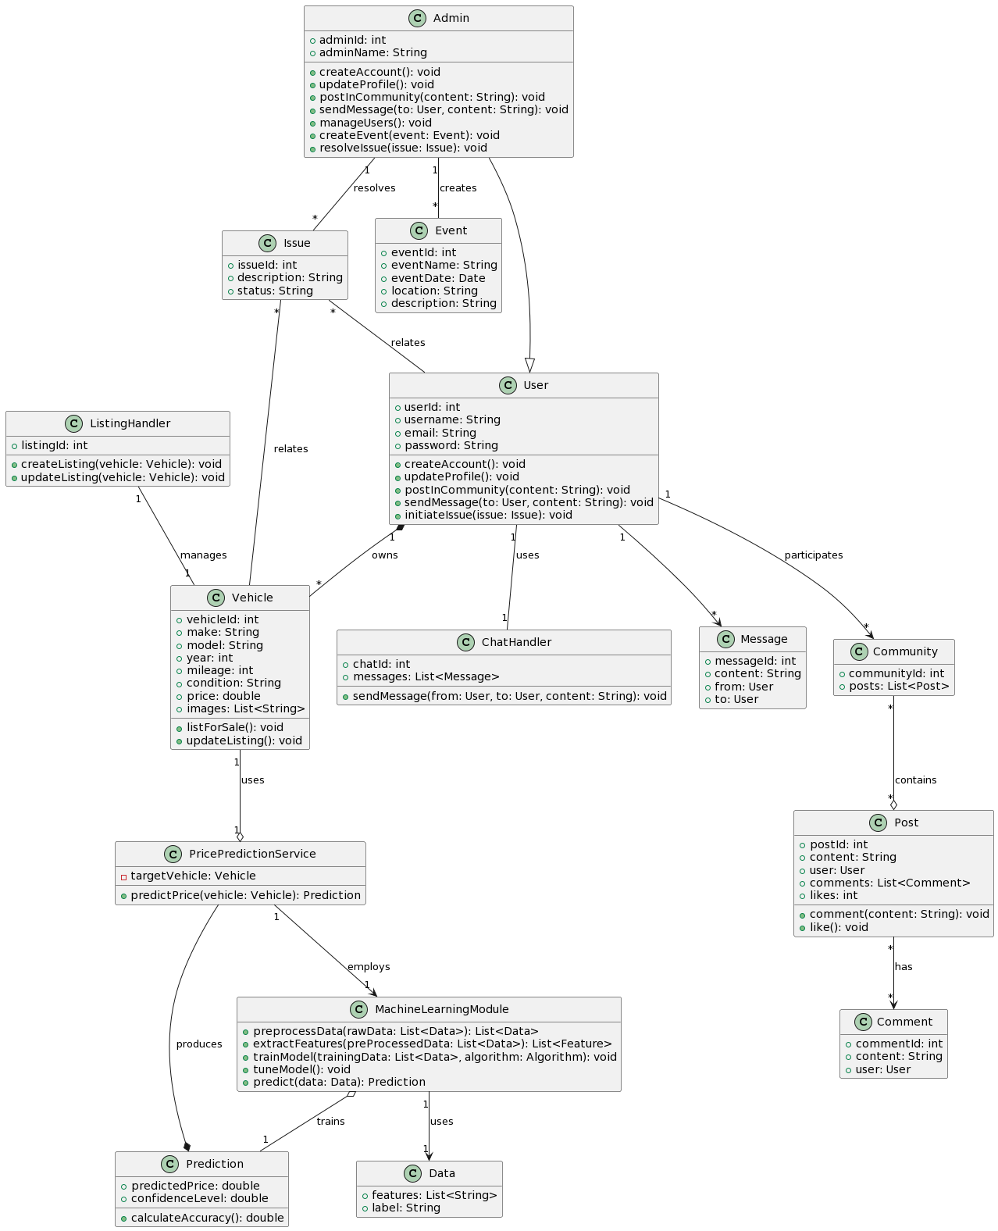

Figure 6 Class Diagram

## Architecture Diagram

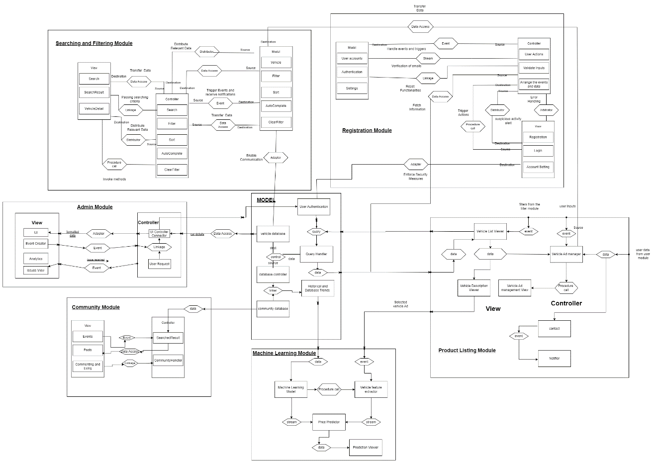

Figure 7 Architecture Diagram

## Database Diagram

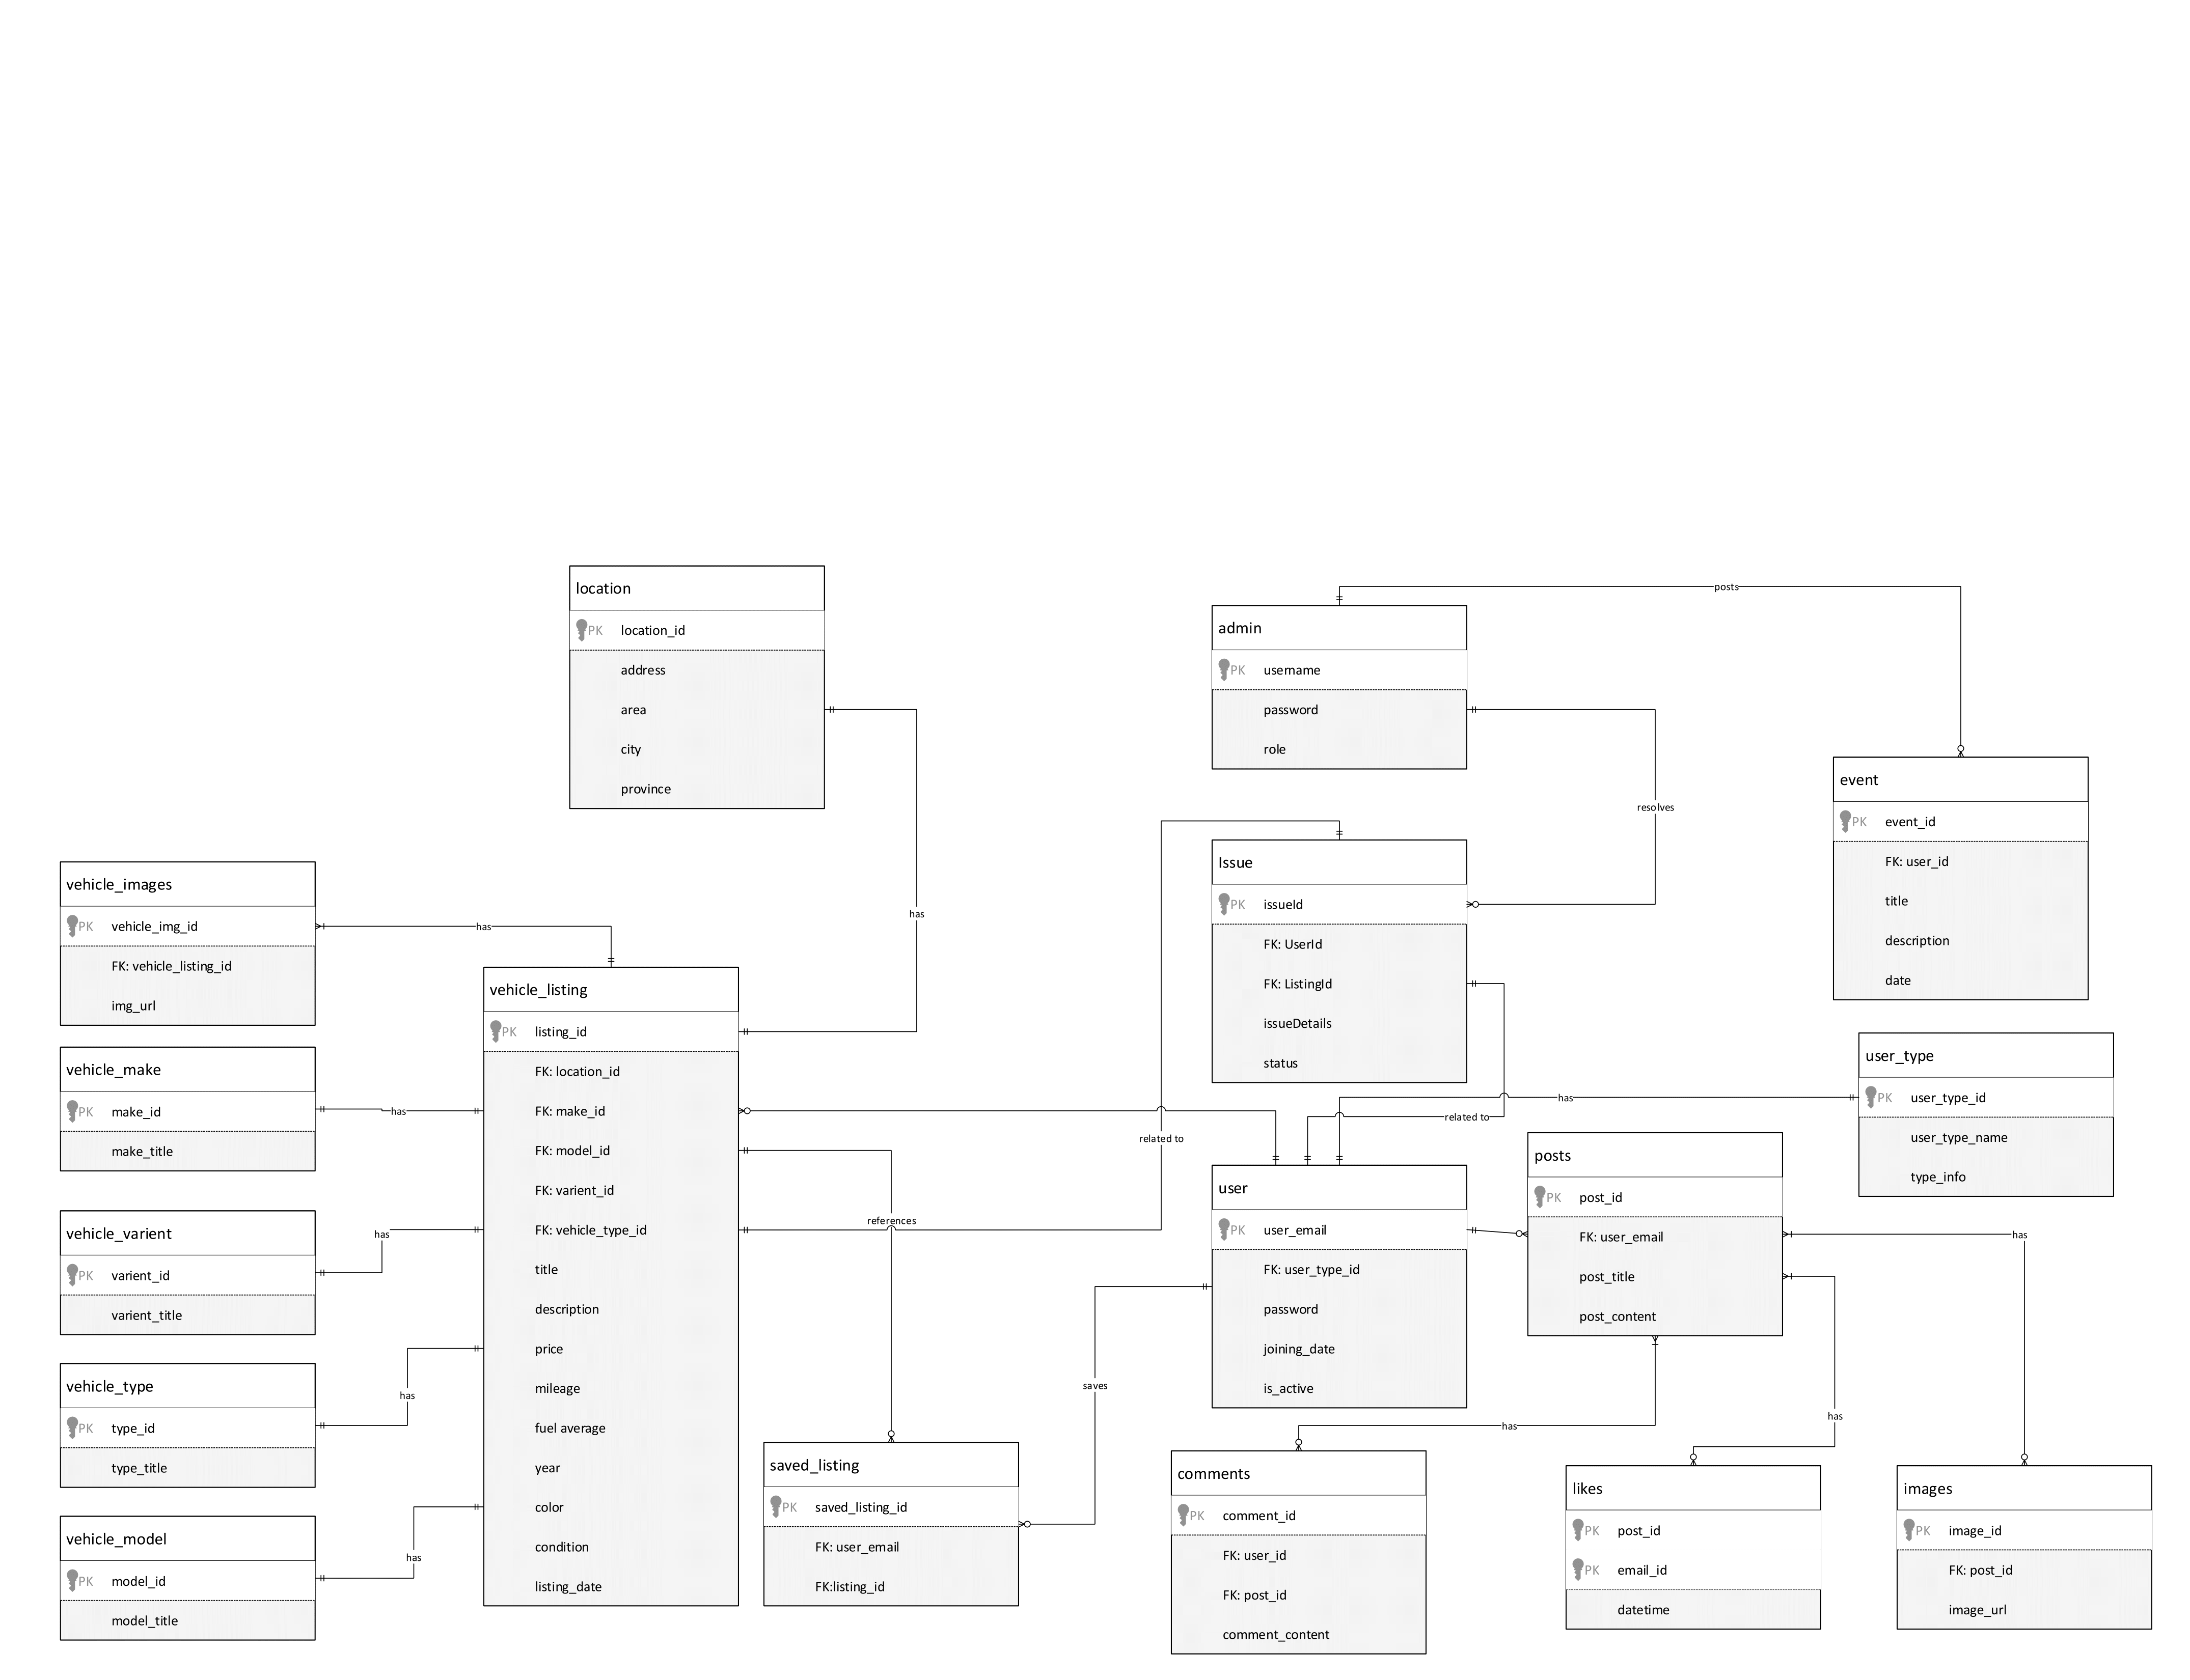

Figure 8 Database Diagram

# Chapter 4 - System Testing

## System Testing

* Test Cases
* Unit/Integration/User Acceptance Testing

## Test Cases

|  |  |
| --- | --- |
| * TC-01 | Test User registration |
| * TC-02 | Test User Login |
| * TC-03 | Test Forgot Password |
| * TC-04 | Test User profile Edit |
| * TC-05 | Test User management/admin panel |
| * TC-06 | Test Vehicle listing |
| * TC-06.1 | Test Editing Vehicle listing |
| * TC-07 | Test Vehicle browsing and buying |
| * TC-08 | Test Search and filtering |
| * TC-09 | Test Contact and messaging |
| * TC-10 | Test Saving and comparison |
| * TC-11 | Test Price prediction |
| * TC-12 | Test Issue reporting |
| * TC-13 | Test Community interaction and help |
| * TC-14 | Test Analytics |
| * TC-NF-01 | Performance |
| * TC-NF-02 | Reliability |
| * TC-NF-03 | Scalability |
| * TC-NF-04 | Availability |
| * TC-NF-05 | Security |
| * TC-NF-06 | Maintainability |
| * TC-NF-07 | Portability |
| * TC-NF-08 | Usability |
| * TC-NF-09 | Interoperability |
| * TC-NF-10 | Compliance |

## Unit Testing

### TC-01 User Registration

|  |  |
| --- | --- |
| **Test Case ID** | TC-01 |
| **Name of Use Case** | User Registration |
| **Actor** | User |
| **Description** | Test the registration process for new users. |
| **Pre-Condition** | The user is not already registered. |
| **Post-Condition** | The user is successfully registered in the system. |
| **Event 1** | User navigates to the registration form. |
| **Event 2** | User fills in required fields (name, email, password, etc.). |
| **Event 3** | User submits the registration form. |
| **Event 4** | System validates and registers the user. |
| **Alternative Flow** | If registration fails, the system shows an error message. |

Table 25 TC-01 User Registration

### TC-02 User Login

|  |  |
| --- | --- |
| **Test Case ID** | TC-02 |
| **Name of Use Case** | User Login |
| **Actor** | User |
| **Description** | Test the login functionality for existing users. |
| **Pre-Condition** | The user is already registered. |
| **Post-Condition** | The user is logged in and directed to the user dashboard. |
| **Event 1** | User navigates to the login page. |
| **Event 2** | User enters registered email and password. |
| **Event 3** | User clicks the login button. |
| **Event 4** | System validates credentials and logs the user in. |
| **Alternative Flow** | If login fails, the system shows an error message. |

Table 26 TC-02 User Login

### TC-03 Forgot Password

|  |  |
| --- | --- |
| **Test Case ID** | TC-03 |
| **Name of Use Case** | Password Reset |
| **Actor** | User |
| **Description** | Test the password reset functionality for users who forget it. |
| **Pre-Condition** | User has a registered account but forgot the password. |
| **Post-Condition** | User successfully resets the password and can log in with the new one. |
| **Event 1** | User selects 'Forgot Password' on the login page. |
| **Event 2** | User enters the registered email address. |
| **Event 3** | User follows the password reset link sent to the email. |
| **Event 4** | User sets a new password and confirms. |
| **Alternative Flow** | If the password reset fails, the system shows an error message. |

Table 27 TC-03 Forgot Password

### TC-04 User Profile Edit

|  |  |
| --- | --- |
| **Test Case ID** | **TC-04** |
| **Use Case** | User Profile Edit |
| **Actor** | Registered Users (Buyers/Sellers) |
| **Description** | Test the system's ability to allow registered users to view, edit, and update their profile information. |
| **Pre-Condition** | User is registered and logged into the system. |
| **Post-Condition** | User successfully updates their profile information |
| **Event 1** | User navigates to the profile page. |
| **Event 2** | User views their current information on the profile page. |
| **Event 3** | User initiates the edit profile functionality. |
| **Event 4** | User updates relevant profile information (e.g., contact details, bio). |
| **Event 5** | User saves the changes made to the profile. |
| **Alt Flow** | If the profile update fails or if there is an issue viewing favorite/saved ads, the system should show an appropriate error message. |

Table 28 TC-03 User Profile Edit

### TC-05 Test User Management

|  |  |
| --- | --- |
| **Test Case ID** | TC-05 |
| **Use Case** | User Management |
| **Actor** | Admin |
| **Description** | Test the admin panel's functionality to manage user accounts, handle reported issues, and post/manage events within the vehicle enthusiast community module. |
| **Pre-Condition** | Admin is logged into the admin panel. |
| **Post-Condition** | Admin successfully manages user accounts, addresses reported issues, and posts/manages events. |
| **Event 1** | Admin accesses the user management interface in the admin panel. |
| **Event 2** | Admin views the list of user accounts. |
| **Event 3** | Admin selects a user account to block/unblock. |
| **Event 4** | Admin blocks/unblocks the selected user account. |
| **Event 5** | Admin navigates to the reported issues module. |
| **Event 6** | Admin views the list of reported issues by general users. |
| **Event 7** | Admin selects a reported issue to review. |
| **Event 8** | Admin takes necessary actions to resolve the reported problem. |
| **Event 9** | Admin navigates to the events module. |
| **Event 10** | Admin posts a new event within the vehicle enthusiast community module. |
| **Event 11** | Admin manages existing events (edit/delete). |
| **Alt Flow** | If any action (blocking/unblocking, handling reported issues, posting/managing events) fails, the system should display an appropriate error message. |

Table 29 TC-03 Test User Management

### TC-06 Test Vehicle listing

|  |  |
| --- | --- |
| **Test Case ID** | **TC-06** |
| **Use Case** | Vehicle Listing |
| **Actor** | Sellers |
| **Description** | Test the system's ability to allow sellers to list their vehicles with images, enforce validation checks, suggest price range, provide manual price setting, enable urgent/featured options, allow removal/disabling of ads, and manage multiple ads per seller. Also, test the automatic disabling of non-active ads after 30 days. |
| **Pre-Condition** | Seller is logged into the system. |
| **Post-Condition** | Seller successfully lists their vehicle ad(s) with specified options. |
| **Event 1** | Seller accesses the vehicle listing interface. |
| **Event 2** | Seller uploads at least two images of the vehicle. |
| **Event 3** | Seller fills out mandatory fields in the listing form. |
| **Event 4** | Seller submits the listing form. |
| **Event 5** | Seller views the suggested price range generated by the machine learning algorithm. |
| **Event 6** | Seller manually sets the price within the suggested range. |
| **Event 7** | Seller receives an alert if the entered price exceeds the suggested range. |
| **Event 8** | Seller marks the advertisement as urgent or featured for increased visibility. |
| **Event 9** | Seller removes or disables their vehicle advertisement when necessary. |
| **Event 10** | System automatically disables non-active ads after 30 days. |
| **Event 11** | Seller posts multiple vehicle ads, limited to five. |
| **Event 12** | Seller, not registered, tries to list a vehicle for sale. |
| **Alt Flow** | If any validation checks fail, the system should display an appropriate error message. If non-registered users attempt to list a vehicle, the system should prompt them to register. |

Table 30 TC-06 Test Vehicle Listing

### TC-06.1 Test Editing Vehicle listing

|  |  |
| --- | --- |
| **Test Case ID** | **TC-15** |
| **Use Case** | Edit Vehicle Details |
| **Actor** | Sellers |
| **Description** | Test that users can modify details of their existing vehicle listings. |
| **Pre-Condition** | Existing vehicle listing is available. |
| **Post-Condition** | Vehicle details are successfully updated. |
| **Event 1** | Navigate to the edit page for the vehicle listing. |
| **Event 2** | Modify details including make, model, year, mileage, condition, and price. |
| **Event 3** | Save the changes. |
| **Event 4** | Verify that the updated details are reflected in the vehicle listing. |
| **Alt Flow** | If changes are not saved or not reflected in the listing, the test fails. |

Table 31 TC-06.1 Test Vehicle Listing

### TC-07 Test Vehicle browsing and buying

|  |  |
| --- | --- |
| **Test Case ID** | **TC-07** |
| **Use Case** | Vehicle Browsing and Buying |
| **Actor** | Buyers |
| **Description** | Test the system's functionality to allow buyers to browse and buy vehicles, view relevant listings, compare prices, send inquiries, apply filters, view the vehicle location on a map, and see nearby ads. |
| **Pre-Condition** | Buyer is logged into the system. |
| **Post-Condition** | Buyer successfully browses and interacts with the vehicle listings. |
| **Event 1** | Buyer accesses the vehicle browsing interface. |
| **Event 2** | System displays a list of relevant vehicles based on date, type, and other user filters. |
| **Event 3** | Buyer clicks on a listed vehicle for detailed information. |
| **Event 4** | System displays comprehensive vehicle details, including specifications, images, and seller's contact details. |
| **Event 5** | Buyer compares the listed price with the machine learning algorithm's estimated value. |
| **Event 6** | Buyer sends inquiries or messages to sellers directly from the vehicle details page. |
| **Event 7** | Buyer filters vehicles based on make, model, year, and price range. |
| **Event 8** | System provides a map to view the location of the vehicle. |
| **Event 9** | System shows the most prominent features clearly on the vehicle description page. |
| **Event 10** | System displays nearby vehicle ads to the current browsing user. |
| **Alt Flow** | If any filtering or inquiry processes fail, the system should display an appropriate error message. |

Table 32 TC-07 Test Vehicle Browsing and Buying

### TC-08 Test Search and filtering

|  |  |
| --- | --- |
| **Test Case ID** | **TC-08** |
| **Use Case** | Search and Filtering |
| **Actor** | Users |
| **Description** | Test the system's search functionality, related ad suggestions, and filtering options for refining search results based on user preferences. |
| **Pre-Condition** | User is logged into the system. |
| **Post-Condition** | User successfully searches for vehicles, receives related ad suggestions, and applies filters. |
| **Event 1** | User accesses the search functionality. |
| **Event 2** | User enters keywords, vehicle type, manufacturer, or model in the search bar. |
| **Event 3** | System displays search results based on the entered criteria. |
| **Event 4** | User filters search results based on specific preferences (mileage, condition, location). |
| **Event 5** | System prompts the user for location permission to enable location-based filtering. |
| **Event 6** | User grants or denies location permission. |
| **Event 7** | System refines search results based on the user's location, if permitted. |
| **Alt Flow** | If the search results or related ad suggestions do not align with the entered criteria, the system should display an appropriate error message. If the user denies location permission, the system should adjust the search results accordingly. |

Table 33 TC-08 Test Search and Filtering

### TC-09 Test Contact and Messaging

|  |  |
| --- | --- |
| **Test Case ID** | **TC-09** |
| **Use Case** | Contact and Messaging |
| **Actor** | Buyers, Sellers |
| **Description** | Test the system's functionality to allow buyers to contact sellers, view contact information, notify sellers of viewed contacts, and facilitate real-time communication through an in-app messaging system. |
| **Pre-Condition** | Buyer and seller are logged into the system. |
| **Post-Condition** | Buyer and seller successfully communicate through the system's messaging module. |
| **Event 1** | Buyer views a listed vehicle ad. |
| **Event 2** | System provides an option for the buyer to contact the seller. |
| **Event 3** | Buyer requests to view the contact information of the seller. |
| **Event 4** | System displays contact information to registered buyers only. |
| **Event 5** | System notifies the seller that their contact information has been viewed. |
| **Event 6** | Seller receives a notification through the system's messaging system. |
| **Event 7** | Buyer and seller engage in real-time communication through the in-app chat module. |
| **Event 8** | Messages are sent and received in real-time. |
| **Alt Flow** | If the contact information is not displayed, the system should display an appropriate error message. If messaging fails, the system should provide an error notification. |

Table 34 TC-09 Test Contact and Messaging

### TC-10 Test Saving and comparison

|  |  |
| --- | --- |
| **Test Case ID** | **TC-10** |
| **Use Case** | Saving and Comparison |
| **Actor** | Buyers, Sellers |
| **Description** | Test the system's functionality to allow buyers to save and compare vehicle ads, view liked listings, and provide sellers with information on the number of likes/interests. |
| **Pre-Condition** | Buyer is logged into the system. |
| **Post-Condition** | Buyer successfully saves, compares, and manages liked vehicle ads. |
| **Event 1** | Buyer likes and saves multiple vehicle ads for future viewing. |
| **Event 2** | Buyer views the list of liked vehicle listings. |
| **Event 3** | Buyer compares among the saved vehicle ads to show distinguishing features. |
| **Event 4** | Buyer un-likes/un-saves a previously liked vehicle ad. |
| **Event 5** | Seller views the number of likes or interests on their listed vehicles. |
| **Alt Flow** | If liking/saving or un-liking/un-saving fails, the system should display an appropriate error message. If comparing fails, the system should notify the user accordingly. |

Table 35 TC-03 Test Saving and comparison

### TC-11 Test Price prediction

|  |  |
| --- | --- |
| **Test Case ID** | **TC-11** |
| **Use Case** | Price Prediction |
| **Actor** | Sellers, Buyers |
| **Description** | Test the system's functionality to predict the price range of a vehicle being listed for sale based on explicit details provided by the seller. This includes testing the accuracy of the machine learning model and ensuring that the predicted price is displayed to both the seller and the buyer. |
| **Pre-Condition** | Seller and buyer are logged into the system. |
| **Post-Condition** | Seller lists a vehicle with a predicted price, and the buyer views the predicted price. |
| **Event 1** | Seller lists a vehicle for sale. |
| **Event 2** | Seller provides explicit details of the vehicle, including year, model, make, current price, and condition. |
| **Event 3** | System uses the machine learning model to predict the price range. |
| **Event 4** | System displays the predicted price range to the seller. |
| **Event 5** | Buyer views the predicted price range for the listed vehicle. |
| **Alt Flow** | If the machine learning model fails to predict the price range, the system should display an appropriate error message. If the predicted price is not displayed to the buyer, the system should provide an error notification. |

Table 36 TC-11 Test Price Prediction

### TC-12 Test Issue reporting

|  |  |
| --- | --- |
| **Test Case ID** | **TC-12** |
| **Use Case** | Issue Reporting |
| **Actor** | Buyers, Admin |
| **Description** | Test the system's functionality to allow buyers to report issues about inaccurate details in vehicle listings, and test the admin's ability to block/unblock vehicle listings and users based on reported issues. |
| **Pre-Condition** | Buyer is logged into the system. |
| **Post-Condition** | Admin successfully handles reported issues, blocking/unblocking listings or users. |
| **Event 1** | Buyer visits a vehicle listing and notices incorrect details. |
| **Event 2** | Buyer accesses the issue reporting form. |
| **Event 3** | Buyer fills out the form with details about the issue, seller, and concerned vehicle listing. |
| **Event 4** | Buyer submits the issue report to the admin. |
| **Event 5** | Admin accesses the admin panel. |
| **Event 6** | Admin reviews the reported issue and the details provided by the buyer. |
| **Event 7** | Admin blocks/unblocks the concerned vehicle listing based on the reported issue. |
| **Event 8** | Admin blocks/unblocks the user (seller) based on the reported issue. |
| **Alt Flow** | If the issue reporting form submission fails, the system should display an appropriate error message. If admin actions (blocking/unblocking) fail, the system should provide an error notification. |

Table 37 TC-12 Test Issue reporting

### TC-13 Test Community interaction and help

|  |  |
| --- | --- |
| **Test Case ID** | **TC-13** |
| **Use Case** | Community Interaction and Help |
| **Actor** | Users, Admin |
| **Description** | Test the system's community features, including newsfeeds, discussion forums, events, badges, sharing vehicle ads, contacting prominent users, viewing predicted prices, reporting unreliable predictions, upvoting/downvoting posts and comments, and an event calendar. |
| **Pre-Condition** | Users and admin are logged into the system. |
| **Post-Condition** | Users and admin successfully interact with the community features. |
| **Event 1** | User accesses the community page. |
| **Event 2** | System displays the newsfeed with current trends, vehicles, events, and user posts. |
| **Event 3** | Registered user posts content on the newsfeed. |
| **Event 4** | Admin posts main events on the admin newsfeed. |
| **Event 5** | System provides discussion forums for users. |
| **Event 6** | System assigns roles or badges to the most interested or participating users. |
| **Event 7** | User shares their interested vehicle ad within the community for guidance. |
| **Event 8** | Community members contact prominent users for help and guidance. |
| **Event 9** | Community members view predicted prices of shared vehicles. |
| **Event 10** | Community members report "unreliable predictions" to admin. |
| **Event 11** | Users upvote/downvote posts and comments. |
| **Event 12** | System includes an event calendar highlighting upcoming automotive events. |
| **Alt Flow** | If posting content or events fails, the system should display an appropriate error message. If reporting issues or assigning badges fails, the system should provide an error notification. |

Table 38 TC-13 Community interaction and help

### TC-14 Test Analytics

|  |  |
| --- | --- |
| **Test Case ID** | **TC-14** |
| **Use Case** | Analytics and Reporting |
| **Actor** | Admin, Sellers |
| **Description** | Test the system's analytics and reporting features, including visitor statistics, time spent, event interests, and seller-specific metrics. |
| **Pre-Condition** | Admin and sellers are logged into the system. |
| **Post-Condition** | Admin and sellers successfully view relevant analytics and reports. |
| **Event 1** | Admin accesses the analytics and reporting section. |
| **Event 2** | System displays the number of visitors per day, month, and year in the form of graphs. |
| **Event 3** | System shows the time spent by users in the community. |
| **Event 4** | Admin views the number of users interested in upcoming events. |
| **Event 5** | Seller accesses the analytics for their listed vehicle ads. |
| **Event 6** | System displays visitor trends on the seller's listed vehicle ads. |
| **Event 7** | Seller views the number of likes received on their listed vehicles. |
| **Event 8** | Seller views the time spent by users on their listed vehicle ads. |
| **Alt Flow** | If accessing analytics or reports fails, the system should display an appropriate error message. If data is not displayed correctly, the system should provide an error notification. |

Table 39 TC-14 Test Analytics

### TC-NF-01 Test Performance

|  |  |
| --- | --- |
| **Test Case ID** | **TC-NF-01** |
| **Use Case** | Performance |
| **Actor** | System |
| **Description** | Test the system's performance in terms of page loading and responsiveness, as well as the speed of the machine learning algorithm for price prediction. |
| **Pre-Condition** | None |
| **Post-Condition** | System meets performance criteria. |
| **Event 1** | User interacts with the system by loading various pages. |
| **Event 2** | System responds to user interactions within 3 seconds. |
| **Event 3** | User triggers the machine learning algorithm for price prediction. |
| **Event 4** | System generates results within 5 seconds for the price prediction. |
| **Alt Flow** | If page loading or algorithm response exceeds the specified time limits, the system fails the performance test. |

Table 40 TC-NF-01 Test Performance

### TC-NF-02 Test Reliability

|  |  |
| --- | --- |
| **Test Case ID** | **TC-NF-02** |
| **Use Case** | Reliability |
| **Actor** | System |
| **Description** | Test the system's reliability in terms of uptime and accuracy of the machine learning algorithm for price prediction. |
| **Pre-Condition** | None |
| **Post-Condition** | System meets reliability criteria. |
| **Event 1** | Monitor system uptime over a specified period. |
| **Event 2** | System achieves an uptime of at least 99.5%. |
| **Event 3** | Evaluate the accuracy of the machine learning algorithm for price prediction. |
| **Event 4** | Machine learning algorithm achieves an accuracy of at least 95%. |
| **Alt Flow** | If the system's uptime or algorithm accuracy falls below the specified thresholds, the system fails the reliability test. |

Table 41 TC-NF-02 Test Reliability

### TC-NF-03 Test Scalability

|  |  |
| --- | --- |
| **Test Case ID** | **TC-NF-03** |
| **Use Case** | Scalability |
| **Actor** | System |
| **Description** | Test the system's scalability in terms of handling user load and accommodating a growing number of vehicle listings in the database. |
| **Pre-Condition** | None |
| **Post-Condition** | System meets scalability criteria. |
| **Event 1** | Simulate a user load of at least 10,000 simultaneous users. |
| **Event 2** | System handles the simultaneous user load effectively. |
| **Event 3** | Simulate the addition of a growing number of vehicle listings, reaching up to 1 million. |
| **Event 4** | Database scales to accommodate the growing number of vehicle listings. |
| **Alt Flow** | If the system struggles to handle the specified user load or if the database fails to scale appropriately, the system fails the scalability test. |

Table 42 TC-NF-03 Test Scalability

### TC-NF-04 Test Availability

|  |  |
| --- | --- |
| **Test Case ID** | **TC-NF-04** |
| **Use Case** | Availability |
| **Actor** | System |
| **Description** | Test the system's availability by ensuring it is accessible 24/7, with scheduled maintenance windows communicated in advance. |
| **Pre-Condition** | None |
| **Post-Condition** | System meets availability criteria. |
| **Event 1** | Monitor the system's availability over an extended period. |
| **Event 2** | System remains accessible 24/7. |
| **Event 3** | Schedule maintenance windows in advance. |
| **Event 4** | During maintenance windows, display appropriate communication to users about temporary unavailability. |
| **Alt Flow** | If the system experiences unexpected downtime or if maintenance windows are not communicated in advance, the system fails the availability test. |

Table 43 TC-NF-01 Test Availability

### TC-NF-05 Test Security

|  |  |
| --- | --- |
| **Test Case ID** | **TC-NF-05** |
| **Use Case** | Secure Protocols |
| **Actor** | System |
| **Description** | Test the system's implementation of secure protocols for user authentication and data transmission. |
| **Pre-Condition** | None |
| **Post-Condition** | System meets secure protocols criteria. |
| **Event 1** | User logs into the system. |
| **Event 2** | System authenticates the user using secure protocols. |
| **Event 3** | User transmits data within the system. |
| **Event 4** | System ensures secure data transmission. |
| **Alt Flow** | If the system fails to implement secure protocols for authentication and data transmission, it fails the test. |

Table 44 TC-NF-05 Test Security

### TC-NF-06 Test Maintainability

|  |  |
| --- | --- |
| **Use Case** | Maintainability |
| **Actor** | System |
| **Description** | Test the system's maintainability as per FR06. |
| **Pre-Condition** | None |
| **Post-Condition** | System meets maintainability criteria. |
| **Event 1** | Evaluate the system's code and architecture for ease of maintenance. |
| **Event 2** | Assess the system's documentation and tools provided for maintenance. |
| **Alt Flow** | If the system proves difficult to maintain or lacks adequate documentation, it fails the test. |

Table 45 TC-NF-05 Test Maintainability

### TC-NF-07 Test Portability

|  |  |
| --- | --- |
| **Test Case ID** | **TC-NF-07.01** |
| **Use Case** | Portability |
| **Actor** | System |
| **Description** | Test that the system is accessible and usable on major web browsers, including Chrome, Firefox, and Safari. |
| **Pre-Condition** | None |
| **Post-Condition** | System is compatible with specified browsers. |
| **Event 1** | Open the system in the latest version of Google Chrome. |
| **Event 2** | Verify that all features and functionalities work as expected. |
| **Event 3** | Open the system in the latest version of Mozilla Firefox. |
| **Event 4** | Verify that all features and functionalities work as expected. |
| **Event 5** | Open the system in the latest version of Apple Safari. |
| **Alt Flow** | If the system exhibits issues or is not usable on any of the specified browsers, the test fails. |

Table 46 TC-NF-01 Test Portability

### TC-NF-08 Test Usability

|  |  |
| --- | --- |
| **Test Case ID** | **TC-NF-08.03** |
| **Use Case** | Accessibility Standards |
| **Actor** | Users |
| **Description** | Test that the user interface adheres to accessibility standards. |
| **Pre-Condition** | None |
| **Post-Condition** | User interface complies with accessibility standards. |
| **Event 1** | Check for Alt Text: |
| **Event 2** | Inspect images and multimedia elements for the presence of alt text. |
| **Event 3** | Verify that alt text provides meaningful descriptions. |
| **Alt Flow** | If the error messages are unclear, misleading, or not user-friendly, the test fails. |

Table 47 TC-NF-08 Test Usability

### TC-NF-09 Test Interoperability

|  |  |
| --- | --- |
| **Test Case ID** | **TC-NF-09** |
| **Use Case** | APIs for ML Module Integration |
| **Actor** | ML Module, Drive Net Website |
| **Description** | Test that APIs are provided by the ML module to communicate with the Drive Net website for ML predictions. |
| **Pre-Condition** | APIs for ML module and Drive Net website are properly configured. |
| **Post-Condition** | ML module can successfully communicate with the Drive Net website. |
| **Event 1** | Trigger the ML module to provide price predictions for a vehicle listing. |
| **Event 2** | Verify that the ML module sends a request to the Drive Net website's API. |
| **Event 3** | Check that the Drive Net website's API responds with the predicted price. |
| **Event 4** | Test different scenarios to ensure the ML module can consistently communicate with the Drive Net website. |
| **Alt Flow** | If the system fails to integrate with external services or if the ML module cannot communicate effectively with the Drive Net website, the test fails. |

Table 48 TC-NF-09 Test Interoperability

### TC-NF-10 Test Compliance

|  |  |
| --- | --- |
| **Test Case ID** | **TC-NF-09.02** |
| **Use Case** | Compliance |
| **Actor** | Admin Panel |
| **Description** | Test that the admin panel has features to handle reported issues and ensures compliance with community guidelines. |
| **Pre-Condition** | Admin is logged into the admin panel. |
| **Post-Condition** | Admin panel complies with community guidelines and handles reported issues. |
| **Event 1** | Admin accesses the reported issues section. |
| **Event 2** | Verify that the admin panel provides tools to review and address reported issues. |
| **Event 3** | Test that the admin panel enforces community guidelines and takes necessary actions on reported problems. |
| **Alt Flow** | If the system or admin panel fails to comply with relevant data protection and privacy regulations, or if the admin panel lacks features to handle reported issues and ensure compliance with community guidelines, the test fails. |

Table 49 TC-NF-10 Test Compliance

# Chapter 5 – Application

## Web App

This section contains the screenshots of the web app of DriveNet application, that we implemented using Mern Stack.

### Homepage or Market Page

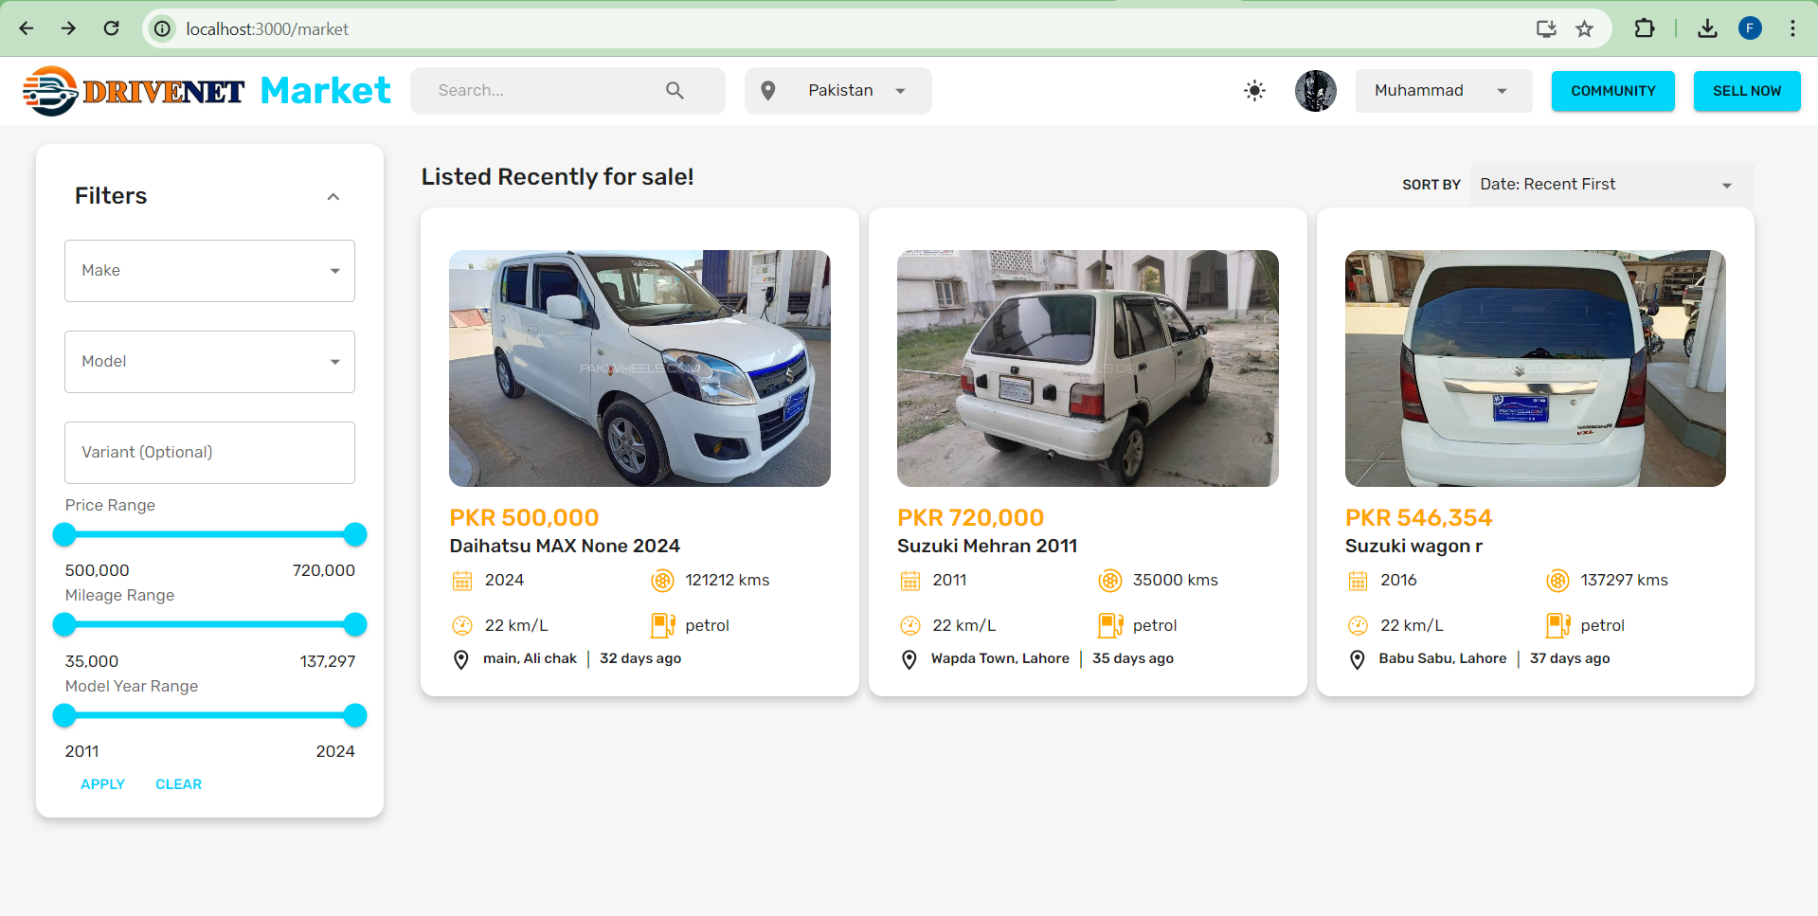

Screenshot 1 Drivenet market page

This page allows the user to browse vehicle ads that sellers have listed for sale. User can apply filters based on their preferences. They are able to sort the ads based on many options such as date, price, or model year etc. User can navigate to other pages from this page.

### Vehicle Description Page

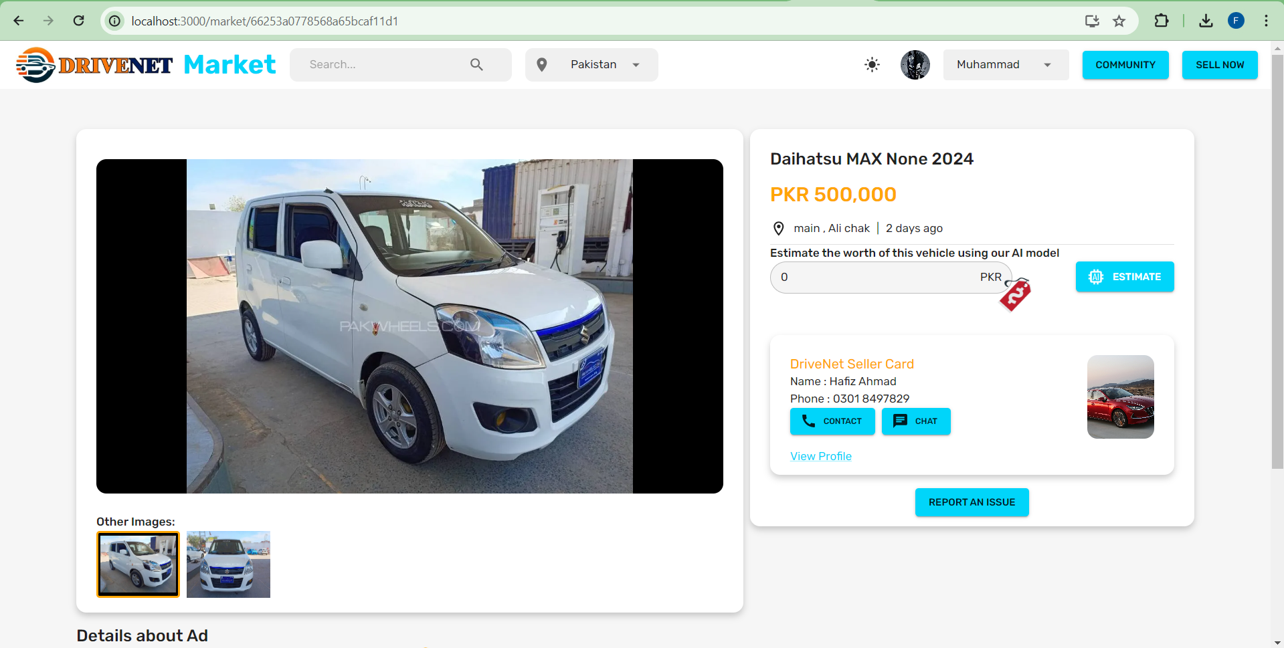

Screenshot 2 Vehicle Description Page

On this page, user can view all details and images of the selected vehicle ad. User can view the estimated price model, if seller has already estimated, otherwise, buyer and request price estimation.

### Vehicle Selling Page

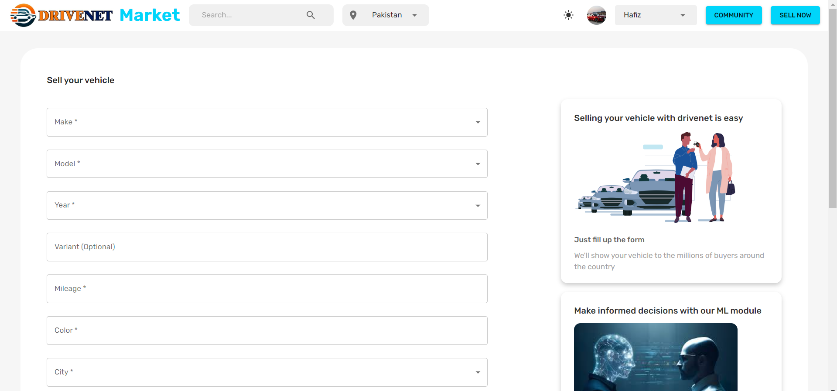

Screenshot 3 Vehicle Selling Page

This page allows the sellers to create new vehicle ad to list their vehicle for sale. This is actually a form that validated and submitted to create a new ad on site.

### User/Seller Profile Page

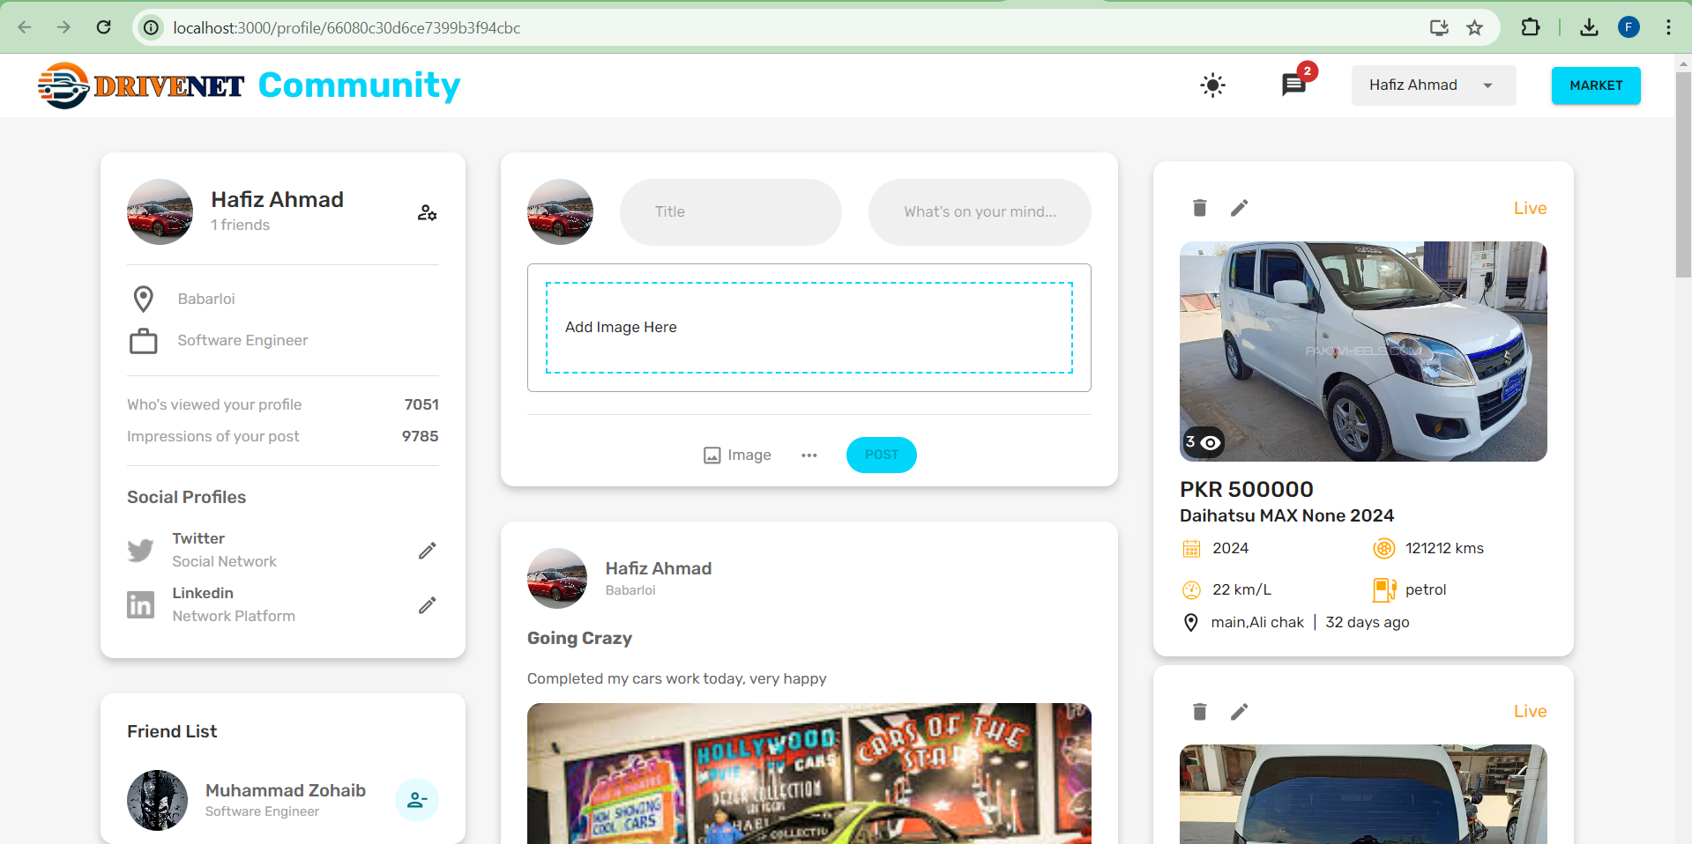

Screenshot 4 User/seller Profile Page

This is user profile page, that shows the posts of user, and the vehicles listed for sale related to that user. This page verify the authenticity of the seller as well.

### Profile Editing Page

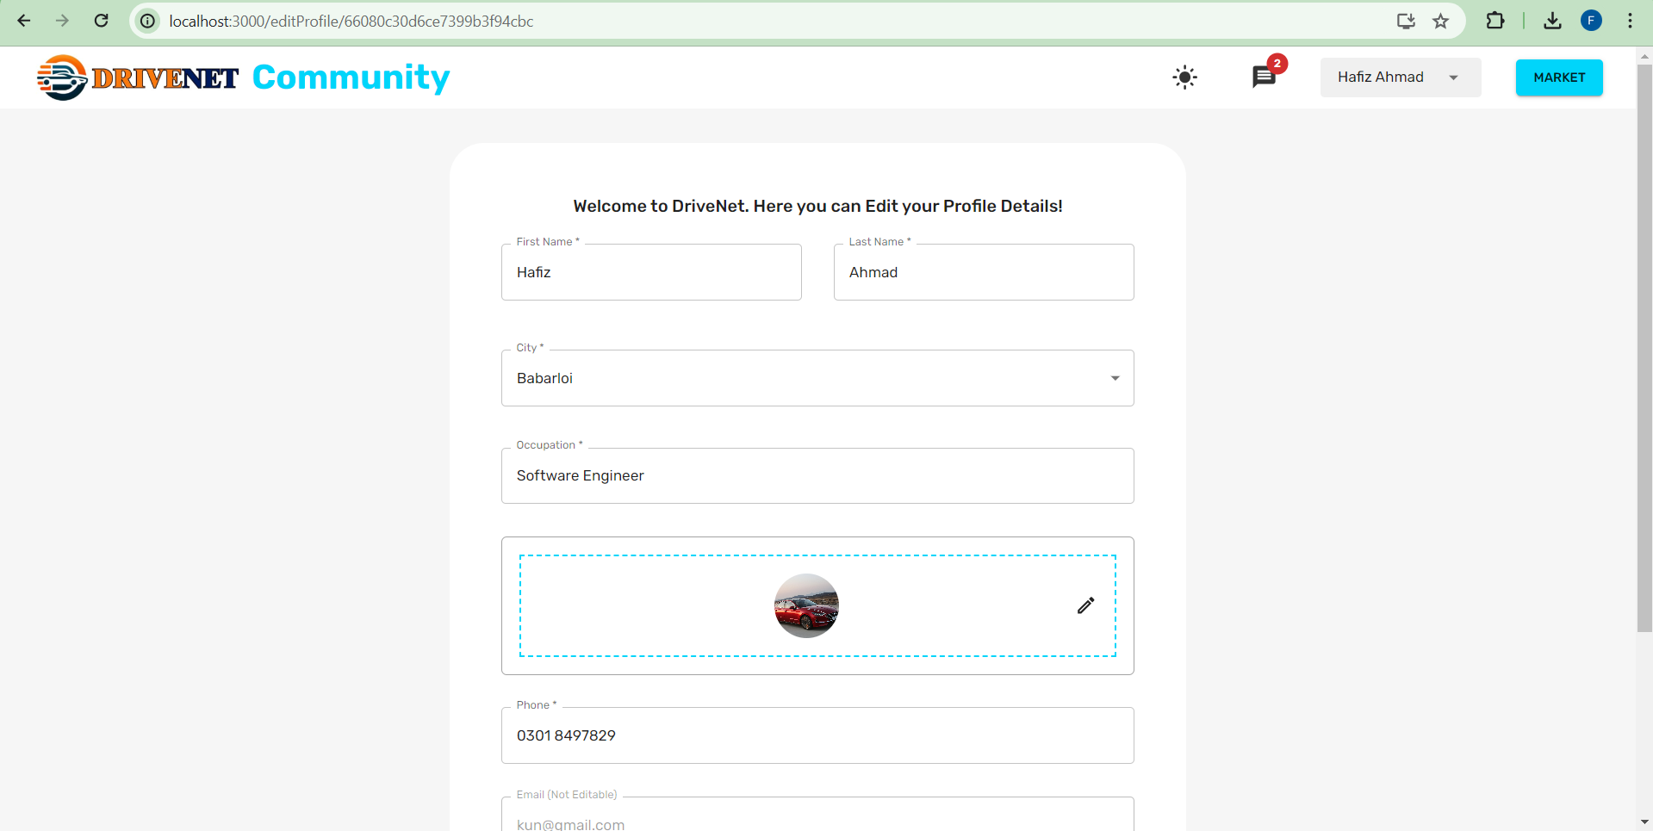

Screenshot 5 Profile Editing Page

On this page, user can edit his personal details, some of these details are also shown on profile page. User can also change password on this page.

### Vehicle Price prediction Component

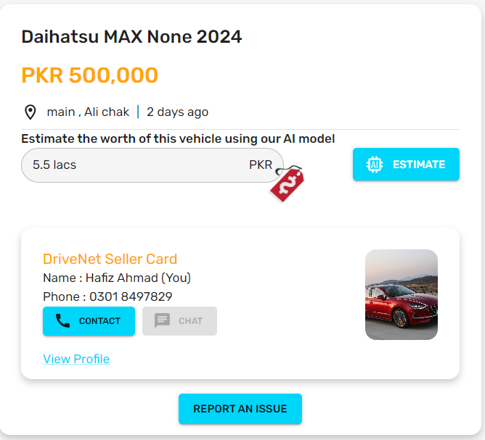

Screenshot 6 Vehicle price prediction component

### Drivenet Community Page

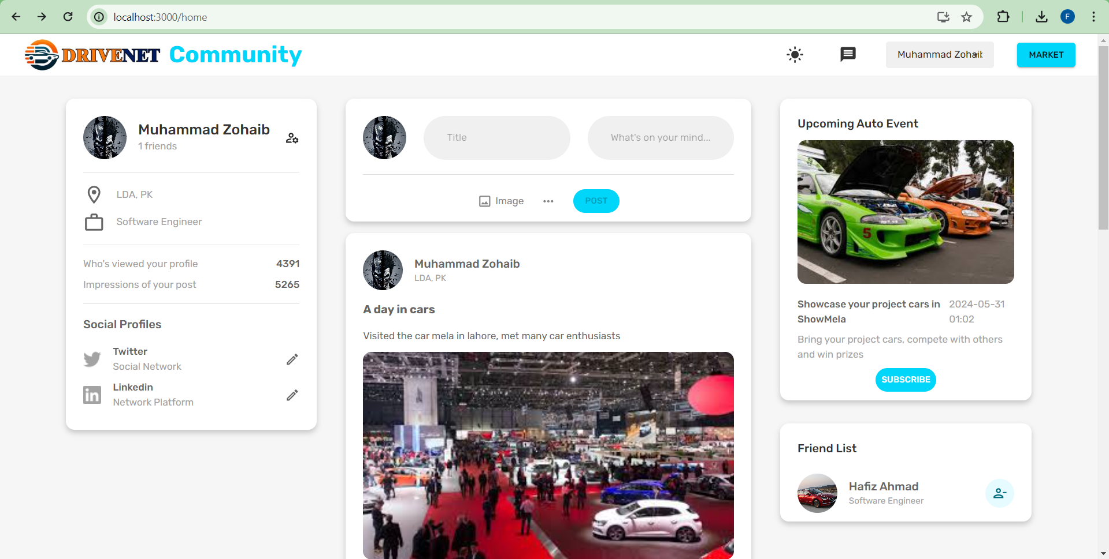

Screenshot 7 DriveNet Community Page

This is the community page that offers users of the site to share common passion for vehicles, register for upcoming events, showcase the project cars, or communicate each other.

### Drivenet Chat Page

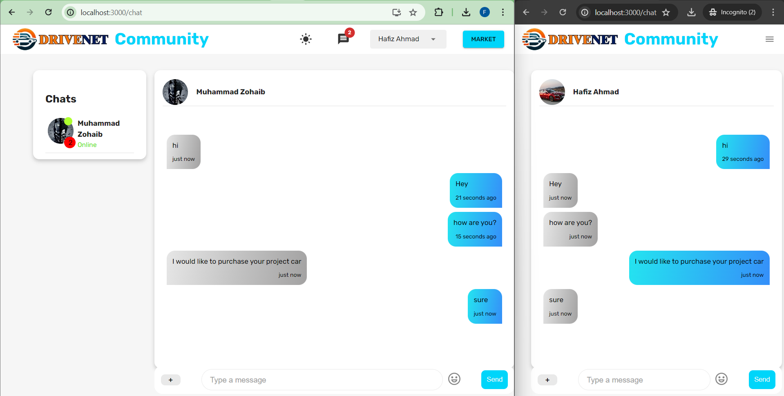

Screenshot 8 Realtime Chatting

Chatting module of our application supports realtime chatting between two users. Users are able to see the online status of each other, and new messages received as notifications. Users can include emogies which enhances the chatting experience. The same module is used by sellers and buyers to contact about any vehicle they saw on the market page. It is just one click away, and sellers is contacted by sending the referenced ad of the vehicle.

### Admin Module

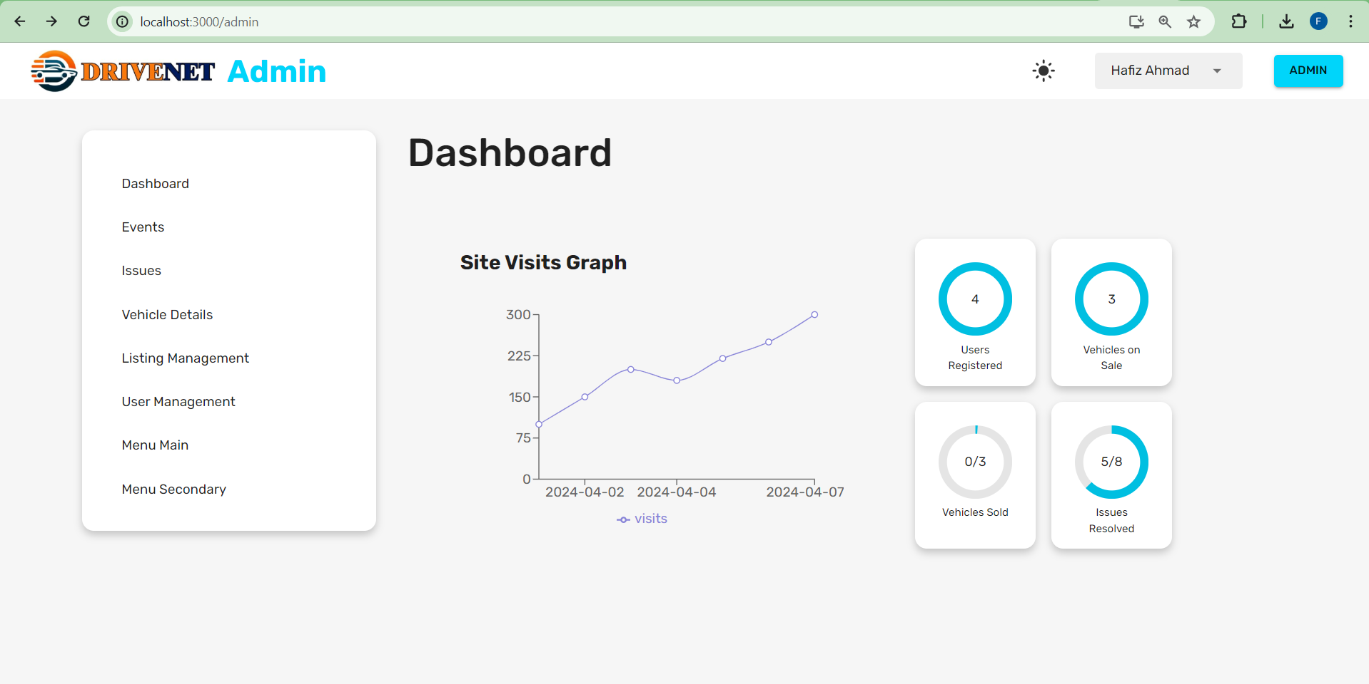

Screenshot 9 Admin Module

The admin portal allows the admin of the site, to manage users, manage events, add vehicle details, or handle issues posted by the users of the site. Admin is able to view site analytics, and repond accordingly.

### Issues Handling Page

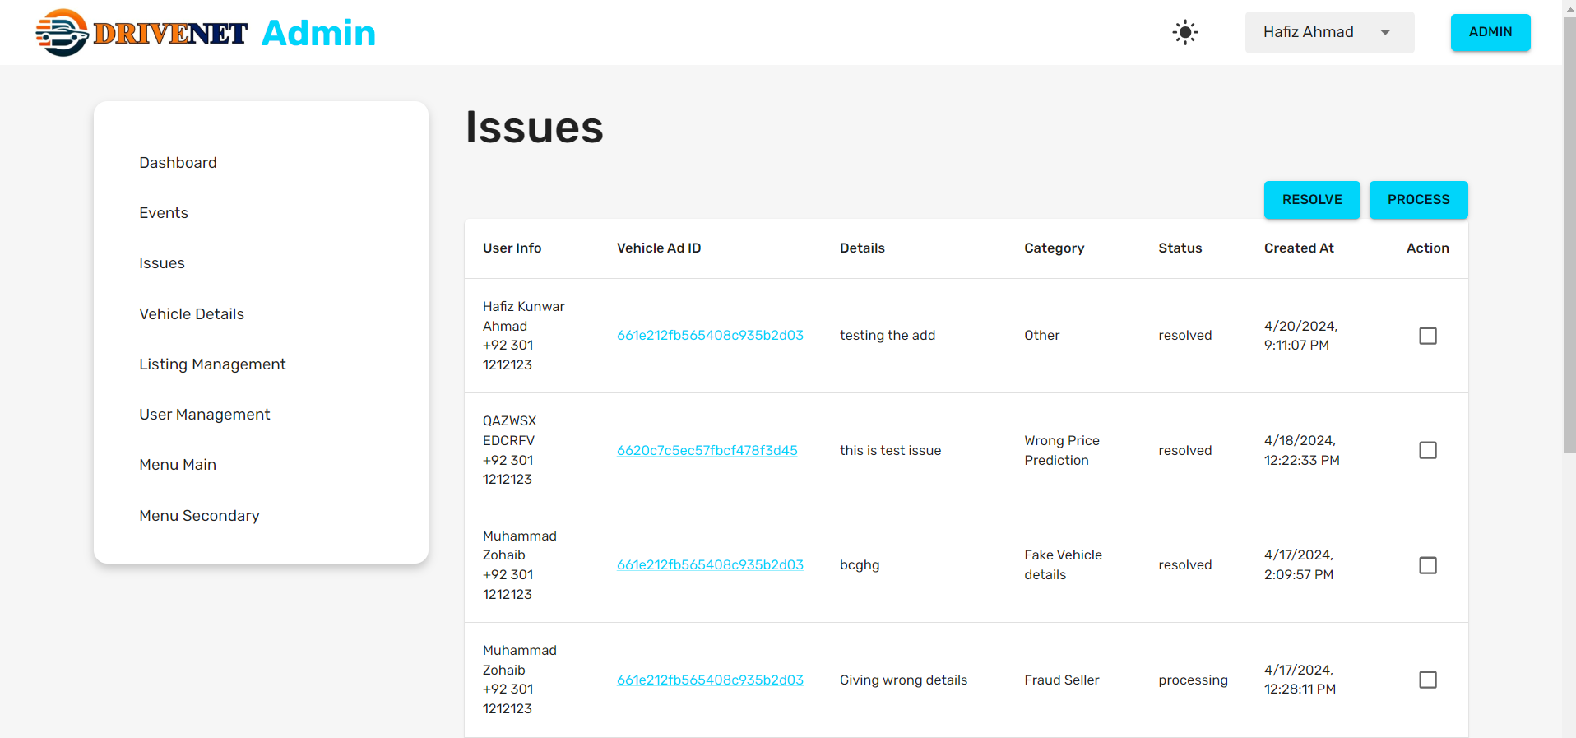

Screenshot 10 Issues Handling Page

## Machine Learning Application

This section shows the working of Machine learning backend, its training and results.

### Comparison of Evaluation Metrics of different models

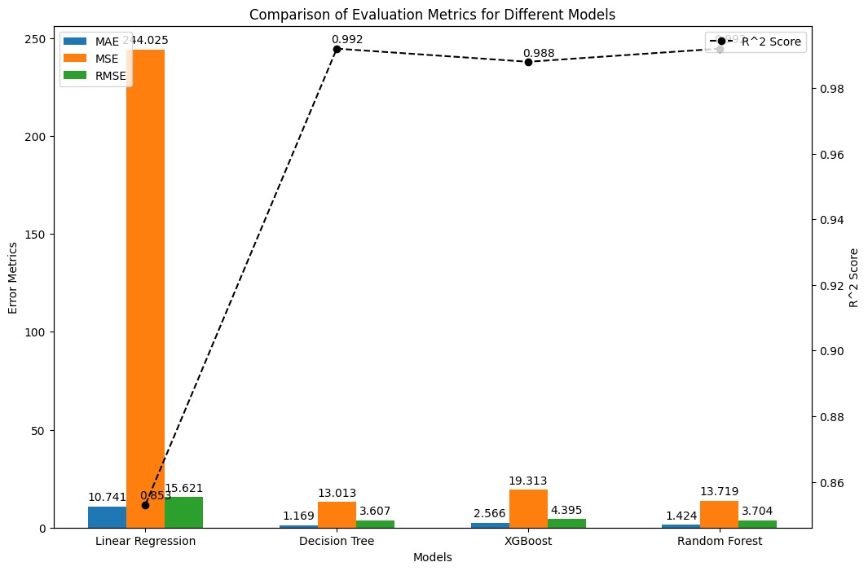

Screenshot 11 Evaluation metrics of different ML models

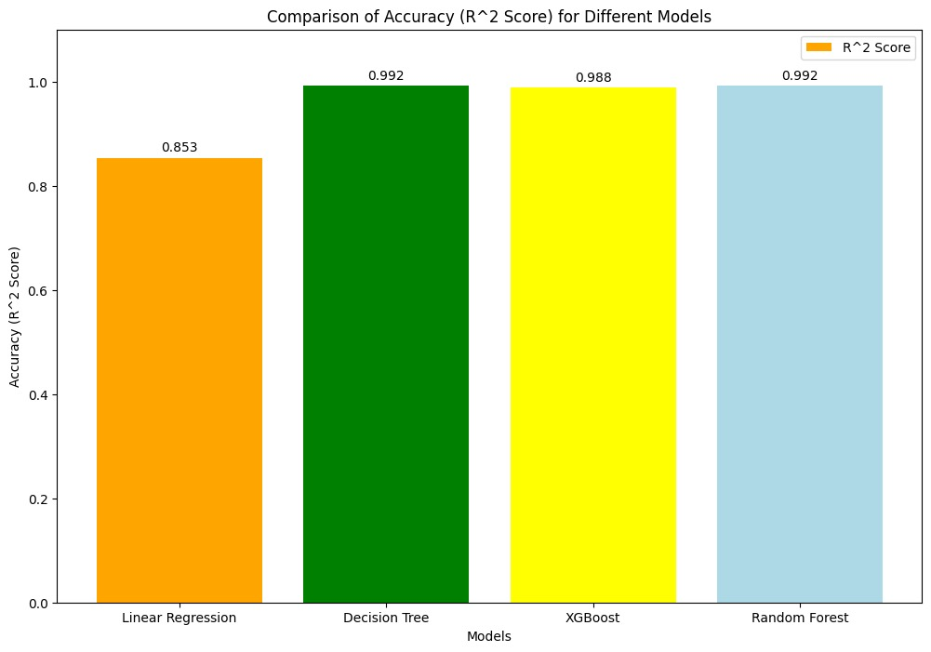

Screenshot 12 Comparison of R2 score of different models

From this graph, we can see that decision tree regression model shows the best results and accuracy, So, we use this model in our implementation.

### Scratch and dent detection

|  |  |
| --- | --- |
| Screenshot 13 Rust Detection | Screenshot 14 Scratch and dent detection |

Our system is successfully able to identify scratches, dents and rusts on the body of the vehicle, and then assign a body condition value based on number of scratches or dents detected, which contributes as an important features in price prediction model.

# Chapter 6 – Conclusion

## Project Summary

The project aims to establish a comprehensive online vehicle trading platform that integrates user-friendly functionalities, machine learning-based price prediction for precise price recommendations, and a vibrant community module. The platform facilitates seamless user registration, efficient vehicle listing, and an innovative price prediction system, offering valuable insights to both buyers and sellers. The community module encourages active user engagement through discussions, comments, and real-time chat interactions, encouraging a positive and respectful environment. Emphasizing scalability, performance, security, and user satisfaction, the platform strives to provide a reliable, accessible, and compatible service across diverse devices. In summary, the project aims to deliver a modern online marketplace that not only focus on selling vehicles but also implements a lively user community to attract vehicle enthusiasts, enhancing the overall platform experience.

## Problems Faced and Lessons Learned

During the initiation of the project, several challenges were encountered and valuable lessons were learned. Following are the problems faced and lessons learned from these problems:

The accuracy of the machine learning-based price prediction heavily relied on the quality and availability of training data. Incomplete or inaccurate data may lead to unreliable predictions. One significant issue involved the integration of the machine learning-based price prediction module, which required extensive fine-tuning to achieve the desired accuracy. We decided to scrap data from famous vehicle selling website PakWheels. There are many datasets also available on Kaggle [8] related to PakWheels which lacks some characteristics related to price prediction. We can also use them after cleaning and merging with the scraped data.

**Lesson Learned:** Sometimes dataset isn’t available to use directly in machine learning. So, we can scrap data from already available different sources, and merge them with available datasets.

Another issue we faced was evaluation of the car based on vehicle engine condition, compression ratio, or suspension condition. We needed to use high resolution cameras to detect high quality pictures from car engine, and there is no proper technique or method to quantify the data about engine or see the internal condition of engine or suspension. So, lacked computing resources, and couldn’t perform the evaluation of engines.

**Lesson Learned:** Identifying small and complex details using the AI require high computational resources, and lack of techniques make it impossible based on the current technology.

Another issue that occurred after deployment may include managing and moderating user-generated content within the Community module or Listing of Inappropriate vehicle ads within the listing module, poses challenges related to inappropriate posts, spam, or conflicts among users. Implementing effective moderation tools can be complex.

**Lesson Learned:** The role of admin is very important while developing systems like this. Admin could block/unblock users, remove un-related content, or delete in-appropriate vehicles ads that could conflict with the community guidelines.

## Future Work

**Collaboration and Partnerships:**

Look for affiliations with car dealerships to increase the amount of real time data and thus increase accuracy. Get in touch with the technology partners to integrate new trends such as Artificial intelligence and Machine learning.

**Car Internal Condition Detection with Computer Vision**

Explore methods, and techniques to quantify the data of cars internal conditions like engine condition, suspension condition, interior condition, tyres condition and other important things, using the images obtained using normal users phone camera. These features are important and contribute much to the price estimation of vehicle. So, writing such alogrithms and techniques may take a lot of time based on current resources, but we have planned to do it in upcoming year.

**Integration with Emerging Technologies**

Share the concept of integrating AR and VR that allows providing virtual test drives and unique experiences of car purchasing. In this way, users can open all sides of a car; in general, these technologies revolutionize the buying process of used cars. This new-age strategy benefits customers, by creating a sense of clarity and assurance about the automobiles that you have in your stock and letting them have a detailed digital inspection of each of these automobiles.

**Ongoing Model Refinement and Reiteration**

Running continuous training on the existing models that will enable our models to evolve with changes in the market such as new models, and prices changes, and new modifications in vehicles and users feedback.

**Security and Privacy Measures:**

Design effective security strategies to safeguard the information of the users and guarantee the confidentiality of the information incorporated in the system.

The security procedures should also be updated frequently and drivenet should ensure that the system is in compliance with the regulations in data protection.

# References

|  |  |
| --- | --- |
| [1] | S. Munj, “Pakwheels Inspection,” [Online]. Available: https://www.pakwheels.com/pakwheels-inspection/new?campaignid=20839233007&adgroupid=157931532402&keyword=pakwheels%20inspection&device=c&matchtype=p&network=g&gclid=EAIaIQobChMI_Yb0uOeCgwMV3UNBAh2i3Q3XEAAYASABEgLFEPD_BwE. [Accessed 12 2023]. |
| [2] | “OLX Motors,” [Online]. Available: https://www.olx.com.pk/motors/car-inspection/?utm_source=google&utm_medium=cpc&utm_campaign=LHR-CarInspection-En&utm_term=CarInspectionLahore&utm_content=496392572070&nst=0&gclid=EAIaIQobChMI6968iumCgwMVpzgGAB1_TQm4EAAYASAAEgJC4PD_BwE&gclsrc=aw.ds. [Accessed 28 11 2023]. |
| [3] | S. Munj, “Pakwheels,” 12 2023. [Online]. Available: https://www.pakwheels.com/. |
| [4] | “OLX Motors,” [Online]. Available: https://www.olx.com.pk/motors/. [Accessed 28 11 2023]. |
| [5] | “CarWow UK,” [Online]. Available: https://www.carwow.co.uk/#gref. [Accessed 1 12 2023]. |
| [6] | “Vava Cars,” [Online]. Available: https://tr.vava.cars/?lang=en. [Accessed 1 12 2023]. |
| [7] | “TrueCar,” [Online]. Available: https://www.truecar.com/. [Accessed 5 12 2023]. |
| [8] | “Kaggle Pakwheel dataset,” [Online]. Available: https://www.kaggle.com/discussions/general/443189. [Accessed 17 11 2023]. |
| [9] | a. https://www.pakwheels.com/main/about_us#:~:text=Founded%20in%202003%2C%20PakWheels.com. |
| [10] | PakWheels, “About us”. |
| [11] | “kaggle,” [Online]. Available: https://www.kaggle.com/. [Accessed 16 11 2023]. |

# Appendix A

## Originality Report

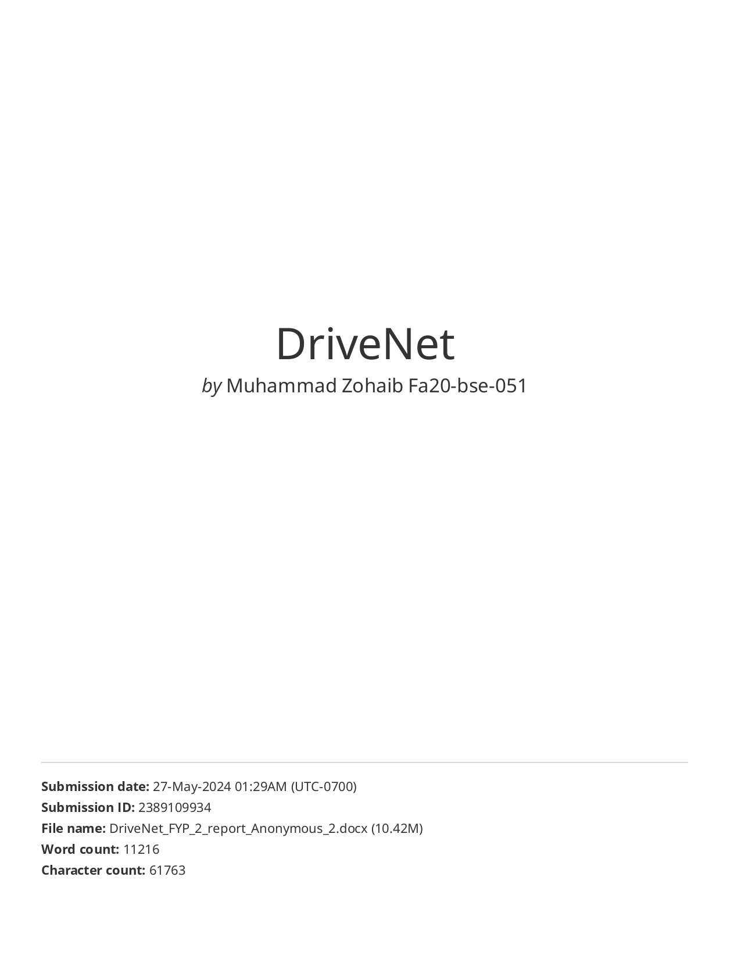

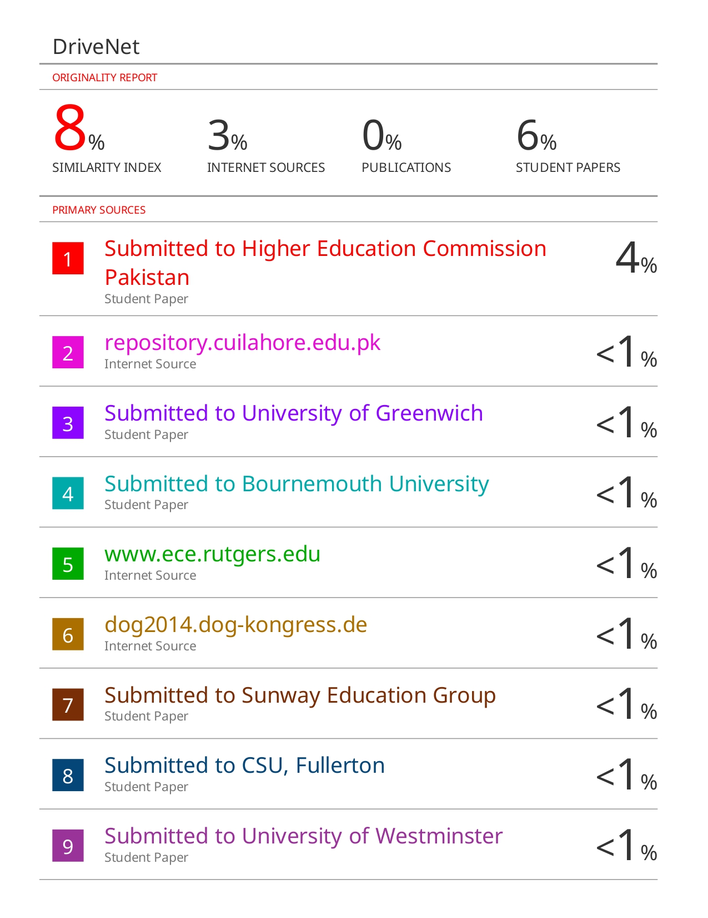

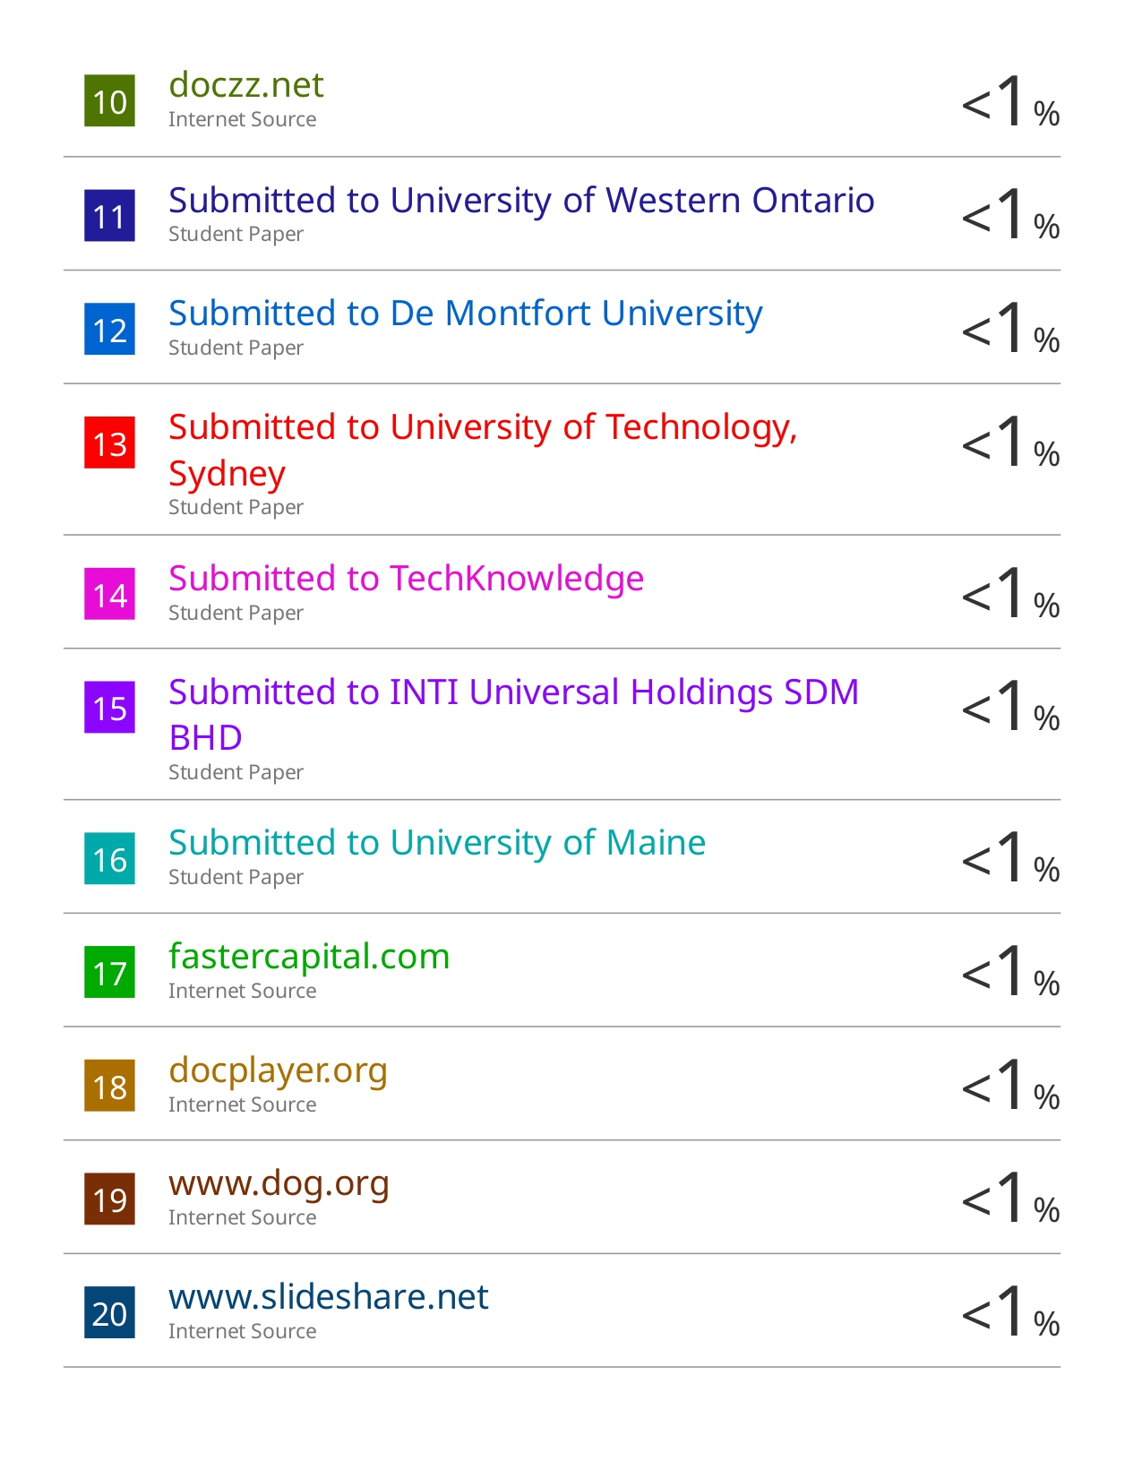



## AI Plagiarism Report

